TABLE OF CONTENTS

UNITED STATES

SECURITIES AND EXCHANGE COMMISSION

Washington, D.C. 20549

SCHEDULE 14A

Proxy Statement Pursuant to Section 14(a)
of the Securities Exchange Act of 1934

(Amendment No. )

Filed by the Registrant ☒

Filed by a Party other than the Registrant ☐

Check the appropriate box:

☐ Preliminary Proxy Statement

☐ Confidential, for Use of the Commission Only (as permitted by Rule 14a-6(e)(2))

☒ Definitive Proxy Statement

☐ Definitive Additional Materials

☐ Soliciting Material Pursuant to Section 240.14a-12

AMERICAN FINANCIAL GROUP, INC.

(Name of Registrant as Specified In Its Charter)

(Name of Person(s) Filing Proxy Statement if other than the Registrant)

Payment of Filing Fee (Check the appropriate box):

- No fee required.

  - Fee computed on table in exhibit required by Item 25(b) per Exchange Act Rules 14a-6(i)(4) and 0-11.

  - Fee paid previously with preliminary materials.

TABLE OF CONTENTS
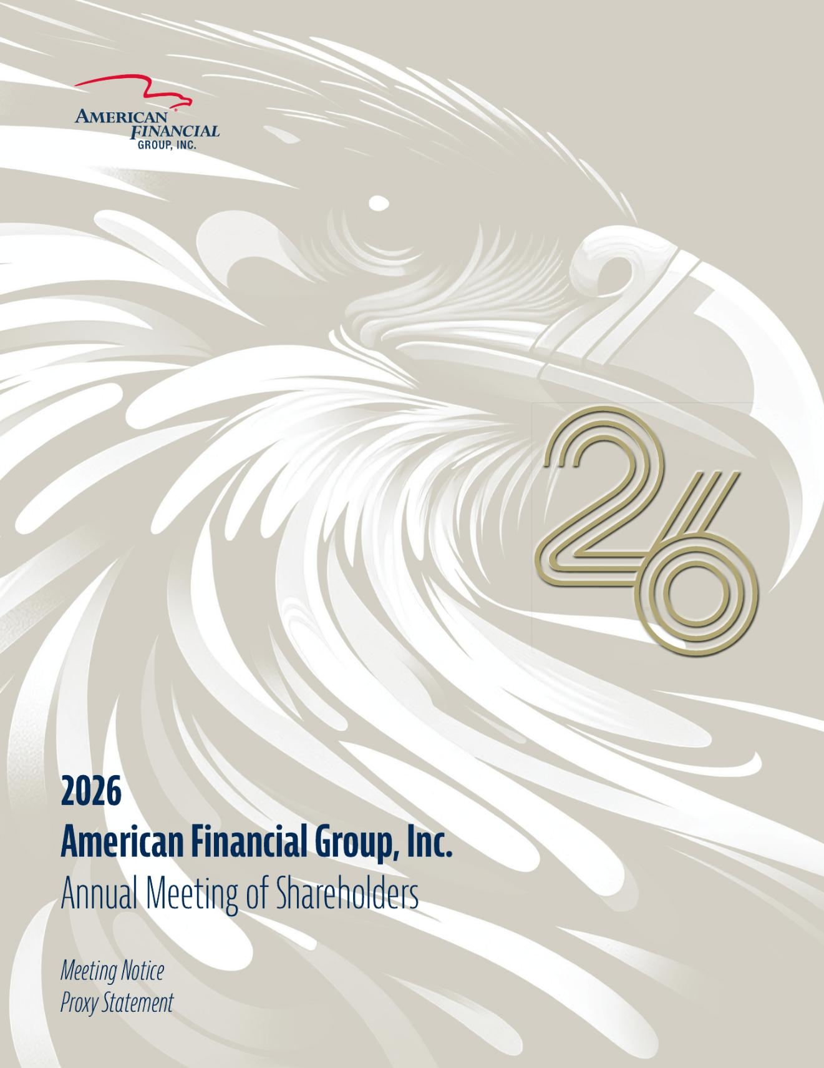

TABLE OF CONTENTS

Notice of 2026 Annual
Meeting of Shareholders
DEAR SHAREHOLDER:
Our annual meeting of shareholders will be held by live audio webcast on
Wednesday, May 20, 2026, for the following purposes:

Items

- To elect 12 directors;


- To ratify the appointment of our independent registered public accounting firm; and

- To approve on an advisory basis our named executive officer compensation.

Shareholders will also transact such other business as may properly come before the meeting or any adjournment or postponement of the meeting.

The 2026 annual meeting of shareholders will be a virtual meeting conducted via audio webcast. You will be able to participate in the virtual meeting online, vote your shares electronically and submit questions during the meeting by visiting www.virtualshareholdermeeting.com/AFG2026.

You may vote if you were a shareholder of record at the close of business on

March 27, 2026. Our proxy materials are available via the internet, which allows us to reduce printing and delivery costs.

We want your shares to be represented at the meeting and urge you to vote. For instructions on voting and more information about the annual meeting, please refer to page 67 under “Information about the Annual Meeting and Voting.”
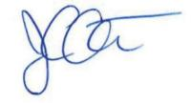

Joseph C. Alter

Vice President and Secretary

Cincinnati, Ohio

April 3, 2026

MEETING DETAILS
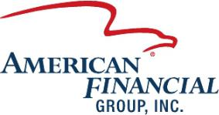


Date:

May 20, 2026

Time:

11:00 a.m. Eastern Time

Location:

www.virtualshareholder

meeting.com/AFG2026

TABLE OF CONTENTS
 | 2026 Proxy Statement Summary |  |  |  |  |  |  |  |  |  |  |  |  |  |  |  |  |  |  |  |  |  |  |  |  |  |  |  |  |  |  |  |  |  |  |  | 1
 | Corporate Governance Highlights |  |  |  |  |  |  |  |  |  |  |  |  |  |  |  |  |  |  |  |  |  |  |  |  |  |  |  |  |  |  |  |  |  |  |  | 5
 | Proposals
 |  | Proposal No. 1 – Election of 12 Directors |  |  |  |  |  |  |  |  |  |  |  |  |  |  |  |  |  |  |  |  |  |  |  |  |  |  |  |  |  |  |  |  |  |  | 9
 |  | Proposal No. 2 – Ratification of Appointment of Independent Registered Public Accounting Firm |  |  |  |  |  |  |  |  |  |  |  |  |  |  |  |  |  |  |  |  |  |  |  |  |  |  |  |  |  |  |  |  |  |  | 18
 |  | Proposal No. 3 – Advisory Vote on Compensation of our Named Executive Officers |  |  |  |  |  |  |  |  |  |  |  |  |  |  |  |  |  |  |  |  |  |  |  |  |  |  |  |  |  |  |  |  |  |  | 20
 | Company Information |  |  |  |  |  |  |  |  |  |  |  |  |  |  |  |  |  |  |  |  |  |  |  |  |  |  |  |  |  |  |  |  |  |  |  | 21
 |  | Management |  |  |  |  |  |  |  |  |  |  |  |  |  |  |  |  |  |  |  |  |  |  |  |  |  |  |  |  |  |  |  |  |  |  | 21
 |  | Security Ownership of Certain Beneficial Owners and Management |  |  |  |  |  |  |  |  |  |  |  |  |  |  |  |  |  |  |  |  |  |  |  |  |  |  |  |  |  |  |  |  |  |  | 22
 | Corporate Governance |  |  |  |  |  |  |  |  |  |  |  |  |  |  |  |  |  |  |  |  |  |  |  |  |  |  |  |  |  |  |  |  |  |  |  | 24
 |  | Leadership Structure |  |  |  |  |  |  |  |  |  |  |  |  |  |  |  |  |  |  |  |  |  |  |  |  |  |  |  |  |  |  |  |  |  |  | 24
 |  | Board of Directors and Committees |  |  |  |  |  |  |  |  |  |  |  |  |  |  |  |  |  |  |  |  |  |  |  |  |  |  |  |  |  |  |  |  |  |  | 25
 |  | Audit Committee Report |  |  |  |  |  |  |  |  |  |  |  |  |  |  |  |  |  |  |  |  |  |  |  |  |  |  |  |  |  |  |  |  |  |  | 28
 |  | Majority Voting for Directors |  |  |  |  |  |  |  |  |  |  |  |  |  |  |  |  |  |  |  |  |  |  |  |  |  |  |  |  |  |  |  |  |  |  | 29
 |  | Director Nomination Process and Qualifications of Candidates |  |  |  |  |  |  |  |  |  |  |  |  |  |  |  |  |  |  |  |  |  |  |  |  |  |  |  |  |  |  |  |  |  |  | 30
 |  | Director Independence |  |  |  |  |  |  |  |  |  |  |  |  |  |  |  |  |  |  |  |  |  |  |  |  |  |  |  |  |  |  |  |  |  |  | 30
 |  | Other Corporate Governance Matters, Practices and Procedures |  |  |  |  |  |  |  |  |  |  |  |  |  |  |  |  |  |  |  |  |  |  |  |  |  |  |  |  |  |  |  |  |  |  | 31
 | Compensation Discussion and Analysis |  |  |  |  |  |  |  |  |  |  |  |  |  |  |  |  |  |  |  |  |  |  |  |  |  |  |  |  |  |  |  |  |  |  |  | 37
 |  | Overview of Compensation Program |  |  |  |  |  |  |  |  |  |  |  |  |  |  |  |  |  |  |  |  |  |  |  |  |  |  |  |  |  |  |  |  |  |  | 37
 |  | 2025​ | Compensation Components |  |  |  |  |  |  |  |  |  |  |  |  |  |  |  |  |  |  |  |  |  |  |  |  |  |  |  |  |  |  |  |  |  | 43
 |  | 2025​ | Compensation Determinations and Results |  |  |  |  |  |  |  |  |  |  |  |  |  |  |  |  |  |  |  |  |  |  |  |  |  |  |  |  |  |  |  |  |  | 45
 | Executive Compensation |  |  |  |  |  |  |  |  |  |  |  |  |  |  |  |  |  |  |  |  |  |  |  |  |  |  |  |  |  |  |  |  |  |  |  | 54
 |  | Summary Compensation Table |  |  |  |  |  |  |  |  |  |  |  |  |  |  |  |  |  |  |  |  |  |  |  |  |  |  |  |  |  |  |  |  |  |  | 54
 |  | Potential Payments upon Termination or Change in Control |  |  |  |  |  |  |  |  |  |  |  |  |  |  |  |  |  |  |  |  |  |  |  |  |  |  |  |  |  |  |  |  |  |  | 55
 |  | Grants of Plan-Based Awards |  |  |  |  |  |  |  |  |  |  |  |  |  |  |  |  |  |  |  |  |  |  |  |  |  |  |  |  |  |  |  |  |  |  | 56
 |  | Outstanding Equity Awards at Fiscal Year-End |  |  |  |  |  |  |  |  |  |  |  |  |  |  |  |  |  |  |  |  |  |  |  |  |  |  |  |  |  |  |  |  |  |  | 57
 |  | Option Exercises and Stock Vested |  |  |  |  |  |  |  |  |  |  |  |  |  |  |  |  |  |  |  |  |  |  |  |  |  |  |  |  |  |  |  |  |  |  | 58
 |  | Nonqualified Defined Contribution and Other Nonqualified Deferred Compensation Plans |  |  |  |  |  |  |  |  |  |  |  |  |  |  |  |  |  |  |  |  |  |  |  |  |  |  |  |  |  |  |  |  |  |  | 58
 |  | Compensation Committee Report |  |  |  |  |  |  |  |  |  |  |  |  |  |  |  |  |  |  |  |  |  |  |  |  |  |  |  |  |  |  |  |  |  |  | 59
 |  | Director Compensation and Stock Ownership Guidelines |  |  |  |  |  |  |  |  |  |  |  |  |  |  |  |  |  |  |  |  |  |  |  |  |  |  |  |  |  |  |  |  |  |  | 59
 |  | Ratio of Co-CEO Total Pay to “Median Employee” Total Pay |  |  |  |  |  |  |  |  |  |  |  |  |  |  |  |  |  |  |  |  |  |  |  |  |  |  |  |  |  |  |  |  |  |  | 60
 |  | Pay versus Performance |  |  |  |  |  |  |  |  |  |  |  |  |  |  |  |  |  |  |  |  |  |  |  |  |  |  |  |  |  |  |  |  |  |  | 62
 |  | Equity Compensation Plan Information |  |  |  |  |  |  |  |  |  |  |  |  |  |  |  |  |  |  |  |  |  |  |  |  |  |  |  |  |  |  |  |  |  |  | 65
 | Information About the Annual Meeting and Voting |  |  |  |  |  |  |  |  |  |  |  |  |  |  |  |  |  |  |  |  |  |  |  |  |  |  |  |  |  |  |  |  |  |  |  | 67
 | Other Matters |  |  |  |  |  |  |  |  |  |  |  |  |  |  |  |  |  |  |  |  |  |  |  |  |  |  |  |  |  |  |  |  |  |  |  | 71
 |  | Copies of Annual Report on Form 10-K |  |  |  |  |  |  |  |  |  |  |  |  |  |  |  |  |  |  |  |  |  |  |  |  |  |  |  |  |  |  |  |  |  |  | 71
 |  | Submitting Shareholder Proposals for the 2027 Annual Meeting of Shareholders |  |  |  |  |  |  |  |  |  |  |  |  |  |  |  |  |  |  |  |  |  |  |  |  |  |  |  |  |  |  |  |  |  |  | 71

2026 Proxy Statement | American Financial Group i

TABLE OF CONTENTS

2026 Proxy

Statement Summary

This summary highlights information contained elsewhere in this proxy statement. This summary does not contain all of the information you should consider. You should read the entire proxy statement carefully before voting.

MEETING DETAILS

(see “Information about the Annual Meeting and Voting” beginning on page 67):




Date: | Time: | Location:
May 20, 2026 | 11:00 a.m. | www.virtualshareholder
 | Eastern Time | meeting.com/AFG2026

WAYS TO VOTE





Through | By toll free | By mail: | Virtually:
the Internet: | telephone: | Follow instructions | At the Annual
www.proxyvote.com | (800) 690-6903 | on your proxy card | Meeting

MATTERS TO BE VOTED ON:

 |  |  | Board
 | Items |  | Recommendation
1 |  | Election of 12 | FOR
 |  | Director Nominees | each nominee
2 |  | Ratification of Appointment of Independent | FOR
 |  | Registered Public Accounting Firm | FOR
3 |  | Advisory Vote to Approve Compensation | FOR
 |  | of Named Executive Officers (“Say-on-Pay”) | FOR

Page

Page 9

Page 18

Page 20

2026 Proxy Statement | American Financial Group 1

TABLE OF CONTENTS

PROXY STATEMENT SUMMARY

BOARD COMMUNICATIONS:

Joseph C. Alter | Gregory G. Joseph
Vice President, Deputy General | Lead Independent Director
Counsel & Secretary | American Financial Group, Inc.
American Financial Group, Inc. | Great American Insurance Group Tower
Great American Insurance Group Tower | 301 East Fourth Street
301 East Fourth Street | Cincinnati, Ohio 45202
Cincinnati, Ohio 45202

Throughout this proxy statement, we refer to information and documents that are available on our website. The content posted on, or accessible through, our website is not incorporated by reference into this proxy statement or any of our filings with the SEC and may be revised by us (in whole or in part) at any time and from time to time.

OUR VALUES

Our values form the foundation of our business, shape our priorities, and set our expectations for how we conduct our business, service our customers and interact with each other.
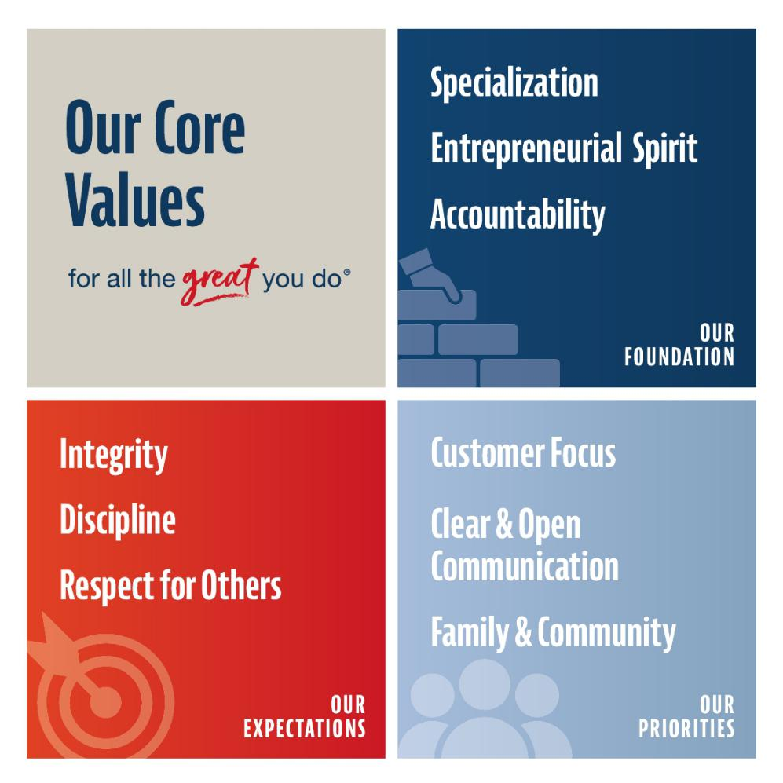

2 2026 Proxy Statement | American Financial Group

TABLE OF CONTENTS

PROXY STATEMENT SUMMARY

OUR PURPOSE

We enable individuals and businesses to manage financial risk by providing insurance products and services tailored to meet their specific and ever-changing financial risk exposures. We build value for our investors through the strength of our customers’ satisfaction and by consistently producing superior operating results.

A HISTORY DATING BACK MORE THAN 150 YEARS

Our business operates under the Great American Insurance Group, whose history dates back to 1872, with the founding of Great American Insurance Company.
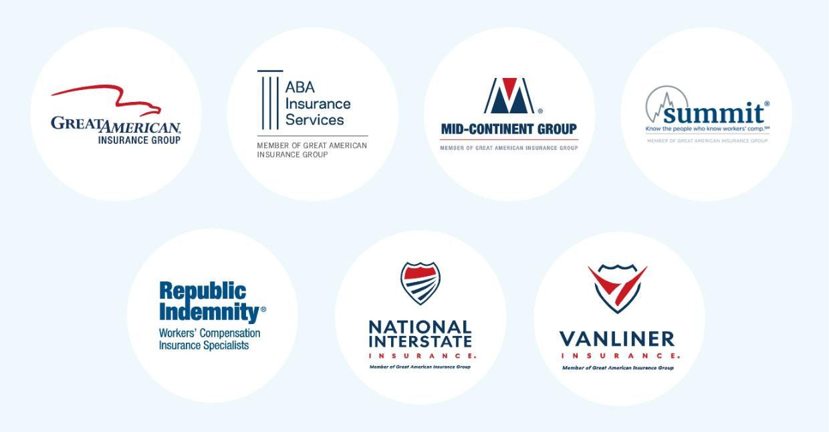

7.6% | >55% |  | 13 years
Points of Statutory | Specialty P&C |  | Consecutive years
Combined Ratio | Group gross written |  | Specialty P&C GAAP
outperformance | premium produced |  | Combined Ratio has
vs. peers⁽¹⁾ over | by businesses with |  | been under 94%
10 year period ended | “top 10” market
12/31/2025 | rankings

(1) Commercial lines industry data based on AM Best’s Market Segment Report – February 23, 2026.

2026 Proxy Statement | American Financial Group 3

TABLE OF CONTENTS

PROXY STATEMENT SUMMARY

2025 FINANCIAL HIGHLIGHTS

FINANCIAL RESULTS:

 | Core Net Operating |  | Core Operating |  |  | Statutory
 | Earnings Per Share |  | Return on Equity⁽¹⁾⁽²⁾ |  |  | Combined Ratio⁽³⁾
 | (Non-GAAP)⁽¹⁾
 | $10.29 |  | 18​.2% |  |  | 91.3%
 |  |  |  |  |  | Compared to 95.8% for the
 |  |  |  |  |  | commercial lines industry
 | Total Capital Returned |  | Growth in |  |  |  | 5​-Year Total
 | to Shareholders |  | Book Value per Share |  |  |  | Shareholder Return
 |  |  | + Dividends
 | $707 million |  | 17​.2% |  |  |  | 160​.8%


- $274 million in regular dividends - $334 million in special dividends - $99 million in share repurchases - Regular dividend rate increased

10.0% in October 2025, representing 20th consecutive annual dividend increase

Based on 12/31/25 book value per | Compared to 96.0% and
share (excluding AOCI) of $58.38 | 128.8%, respectively, for the
and 2025 dividends of $7.28 per | S&P 500 and S&P 500
share | Property and Casualty Indices

FINANCIAL STRENGTH:⁽⁴⁾
AM Best | Standard & Poor’s | Moody’s
A+(Superior) | A+ (Strong) | A1

Rated “A” (Excellent) or better by AM Best for more than 115 years
One of only four companies to achieve this result

- AFG’s net earnings attributable to shareholders, a GAAP financial measure, include certain items that may not be indicative of its ongoing core operations. AFG believes that its core net operating earnings, a non-GAAP financial measure, provides management, financial analysts, ratings agencies and investors with an understanding of the results from the ongoing operations of the Company by excluding net realized gains and losses and other items that are not necessarily indicative of operating trends. AFG’s management uses core net operating earnings to evaluate financial performance against historical results because it believes this provides a more comparable measure of its continuing business. A reconciliation of net earnings attributable to shareholders to core net operating earnings can be found under “Management’s Discussion and Analysis of Financial Condition and Results of Operations — Results of Operations — General” on page 49 of AFG’s Annual Report on Form 10-K for the year ended December 31, 2025.

- Based on core net operating earnings and using a five-quarter average of ending shareholders’ equity excluding accumulated other comprehensive income.

- Commercial lines industry data based on ©2026 AM Best Company’s Review & Preview Reports.

- Ratings of the Company’s U.S.-based property and casualty insurance companies, where rated.

4 2026 Proxy Statement | American Financial Group

TABLE OF CONTENTS

Corporate Governance Highlights

CORPORATE GOVERNANCE SUMMARY


Board

Independence

and Leadership

Shareholder

Rights

Board

Effectiveness

All key board committees (Audit, Compensation and Corporate Governance) are chaired by and entirely comprised of independent directors.

Lead independent director empowered with broadly defined authorities and responsibilities.

Regular (at least quarterly) executive sessions of independent directors chaired by our lead independent director.

Regular (at least twice annually) independent director executive sessions with the Co-CEOs.

Strong board oversight of enterprise risk.

Individual directors required to tender resignation if they fail to receive a majority of votes cast.

Shareholders have a right to call a special meeting.

No poison pill.


Our Corporate Governance guidelines provide that we will consider Board candidates with a broad range of expertise, experience and qualifications, including candidates from both corporate positions and non-traditional environments such as government, academia and nonprofit organizations.

Our Board consists of directors with a wide variety of skills, experience and attributes.

Our Board and Board committees undertake a robust annual self-evaluation conducted by an outside third-party.

Comprehensive director orientation program for new directors; existing directors typically also attend as opportunity to deepen knowledge and enhance engagement.

Ongoing Board education sessions on varied and timely topics.

Independent directors’ stock ownership guidelines require owning Company shares having a value of at least three times their annual cash retainer.

Director and

Officer Stock

Ownership

Compensation Governance

Each Co-CEO is required to own five times his base salary in Company shares.

All other named executive officers, as well as Company senior management, must own Company shares having a value in excess of one times his or her base salary.

Our executive officers and directors as a group own a substantial percentage of our outstanding common shares, which directly aligns the interests of our executive officers and directors with those of our other shareholders.


Compensation Committee consisting entirely of independent directors oversees all aspects of our named executive officer compensation program.

Periodic engagement of independent compensation consultant to advise regarding compensation program structure.

Performance-based compensation is a majority of Co-CEOs’ potential compensation and a significant portion of our other named executive officers’ compensation.

Annual shareholder advisory vote to approve named executive officer compensation.

No employment agreements, severance agreements or change-in-control agreements with any of our executive officers.

Double-trigger vesting provisions for all equity awards following a change of control.

Executive Clawback Policy for executive officers and recoupment policy for performance awards applicable to senior management employees beyond the executive officers.

The Corporate Governance Committee annually reviews director compensation.

Annual equity grant to directors is a substantial portion of their annual compensation.

2026 Proxy Statement | American Financial Group 5

TABLE OF CONTENTS

CORPORATE GOVERNANCE HIGHLIGHTS

Ethics and

Corporate

Responsibilities

Code of Ethics and Business Conduct, which applies to all officers, employees and directors, is rooted in our values and is designed to promote the highest standards of ethical conduct.

Active and robust ethics and compliance program, which includes required regular employee training.

All employees complete annual conflict of interest questionnaire.

​Required Code of Ethics and Business Conduct training for and certification by all employees annually.

Committed to corporate responsibility and annual Corporate Social Responsibility Report and Sustainability Accounting Standards Board (SASB) Report, which are accessible on our website.

6 2026 Proxy Statement | American Financial Group

TABLE OF CONTENTS

OVERVIEW OF BOARD NOMINEES

Overview of Board Nominees

Board Nominees Snapshot
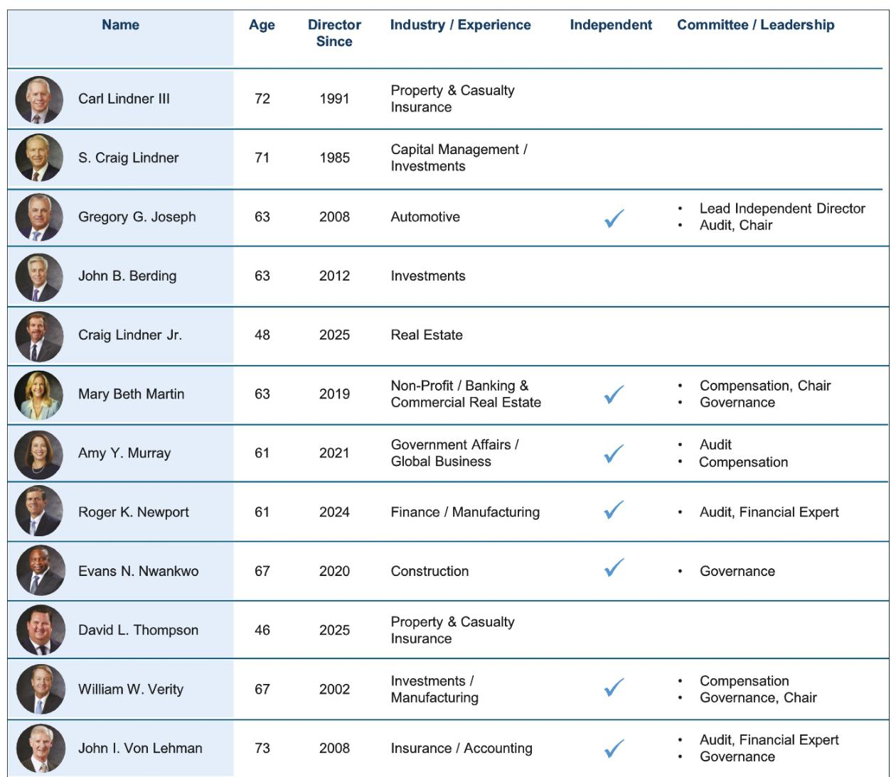

2026 Proxy Statement | American Financial Group 7

TABLE OF CONTENTS

OVERVIEW OF BOARD NOMINEES

Board Nominee Attributes
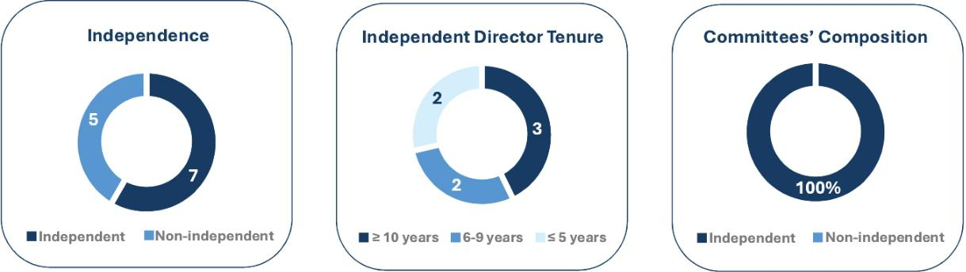

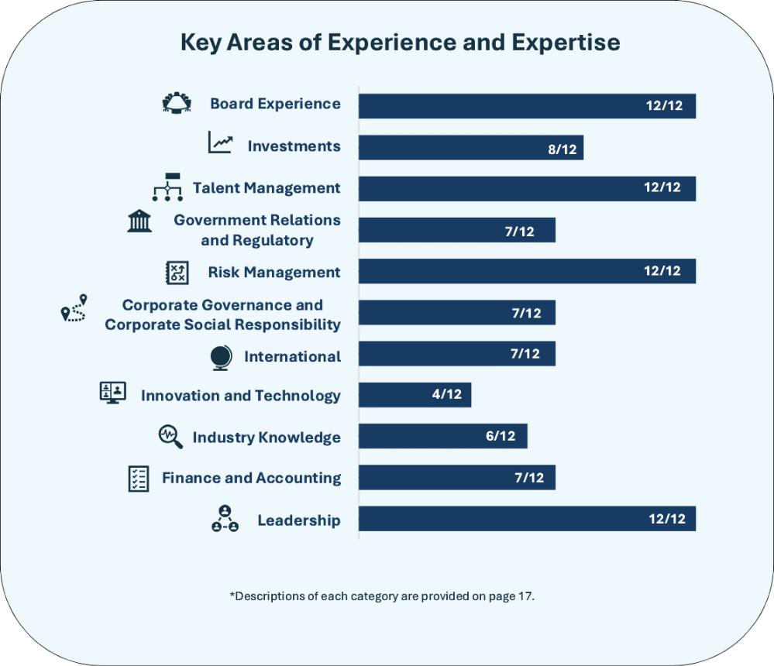

8 2026 Proxy Statement | American Financial Group

TABLE OF CONTENTS

Proposal No. 1

Election of 12 Directors

The Board of Directors oversees the management of the Company on your behalf. The Board reviews AFG’s long-term strategic plans and exercises direct decision-making authority in key areas such as choosing the Co-Chief Executive Officers, setting the scope of their authority to manage the Company’s business day-to-day, and evaluating senior management performance.

Upon the recommendation of the Corporate Governance Committee, the Board of Directors has nominated 12 individuals, each of whom is an incumbent director, to hold office until the next annual meeting of shareholders and until their successors are elected and qualified. If any of the nominees should become unable to serve as a director, the proxies will be voted for any substitute nominee designated by the Board of Directors but, in any event, no proxy may be voted for more than 12 nominees.

Each nominee brings a strong and unique background and set of qualifications to the Board, giving the Board as a whole competence and experience in a wide variety of areas, including corporate governance and board service, nonprofit, governmental, executive management and entrepreneurial experience as well as insurance, finance and accounting expertise. In addition, the nominees’ experiences span multiple regions of the United States and countries around the world, with several bringing broad experience shaped by leadership roles and professional engagement, including international living and working experience. This breadth of perspective supports thoughtful oversight of AFG’s nationwide operations, investment activities and the evolving risk environment, and strengthens the Board’s ability to evaluate strategic opportunities and risks across the Company’s operating footprint. We believe that having multiple independent directors who have served through many insurance cycles (that often last upward of five to seven years) enhances their ability to effectively respond to ever-changing conditions in the property and casualty insurance industry.

In evaluating the nominees, the Board considered both individual qualifications and how the collective skills, experiences and perspectives of the nominee directors support effective oversight of AFG’s strategy, risk profile and long-term shareholder value creation.

The Board of


Directors

recommends that

shareholders vote

FOR the election of

these 12 nominees

as directors.

2026 Proxy Statement | American Financial Group 9

TABLE OF CONTENTS

PROPOSAL NO. 1

The nominees for election to the Board of Directors are as follows:
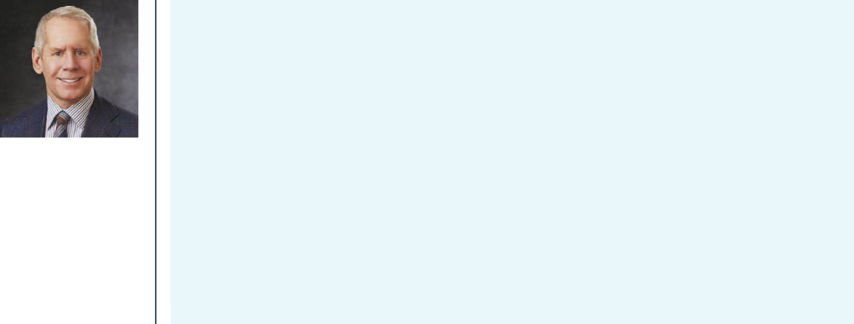

Age | 72

Director

Since | 1991
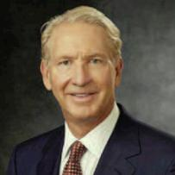

Carl H. Lindner III

Mr. Lindner has been Co-Chief Executive Officer since January 2005 and served as Co-President from 1996 until June 2023. Until 2010, for over ten years, Mr. Lindner served as President, and since 2010, Mr. Lindner has served as CEO of AFG’s Property and Casualty Insurance Group and has been principally responsible for the Company’s property and casualty insurance operations.

Mr. Lindner brings deep institutional knowledge of the Company and decades of leadership experience to AFG’s specialty property and casualty insurance operations. His experience overseeing underwriting discipline, risk selection and capital deployment across multiple insurance and economic cycles enables him to help the Board evaluate strategy, risk, the competitive environment and long-term operating decisions from a shareholder-aligned perspective.


Age | 71

Director

Since | 1985

S. Craig Lindner

Mr. Lindner has been Co-Chief Executive Officer since January 2005 and served as Co-President from 1996 until June 2023. Mr. Lindner served as President of Great American Financial Resources, Inc. (“GAFRI”), a subsidiary of the Company, for more than ten years prior to 2018 when he was elected Chief Executive Officer and was principally responsible for GAFRI’s annuity operations until their sale in 2021. Until 2011, for over ten years, Mr. Lindner served as President of American Money Management Corporation (“AMMC”), a subsidiary that provides investment services for the Company and certain of its affiliated companies, and Mr. Lindner continues to be primarily responsible for the Company’s investment portfolio.

With extensive experience overseeing AFG’s investment portfolio, capital management strategy and long-term financial planning, Mr. Lindner provides the Board with critical insight into strategic initiatives, capital management and balance sheet strength. His leadership navigating varying market and interest-rate environments enhances the Board’s oversight of investment and capital allocation decisions that are critical to long-term shareholder value creation.

10 2026 Proxy Statement | American Financial Group

TABLE OF CONTENTS

PROPOSAL NO. 1
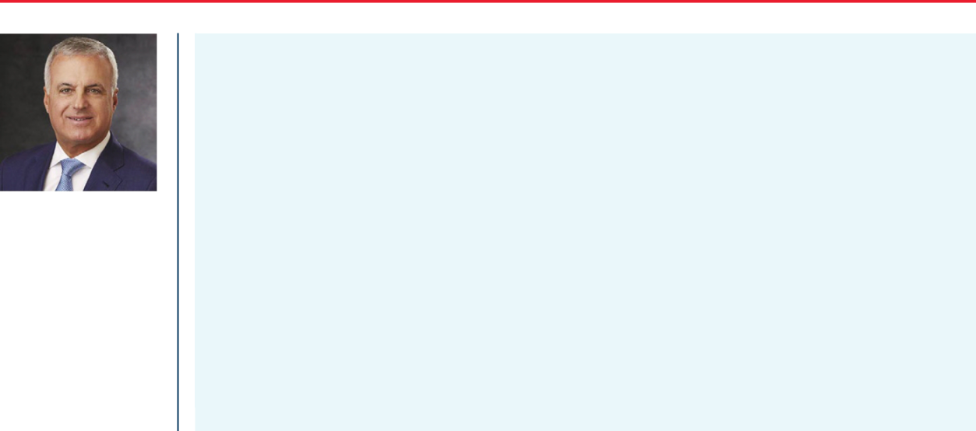

Age | 63

Director

Since | 2008
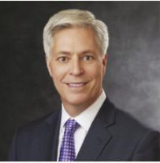

Gregory G. Joseph

Mr. Joseph, an attorney, is an executive and a principal of various automotive retailers in the Greater Cincinnati, Ohio area known as the Joseph Automotive Group. Since 2005, Mr. Joseph has served on the Board of Trustees of Xavier University, a private university located in Cincinnati, Ohio. He served on the board of directors of Infinity Property & Casualty Corporation, an insurance company primarily offering personal automobile insurance, which was purchased by Kemper Corp. in 2018, from 2003 to 2008, the last two years as the lead director.

Mr. Joseph contributes strong independent leadership and industry acumen shaped by his prior experience as a lead director of a publicly traded insurance company and his service as AFG’s Lead Independent Director. His broad background and deep experience with public and private businesses enable him to provide the Board with insights and advice on the broad variety of situations and issues that face the Company and the Board.


Age | 63

Director

Since | 2012

John B. Berding

Mr. Berding was elected President of AFG in June 2023 and President of AMMC in January 2011. Prior to his role as President, he held a number of investment-related executive positions with AMMC and other AFG subsidiaries. Mr. Berding has over 30 years of experience as an investment professional, and he has spent his entire career with the Company and its affiliates.

Mr. Berding’s more than three decades with the Company, including his longstanding leadership of its investment operations and in his current role as President of AFG, enable him to provide valuable perspective on AFG’s investment portfolio and strategy. His familiarity with AFG’s investment framework and risk management practices support the Board’s oversight of investment performance and capital deployment.

2026 Proxy Statement | American Financial Group 11

TABLE OF CONTENTS

PROPOSAL NO. 1
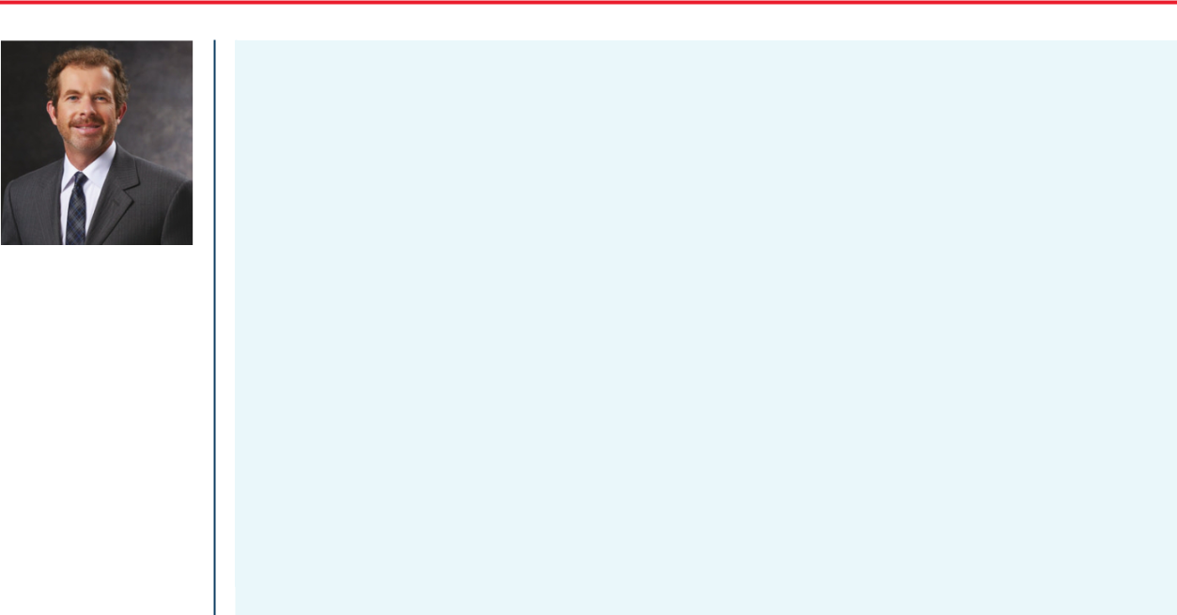

Age | 48

Director

Since | 2025
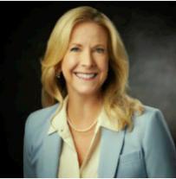

Craig Lindner Jr.

Mr. Lindner currently serves as the Divisional President of AFG Real Estate Investments, a position he has held since 2017. In this role, he manages the Company’s portfolio of apartments, resort and marina properties and other commercial real estate, in addition to its extensive portfolio of commercial mortgages. Mr. Lindner joined AFG in 2002. Over the course of a 20-plus year career in real estate investing and the insurance industry, he has played a key role in overseeing the management and operations of the Company’s investments in real estate equity and debt. During much of this time, he also served as a member of the executive team of GAFRI’s annuity operations until the time of its sale in 2021. He previously served on the Board of Directors of Cranemere, a long-term industrial holding company, from 2017-2020.

Through his leadership of AFG’s real estate investment and commercial mortgage portfolio, Mr. Lindner provides the Board with direct insight into a significant component of the Company’s alternative investment strategy. His operational and investment experience enhances the Board’s ability to oversee asset diversification, risk management and income generation within the investment portfolio.


Age | 63

Director

Since | 2019

Mary Beth Martin

Ms. Martin is the retired Executive Director of the Farmer Family Foundation, a role in which she served from 2007 until November 2025. The Farmer Family is a private family foundation focused on advancing education, health care and other community initiatives. Under Martin’s leadership, the Foundation launched and expanded several programs, including investments in neurodegenerative disease research and the establishment of Accelerate Great Schools, which supports the growth of schools for at-risk youth. As Executive Director, she managed the organization’s philanthropic goals and objectives and oversaw grant investments. For over 20 years, Ms. Martin previously served in the banking and commercial real estate industries where she led commercial real estate, private bank, trust, and asset management groups at regional banking institutions. She serves on the advisory board of Oswald Company, Inc., a privately-held construction and development firm.

Ms. Martin is active in her community and currently serves on the Board of Directors of a number of charitable organizations, including Accelerate Great Schools, where she also serves as Secretary and Treasurer, Teach for America Ohio and Ohio Excels.

Ms. Martin brings a combination of executive leadership in the nonprofit sector and experience across banking, asset management and commercial real estate. Her broad financial and organizational background, together with her role as Chair of the Compensation Committee, contributes to the Board’s effective administration of executive compensation and governance responsibilities.

12 2026 Proxy Statement | American Financial Group

TABLE OF CONTENTS

PROPOSAL NO. 1


Age | 61

Director

Since | 2021

Amy Y. Murray

Ms. Murray has over 35 years of leadership experience in the corporate world and in local and federal government. From March 2020 to January 2021, her roles included Acting Deputy Assistant Secretary of Defense, Industrial Policy and Director of the Office of Small Business for the U.S. Department of Defense. During 2011 and from 2013-2020, Ms. Murray was a member of the Cincinnati, Ohio City Council serving at various times as chair or vice chair of numerous committees. Also, from 2000-2014, she served as founder and chief consultant of The Japan Consulting Group, advising on strategies for successful business relationships with Japanese companies, both in Japan and the United States. Prior thereto, Ms. Murray spent 14 years in various positions at the Procter & Gamble Company, a leading multinational manufacturer of consumer-packaged goods, including as a manager of Global Business Development for Asia. Ms. Murray completed the National Association of Corporate Directors’ (“NACD”) Cyber-Risk Oversight Program and received the CERT Certificate in Cybersecurity Oversight issued by the Software Engineering Institute at Carnegie Mellon University. In addition, in 2026 she earned certification in the NACD’s Effective AI Oversight for Directors Program, also through Carnegie Mellon. She serves on the boards of the Mayfield Education & Research Foundation and The Shepherd Chemical Company. Ms. Murray is active in the community, having served on the boards of several charitable organizations including Cincinnati Zoo and Botanical Society and Boy Scouts of America – Dan Beard Council.

Ms. Murray offers a diverse skill set spanning government service and corporate leadership in the United States and abroad. Her experience addressing external affairs, data security and public policy matters, together with sustained engagement on technology matters, strengthens the Board’s approach to enterprise risk management and compliance in an evolving risk environment.

2026 Proxy Statement | American Financial Group 13

TABLE OF CONTENTS

PROPOSAL NO. 1
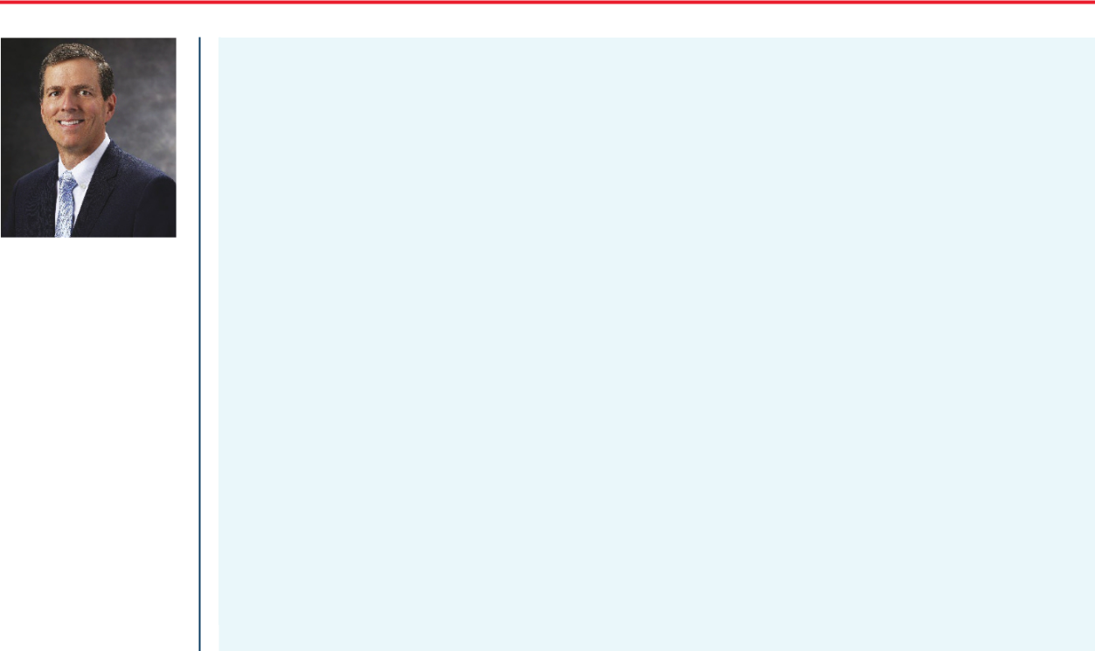

Age | 61

Director

Since | 2024
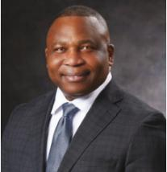

Roger K. Newport

Mr. Newport served as Chief Executive Officer and a Director of AK Steel Holding Corporation, a publicly-traded manufacturing company, from January 2016 until March 2020, when he retired in connection with the acquisition of AK Steel by Cleveland-Cliffs Inc. Prior to that, Mr. Newport served in other executive roles at AK Steel, including Executive Vice President, Finance and Chief Financial Officer, as well as Controller and Chief Accounting Officer. Mr. Newport served in a variety of other leadership positions since joining AK Steel in 1985, including Vice President, Business Planning and Development, and Assistant Treasurer, Investor Relations. In addition, since 2018, Mr. Newport has been a Director of Alliant Energy Corporation, an energy-services provider that operates as a regulated investor-owned public utility holding company. He currently serves on Alliant Energy’s Compensation Committee and Operations Committee and previously served on its Audit Committee, as Chair, and its Nominating and Governance Committee. Mr. Newport has been active in the community, having served on a variety of local and regional boards for organizations that serve the areas of academia, community development, and at-risk children and families.

Mr. Newport’s experience as a CEO, CFO and audit committee chair of large and complex publicly-traded companies provides the Board with strong leadership and financial oversight expertise. His background in accounting and financial reporting supports the Board’s oversight of financial integrity, internal controls and audit processes, including in his service as an audit committee financial expert.

Age | 67

Director

Since | 2020

Evans N. Nwankwo

Mr. Nwankwo has worked in the commercial construction industry for nearly 44 years and is the Founder and President of Megen Construction Company, one of the region’s premier builders. Megen Construction provides a full range of services including construction management, design/build, general contracting and estimating and program management and was also the first LEED Platinum builder in the State of Ohio. Megen Construction is a top-ten minority-owned business in Greater Cincinnati. Mr. Nwankwo is active in his community and around the world. He is the founder of NuWay Foundation, a charitable organization focused on improving the lives and economic conditions of the less fortunate in African villages through health, opportunity, pure water and education (H.O.P.E.). He is the Board Chairman of Ambassadors for Self Determination, a nonprofit organization focused on assisting regions of the world with their efforts towards self-determination of their governance. He is a member of the United Way Tocqueville Society and has served on the Board of Directors of a number of charitable organizations, including the American Red Cross (Cincinnati Chapter) and the Salvation Army of Greater Cincinnati.

As a founder and leader of a large construction enterprise, Mr. Nwankwo is well-positioned to contribute insight into operational risk management and entrepreneurial decision-making. His experience as a business owner and community leader – both locally and in Nigeria – adds a distinct perspective to the Board’s evaluation of strategic risk and operational resilience considerations.

14 2026 Proxy Statement | American Financial Group

TABLE OF CONTENTS

PROPOSAL NO. 1
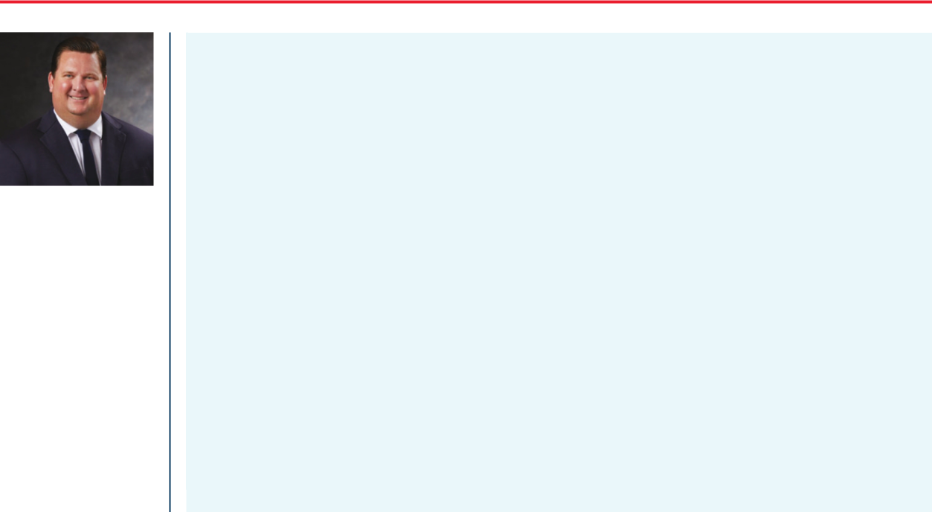

Age | 46

Director

Since | 2025
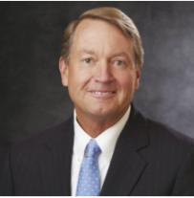

David L. Thompson

Mr. Thompson currently serves as Chair of the Board, President and Chief Operating Officer of Great American Insurance Company, AFG’s flagship property and casualty insurance company. Since joining Great American in 2006, he has served in various senior management capacities and has had direct executive oversight of many of Great American’s specialty property and casualty businesses, as well as its corporate reinsurance operations, the Company’s wholly owned retail agency, Dempsey & Siders, and was instrumental in the formation of its Predictive Analytics function. Raised in a multi-lingual, international household, Mr. Thompson spent his formative years in Poland, Germany, Switzerland, Hungary and Russia before returning to the United States.

Mr. Thompson serves on the Board of Directors of the American Property Casualty Insurance Association (APCIA).

Through his leadership of AFG’s property and casualty insurance operations within the Great American Insurance Group, Mr. Thompson brings a deep operational perspective to the Board. His broad experience across the Company’s specialty P&C businesses enables him to contribute practical, real-time business understanding while also helping inform strategic decision-making and long-term value creation.


Age | 67

Director

Since | 2002

William W. Verity

Mr. Verity has been Chair and CEO of Verity Investment Partners, an investment management company, since 2002, and prior to that, he was a Partner of Pathway Guidance LLC, an executive consulting firm. Previously, Mr. Verity was Chair and CEO of ENCOR Holdings, Inc., which owned and operated several product and manufacturing companies, and he worked as an associate in corporate finance at Alex. Brown & Sons, an investment bank. He previously served on the Board of Directors of Chiquita Brands International, Inc., an international food products marketer and distributor.

Mr. Verity’s executive leadership experience and extensive board service with public and private companies provide valuable expertise in corporate governance, executive compensation and strategic planning. His executive experience supports effective Board oversight of leadership development, succession planning and governance matters, in addition to his ability to advise on complex asset management and investment issues.

2026 Proxy Statement | American Financial Group 15

TABLE OF CONTENTS

PROPOSAL NO. 1
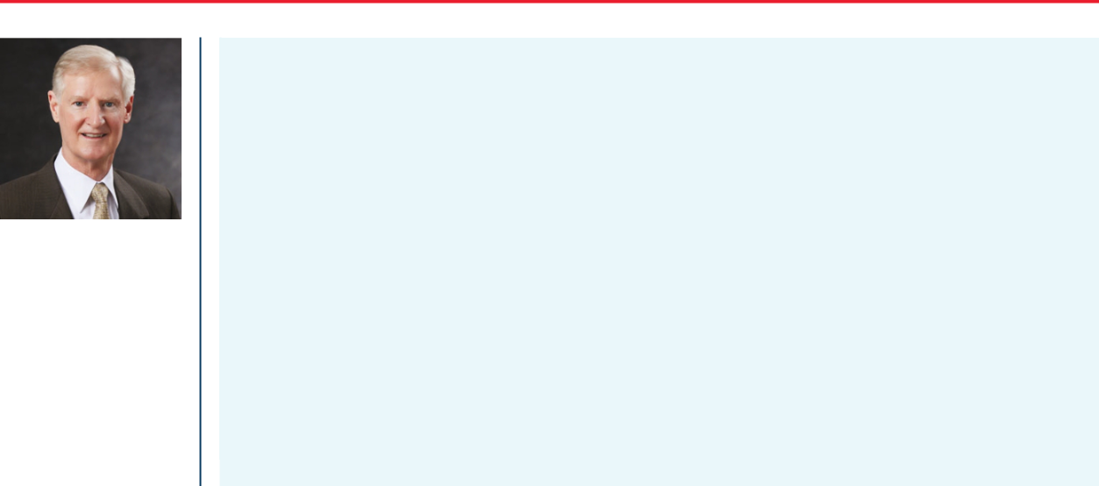

Age | 73

Director

Since | 2008

John I. Von Lehman

Mr. Von Lehman began his career as a certified public accountant for Haskins & Sells, a predecessor of Deloitte, LLP. For more than five years until his retirement in 2007, Mr. Von Lehman served as Executive Vice President, Chief Financial Officer, Secretary and a director of The Midland Company, an Ohio-based provider of specialty insurance products. He served on the Board of Directors and as Chairman of the Audit Committee of Ohio National Mutual Funds until 2016 and is involved with several Cincinnati-based charitable organizations.

As a retired long-time executive of The Midland Company, a property and casualty insurance company, Mr. Von Lehman brings deep industry knowledge, together with extensive finance and accounting experience, including as a certified public accountant. His expertise in financial reporting, internal controls and risk assessment supports the Board’s oversight of those areas and enable him to serve as an audit committee financial expert.

16 2026 Proxy Statement | American Financial Group

TABLE OF CONTENTS

PROPOSAL NO. 1

SUMMARY OF ATTRIBUTES AND EXPERIENCE OF BOARD NOMINEES

In considering each director nominee, the Board and the Corporate Governance Committee evaluated each individual’s qualifications, qualities and skills to serve as a director. The Board believes that each director nominee brings a unique and valuable mix of experience and attributes to the Board. The following matrix provides information regarding the director nominees, including certain areas of knowledge, skills and experience that the Board believes are relevant to our business and strategic goals. The type and degree of knowledge, skill and experience below varies among our directors. The matrix is a non-exclusive summary and does not include all knowledge, skills, experience or other attributes of our directors that may be relevant and valuable to their service on our Board; a director may possess other relevant and important knowledge, skills and experience not indicated in the matrix. Additional information on each director nominee, including some of their specific experience, qualifications, attributes or skills, is set forth in the biographies on pages 10 to 16 of this proxy statement.
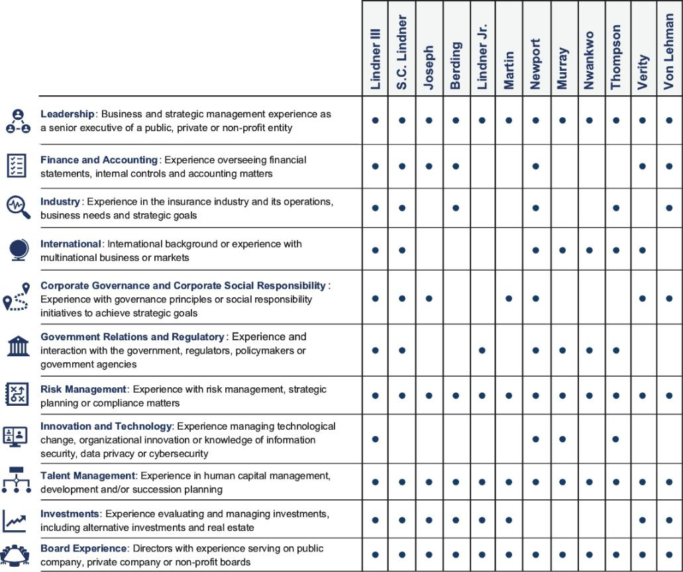

2026 Proxy Statement | American Financial Group 17

TABLE OF CONTENTS

Proposal No. 2

Ratification of Appointment of Independent Registered Public

Accounting Firm



The Company’s Audit Committee Charter requires that the Audit Committee appoint annually an independent registered public accounting firm to serve as auditors. In February 2026, the Audit Committee appointed Ernst & Young LLP to serve as the Company’s independent registered public accounting firm for 2026.

Although the Audit Committee has the sole authority to appoint auditors, shareholders are being asked to ratify this appointment. If the shareholders do not ratify the appointment, the Audit Committee will take that fact into consideration but may determine to continue to retain Ernst & Young. However, the Audit Committee in its discretion may engage a different independent registered public accounting firm at any time during the year if the Audit Committee determines that such a change would be in the best interests of the Company whether or not the shareholders ratify the appointment.

AUDIT FEES AND NON-AUDIT FEES

The Board of

Directors

recommends that

shareholders vote

FOR the ratification

of the Audit

Committee’s

appointment of

Ernst & Young as

our independent

registered public

accounting firm for

2026.

The following table presents fees for professional services performed by Ernst & Young for the years ended December 31, 2025 and 2024.

 |  | 2025 | 2024
Audit fees⁽¹⁾ | $8,594,000 |  | $8,094,000
Audit related fees |  | — | —
Tax fees⁽²⁾ | ​ | 445,000 | 522,000
All other fees⁽³⁾ | ​ | 642,000 | ​ 611,000
Total | $9,681,000 |  | $9,227,000

- These aggregate fees were for audits of the financial statements (including services incurred to render an opinion under Section 404 of the Sarbanes-Oxley Act of 2002), subsidiary insurance company audits, reviews of SEC filings, and quarterly reviews.

- These fees relate primarily to tax compliance engagements for preparation and review of foreign tax returns and certain collateralized loan obligations, in addition to other tax advisory services.

- These fees relate primarily to agreed-upon procedure engagements for certain collateralized loan obligation structures managed by AFG.

Representatives of Ernst & Young are expected to be at the meeting and will be given the opportunity to make a statement if they so desire. They will also be available to respond to appropriate questions from shareholders.

18 2026 Proxy Statement | American Financial Group

TABLE OF CONTENTS

PROPOSAL NO. 2

PRE-APPROVAL OF SERVICES PROVIDED BY THE INDEPENDENT REGISTERED PUBLIC ACCOUNTING FIRM

The Audit Committee has adopted policies that require pre-approval for any audit and non-audit services to be provided to AFG by Ernst & Young LLP. The Audit Committee delegated authority to the Committee Chairperson to pre-approve certain non-audit services which arise between meetings of the Audit Committee. Pursuant to these procedures and delegation of authority, the Audit Committee was informed of and pre-approved any such audit and other services during 2025. No services were provided with respect to the de minimis waiver process provided by rules of the SEC.

2026 Proxy Statement | American Financial Group 19

TABLE OF CONTENTS

Proposal No. 3

Advisory Vote on Compensation of our Named Executive Officers

This proposal provides shareholders with the opportunity to cast a non-binding, advisory vote to approve the compensation of the Company’s named executive officers as disclosed in this Proxy Statement (commonly referred to as “Say-on-Pay”). Our practice is to conduct this non-binding, advisory vote on an annual basis, and at our 2023 Annual Meeting, our shareholders overwhelmingly supported the continuation of this practice. The Compensation Committee and the Board of Directors continue to believe that AFG’s executive compensation program appropriately aligns pay with performance and emphasizes long-term shareholder value creation.

As described below under the heading “Compensation Discussion and Analysis” beginning on page 37 of this proxy statement, we seek to closely align the interests of our named executive officers with the interests of our shareholders. We structure our programs to discourage excessive risk-taking through a balanced use of compensation vehicles and metrics with an overall goal of delivering sustained long-term shareholder value while aligning our executives’ interests with those of our shareholders. Further, our programs require that a substantial portion of each named executive officer’s compensation be contingent on delivering performance results that benefit our shareholders. Our compensation programs are designed to reward our named executive officers for achieving short-term and long-term strategic and operational goals designed to increase total shareholder return. Shareholders should note that, because the advisory vote on executive compensation occurs well after the beginning of the compensation year and because the different elements of our executive compensation programs are designed to operate in an integrated manner and to complement one another, in many cases it may not be appropriate or feasible to change our executive compensation programs in consideration of any one year’s advisory vote on executive compensation by the time of the following year’s annual meeting of shareholders.

The Board of


Directors

recommends that

shareholders vote

FOR the approval of

the compensation of

our named

executive officers as

disclosed in this

proxy statement.

The vote on this matter is not intended to address any specific element of compensation; rather, the vote relates to the compensation of our named executive officers, as described in this proxy statement in accordance with the compensation disclosure rules of the SEC. The vote is advisory, which means that the vote is not binding on the Company, our Board of Directors or the Compensation Committee. Nevertheless, the Board and the Compensation Committee carefully review the voting results when evaluating executive compensation decisions and program design.

Accordingly, we ask our shareholders to approve, on an advisory basis, the compensation of the named executive officers, as disclosed in this proxy statement pursuant to the compensation disclosure rules of the SEC, including the Compensation Discussion and Analysis, the Summary Compensation Table and the other related tables and disclosure.

20 2026 Proxy Statement | American Financial Group

TABLE OF CONTENTS

Company Information

MANAGEMENT

The directors, nominees for director and executive officers of the Company are as follows:

 |  |  | Director or
 |  |  | Executive
Name | Age | Position | Since
Carl H. Lindner III | 72 | Co-Chief Executive Officer and Director | 1979
S. Craig Lindner | 71 | Co-Chief Executive Officer and Director | 1980
John B. Berding | 63 | President of AFG, President of American Money Management | 2012
 |  | Corporation and Director
Gregory G. Joseph | 63 | Lead Independent Director | 2008
Craig Lindner Jr. | 48 | Divisional President, AFG Real Estate Investments and Director | 2025
Mary Beth Martin | 63 | Director | 2019
Amy Y. Murray | 61 | Director | 2021
Roger K. Newport | 61 | Director | 2024
Evans N. Nwankwo | 67 | Director | 2020
David L. Thompson | 46 | President and Chief Operating Officer of Great American Insurance | 2022
 |  | Group and Director
William W. Verity | 67 | Director | 2002
John I. Von Lehman | 73 | Director | 2008
Michelle A. Gillis | 57 | Senior Vice President, Chief Human Resources Officer and Chief | 2013
 |  | Administrative Officer
Brian S. Hertzman | 55 | Senior Vice President and Chief Financial Officer | 2020
Mark A. Weiss | 59 | Senior Vice President, General Counsel and Chief Compliance | 2022
 |  | Officer

Mr. Carl H. Lindner III and Mr. S. Craig Lindner are brothers, Mr. S. Craig Lindner is the father of Craig Lindner Jr., and Mr. Carl H.

Lindner III is the father-in-law of David L. Thompson.

Michelle A. Gillis was appointed Chief Human Resources Officer in 2022 and became Senior Vice President and Chief Administrative Officer of the Company in March 2013. She has responsibility for human resources, including talent management and total rewards. She also oversees corporate marketing and branding, real estate and numerous shared services areas. Since joining Great American Insurance Company in 2004, Ms. Gillis held various senior human resource management positions. Previously, Ms. Gillis spent several years in senior human resources roles in the financial services sector. Ms. Gillis holds an active accreditation as Senior Professional in Human Resources (SPHR) from the Human Resources Certification Institute.

Brian S. Hertzman became Senior Vice President and Chief Financial Officer of the Company in August 2020. Prior to his election, he served as Vice President since 2014 and Controller since 2012. Mr. Hertzman, a licensed certified public accountant (inactive), joined AFG in 1991 and has held positions of increasing responsibility within the Company’s finance and accounting areas during his over 30 year tenure. As Vice President and Controller of AFG, Mr. Hertzman had responsibility for oversight of accounting policies and procedures in compliance with GAAP and other applicable regulations and financial reporting to the Securities and Exchange Commission.

Mark A. Weiss was elected Senior Vice President and General Counsel of the Company effective December 1, 2022. He served as the Chief Compliance Officer from 2020 until April 2025. He joined AFG in 2010 and has served in various capacities, most recently as Vice President and Assistant General Counsel. Mr. Weiss was a partner at Keating Muething & Klekamp PLL prior to joining the Company.

Information regarding all nominees for director is set forth beginning on page 9 under “Proposals — Proposal No. 1 — Election of 12 Directors.”

2026 Proxy Statement | American Financial Group 21

TABLE OF CONTENTS

COMPANY INFORMATION

SECURITY OWNERSHIP OF CERTAIN BENEFICIAL OWNERS AND MANAGEMENT

The following table sets forth certain information regarding beneficial ownership of common shares by each of the Company’s directors and the named executive officers and by all directors and executive officers of the Company as a group. The table also includes those who are known by the Company to own beneficially more than 5% of the issued and outstanding common shares. Except as otherwise provided below, information in the table is as of March 13, 2026, and, to the Company’s knowledge, all common shares are beneficially owned and investment and voting power is held solely by the persons named as owners.

 | Common Shares
Name of Beneficial Owner/Group | Beneficially Owned⁽¹⁾ | Percent of Class
Directors and Named Executive Officers

Carl H. Lindner III⁽²⁾

S. Craig Lindner⁽³⁾
John B. Berding⁽⁴⁾

Gregory G. Joseph⁽⁵⁾
Craig Lindner, Jr.⁽⁶⁾

Mary Beth Martin

Amy Y. Murray

Roger K. Newport

Evans N. Nwankwo

William W. Verity

John I. Von Lehman

Brian S. Hertzman

David L. Thompson⁽⁷⁾

Mark A. Weiss⁽⁸⁾
All Directors and Executive Officers as a group (15 persons)⁽⁹⁾ Other Beneficial Owners of More than 5% of the Common Shares

​ 5,662,146 |  | ​ 6.8%
​ 5,141,226 |  | ​ 6.2%
​ | 138,882 | *
​ | 123,537 | *
​ 1,853,091 |  | ​ 2.2%
​ | 10,194 | *
​ | 2,651 | *
​ | 3,662 | *
​ | 6,347 | *
​ | 13,119 | *
​ | 12,463 | *
​ | 18,033 | *
​ 1,557,736 |  | ​ 1.9%
​ | 21,188 | *
14,050,220​ |  | 16​.9%

The Vanguard Group⁽¹⁰⁾ | 8,187,402 | 8.7%
BlackRock, Inc.⁽¹¹⁾ | 7,995,504 | 8.5%
FMR, LLC⁽¹²⁾ | 5,121,287 | 7.9%

(* means less than 1%)

- Includes the following number of shares held in the Company’s 401(k) Retirement and Savings Plan (RASP) (provided as of March 13, 2026): S. Craig Lindner – 120,495; John B. Berding – 53,112; Brian S. Hertzman – 4,034; and Craig Lindner Jr. – 4,433. For Mr. Berding and Mr. Hertzman, shares owned excludes shares held in the RASP, for which each serves on the Administrative Plan Committee, other than those shares allocated to his personal RASP account.

- Includes 3,643,670 shares held in trusts over which he holds voting and dispositive power; 343,162 shares held by a trust over which his spouse has voting and dispositive power; 838,480 shares held in a limited liability company over which shares he holds dispositive power; 509,622 shares held by a charitable foundation over which he shares voting and dispositive power with his brother, S. Craig Lindner and his mother; 63,834 shares held in trusts for family members over which he holds voting and dispositive power; and 263,378 shares held in two charitable foundations over which he and/or his spouse have or share voting and dispositive power. Mr. Lindner’s address is 301 East Fourth Street, Cincinnati, Ohio, 45202.

- Includes 4,015,209 shares held in trusts over which he has voting and dispositive power; 134,044 shares held in a trust over which he has dispositive power; 116,578 shares held by a trust over which his spouse has voting and dispositive power; 509,622 shares held by a charitable foundation over which he shares voting and dispositive power with his brother, Carl H. Lindner III and his mother; 6,000 shares held in trusts for family members over which he holds voting and dispositive power; and 239,278 shares held by a charitable foundation over which he shares voting and dispositive power with his spouse. Mr. Lindner’s address is 301 East Fourth Street, Cincinnati, Ohio, 45202.

- Includes 1,899 shares held by family trusts.

- Includes 68,009 shares held by companies in which he is a minority shareholder and for which he serves as an executive officer or director, 3,000 shares held by a family partnership in which he holds a 25% interest and 6,618 shares held as trustee in trusts for the benefit of family members and 334 shares held by spouse. Does not include 83,684 shares held by Mr. Joseph’s father for which Mr. Joseph holds a power of attorney; Mr. Joseph disclaims beneficial ownership of such shares.

22 2026 Proxy Statement | American Financial Group

TABLE OF CONTENTS

COMPANY INFORMATION

- Includes 329,163 shares held in trusts over which he holds voting and dispositive power; 10,327 shares held by his spouse; 27,442 shares as custodian for his minor children; 552,104 shares held in trusts for family members over which he holds dispositive power; 134,044 shares held in trusts for family members over which he holds voting power; and 795,578 shares held in trusts for family members over which he holds voting and dispositive power.

- Includes 1,454,947 shares held in trusts for family members where he or his spouse has voting and dispositive power, 72,797 shares held in a charitable trust where his wife shares voting and dispositive power and 29,992 shares held by his spouse as custodian for his minor children.

- Includes 9,461 shares held in trust.

- Shares held by all directors, nominees and executive officers as a group is calculated by counting shares over which Carl H. Lindner III and S. Craig Lindner share voting and dispositive power only once.

- Based solely on information contained in the prior Schedule 13G amendment filed with the SEC by The Vanguard Group, on January 30, 2026, reporting shared voting power of 514,751 shares and shared dispositive power of 7,297,408 shares. The address for The Vanguard Group is 100 Vanguard Blvd., Malvern, Pennsylvania, 19355. The Vanguard Group subsequently reported that due to an internal realignment it no longer has, or is deemed to have, beneficial ownership over Company shares beneficially owned by various Vanguard subsidiaries and/or business divisions.

- Based solely on information contained in the most recent Schedule 13G amendment filed with the SEC by BlackRock, Inc., on October 17, 2025, reporting sole voting power of 6,548,769 shares and sole dispositive power of 7,071,034 shares. The address for BlackRock, Inc. is 50 Hudson Yards, New York, NY, 10001.
- Based solely on information contained in the most recent Schedule 13G filed with the SEC by FMR LLC, on August 6, 2025. FMR, LLC is a parent holding company of certain entities as described in such Schedule 13G and has sole voting power of 6,445,076 shares and sole dispositive power of
6,586,231.31 shares. Abigail P. Johnson, who, together with other members of the Johnson family own shares representing 49% of the voting power of FMR LLC, has sole dispositive power over 6,586,231.31 common shares. The address for FMR LLC is 245 Summer Street, Boston, MA.

2026 Proxy Statement | American Financial Group 23

TABLE OF CONTENTS

Corporate Governance

LEADERSHIP STRUCTURE

Management

The Company has two principal executive officers, Carl H. Lindner III and S. Craig Lindner. Each has been designated as a Co-Chief Executive Officer and each also serves on the Board of Directors.

The Board recognizes that having two principal executive officers is not customary for public companies, including the Company’s peers, but the Board has determined for the reasons set forth below that the executive leadership structure is both appropriate for the Company and optimal for achieving corporate objectives. Notably, the Company does not have numerous additional senior officer designations prevalent at other public companies with senior management responsibilities concentrated among fewer executives.

Carl H. Lindner III serves as CEO of AFG’s Great American Insurance Group and is primarily responsible for AFG’s property and casualty insurance operations. S. Craig Lindner is primarily responsible for AFG’s investment portfolio and heavily involved in the Company’s capital management and strategic planning. While each Co-CEO functions within a clearly defined role with respect to the day-to-day operations of the Company, both Co-CEOs work together closely and are significantly involved in all aspects of Company management. The Co-CEOs work collaboratively in determining overall corporate strategy and planning, as well as in assessing and managing enterprise risks. Because of their close working relationship, either Co-CEO could assume the additional responsibilities of the other in the event such a need arose.

The Co-CEOs are the largest non-institutional shareholders of the Company, and each has served as Co-CEO and/or Co-President since AFG was formed through the merger of predecessor companies in 1994. As of March 13, 2026, the Co-CEOs and other members of the Lindner family own, directly or through trusts and other entities, approximately 20% of AFG’s outstanding common shares. As a result of their long history, the Co-CEOs have unique perspectives and a broad and deep understanding of the Company, its culture, operations and key drivers of success, and are aligned with their fellow shareholders in being principally focused on creating sustainable long-term value. Their respective strengths and areas of focus complement one another, and the Board believes that this results in the best leadership structure for the Company.

The Board of Directors also believes that the Company’s leadership structure aids in succession planning and provides the Company with significant executive depth and leadership experience. The Board continues to believe that the Company’s leadership structure is currently the most appropriate for the Company.

Board of Directors

The Board does not currently have a Chairperson. Additionally, the Board does not have a formal policy as to whether the same person may serve as both the principal executive officer of the Company and Chairperson. At the present time, the Board does not believe that such a policy is necessary because the current Board membership, together with the Company’s management, possesses the requisite leadership and industry skills, expertise and experience to oversee the business and affairs of the Company effectively. The Board believes that this flexibility is in the best interest of the Company and that a one-size-fits-all approach to corporate governance, with a mandated independent Chairperson, would not result in better governance or oversight.

The Company’s Corporate Governance Guidelines provide for the selection of a Lead Director from the independent directors at times when the Company has no Chairperson or no independent Chairperson. The Lead Independent Director is appointed annually and is generally expected to serve for more than one year. The Lead Independent Director has the authority to call meetings of the non-employee directors and to preside over such meetings. When the Chairperson, or in the absence of a Chairperson, the Co-CEOs, are absent, the Lead Independent Director presides over meetings of the Board.

24 2026 Proxy Statement | American Financial Group

TABLE OF CONTENTS

CORPORATE GOVERNANCE

The Lead Independent Director
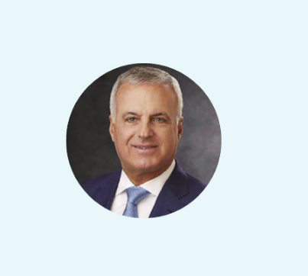

Gregory G. Joseph

Among other delineated responsibilities:

- Serves as a liaison between the non-employee directors and the Co-CEOs, encouraging direct communication between them, including providing feedback and counsel regarding interactions with the Board.

- Consults on Board meeting agendas and other information sent to the Board.

- Reviews the quality, quantity, appropriateness and timeliness of information provided to the Board.
- Consults on and approves Board meeting schedules to ensure there is sufficient time for discussion of all agenda items.
- Facilitates discussion and open dialogue among the independent directors during Board meetings, executive sessions and outside of Board meetings.
- Maintains availability, when appropriate, for consultation and direct communication with shareholders.
- Communicates with the Co-CEOs and, as appropriate, regarding significant matters including decisions reached, suggestions, views or concerns expressed by non-employee directors in executive sessions or outside of Board meetings.

BOARD OF DIRECTORS AND COMMITTEES

There are 12 members on the Board of Directors. The Board met eight times during 2025. Each incumbent director attended at least 75% of total Board and committee meetings to which he or she was appointed and served during 2025. The members of the Board are expected to be present at the annual meeting. All of the Directors attended last year’s annual meeting, which permitted their ability to respond to shareholder questions.

The committees of the Board consist of the Audit Committee, Compensation Committee and Corporate Governance Committee.

Each committee is governed by a charter that defines its role and responsibilities and are available on the Company’s website

at www.AFGinc.com under “Leadership and Governance – Board Committees.” A printed copy of these charters may be obtained

by shareholders upon written request addressed to the Company’s Secretary, at the address set forth under “Board

Communications” in the Proxy Statement Summary.

The below table identifies membership and the Chairperson of each of the current committees of the Board, as well as the number of times each committee met during 2025.

 | Lead |  |  | Corporate
 | Independent | Audit | Compensation | Governance
Director | Director | Committee | Committee | Committee
Gregory G. Joseph |  | Chair
Mary Beth Martin |  |  | Chair | Member
Amy Y. Murray |  | Member | Member
Roger K. Newport |  | Member
Evans N. Nwankwo |  |  |  | Member
William W. Verity |  |  | Member | Chair
John I. Von Lehman |  | Member |  | Member
Meetings in 2025 |  | 8 | 5 | 4

2026 Proxy Statement | American Financial Group 25

TABLE OF CONTENTS

CORPORATE GOVERNANCE

PRIMARY COMMITTEE RESPONSIBILITIES

Audit Committee


Members:

Gregory G. Joseph (Chair) Amy Y. Murray Roger K. Newport John I. Von Lehman

8

Meetings in 2025
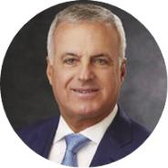

- Oversees the Company’s accounting and financial reporting processes, audits of the financial statements, and internal controls over financial reporting.

- Appoints the Company’s independent registered public accounting firm and oversees the relationship, including by monitoring the auditor’s independence, establishing the auditor’s compensation and reviewing the scope of the auditor’s work, including pre-approval of audit and non-audit services.

- Reviews and discusses with our management and independent registered public accounting firm, the Company’s interim and audited annual financial statements, and recommends to the Board whether the audited annual financial statements should be included in the Company’s annual report on Form 10-K.

- Reviews management’s report on its assessment of the effectiveness of internal control over financial reporting and the independent public accounting firm’s report on the effectiveness of internal control over financial reporting.

- Reviews the adequacy and effectiveness of the Company’s internal controls, including a review of the scope and results of its program.
- Pre-approves all transactions with related persons, whether or not required to be disclosed in the proxy statement.
- Reviews and discusses with management and the independent auditors earnings press releases prior to issuance.
- Discusses with management the Company’s guidelines and policies related to enterprise risk assessment and risk management (including quarterly cybersecurity assessments) and assists the Board of Directors in its oversight of the Company’s enterprise risk management process, including privacy, cybersecurity,

artificial intelligence, social and environmental risks and governance.
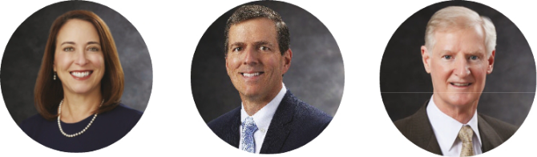

26 2026 Proxy Statement | American Financial Group

TABLE OF CONTENTS

CORPORATE GOVERNANCE

Compensation Committee


Members:

Mary Beth Martin (Chair) Amy Y. Murray William W. Verity

5

Meetings in 2025


- Designs AFG’s executive compensation program to align with the Company’s pay-for-performance compensation philosophy and monitors the program’s adherence to that philosophy.

- Ensures that the total compensation paid to the named executive officers is fair, reasonable and competitive.
- Oversees the Company’s stock incentive plans, incentive plans covering senior executive officers and deferred compensation plans.
- Reviews and approves the executive compensation program and corporate goals and objectives relevant to CEO compensation, evaluates CEO performance in light of those goals and objectives, and determines and approves CEO compensation level(s) based on this evaluation.

- Has the sole authority to retain or obtain the advice of a compensation consultant, outside legal counsel and any other advisors for assistance in carrying out its responsibilities.

- Oversees the Company’s Executive Officer Clawback Policy.


2026 Proxy Statement | American Financial Group 27

TABLE OF CONTENTS

CORPORATE GOVERNANCE

Corporate Governance Committee


Members:

William W. Verity (Chair) Mary Beth Martin Evans N. Nwankwo John I. Von Lehman

4

Meetings in 2025
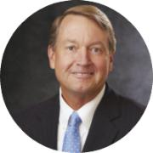

- Oversees Board succession planning, including establishing criteria for selecting new directors and identifying individuals qualified to be Board members as needed.

- Recommends director nominees for the next annual meeting of shareholders, the appointment and removal of members of the Board committees and the amount and form of compensation to non-management directors.

- Reviews the reporting structure, operations and charters for each of the Board committees and recommends changes to the full Board.
- Develops, recommends to the full Board and oversees an annual self-evaluation process of the Board and its committees.
- Advises the Board in connection with succession planning for the Co-CEOs and other key executives.
- Advises the Board with respect to stewardship and sustainability issues in order to assist in the development and refinement of the Company’s strategies and policies in these areas.

- Conducts and facilitates Board and Committee succession and recruitment activities, both in and outside of regular meetings.


AUDIT COMMITTEE REPORT

In accordance with the Audit Committee’s charter, which it reviews annually, the Audit Committee oversees the Company’s financial reporting process on behalf of the Board of Directors. The Company’s management has the primary responsibility for the financial statements, for maintaining effective internal control over financial reporting, and for assessing the effectiveness of internal control over financial reporting. In fulfilling its oversight responsibilities, the Committee reviewed and discussed the audited consolidated financial statements and the related schedules in the Annual Report on Form 10-K with Company management, including a discussion of the quality, not just the acceptability, of the accounting principles; the reasonableness of significant judgments; and the clarity of disclosures in the financial statements, among other matters.

The Committee is comprised solely of independent directors as defined by the NYSE listing standards and Rule 10A-3 of the Securities Exchange Act of 1934 (“Exchange Act”).

The members of the Committee are Gregory G. Joseph (Chairperson), Amy Y. Murray, Roger K. Newport and John I. Von Lehman. The Board has determined that two of the Audit Committee’s members, Mr. Newport and Mr. Von Lehman, are each considered to be an “audit committee financial expert” as defined under SEC rules.

The meetings of the Committee are designed to facilitate and encourage communication among the Committee, the Company’s management, the Company’s internal audit function and the Company’s independent auditor. The Audit Committee schedules its meetings with a view to ensuring that it devotes appropriate attention to all of its tasks. These meetings include, whenever appropriate, executive sessions in which the Audit Committee meets separately with the independent auditors, internal auditors and management personnel.

28 2026 Proxy Statement | American Financial Group

TABLE OF CONTENTS

CORPORATE GOVERNANCE

In addition, the Audit Committee reviews key initiatives and programs aimed at maintaining the effectiveness of the Company’s internal control over financial reporting. Together with senior members of the Company’s management team, the Audit Committee reviews the plans of the internal auditors, the results of internal audit examinations and evaluations by management and the Company’s independent auditors of the Company’s internal control over financial reporting and the quality of the Company’s financial reporting. As part of this process, the Audit Committee monitors the scope and adequacy of the Company’s internal auditing program, including reviewing internal audit department staffing levels and steps taken to maintain the effectiveness of internal procedures and controls.

The Audit Committee recognizes the importance of maintaining the independence of the Company’s independent auditor, both in fact and appearance. Each year, the Committee evaluates the qualifications, performance and independence of the Company’s independent auditor and determines whether to re-engage the current independent auditor. In doing so, the Audit Committee considers a number of factors, including the quality and efficiency of the services provided by the auditors, the auditors’ capabilities and the auditors’ technical expertise. In addition, the Committee has discussed with the independent auditor the firm’s independence from Company management and the Company, including the matters in the letter from the firm required by the Public Company Accounting Oversight Board (United States) (“PCAOB”) Rule 3526, Communication with Audit Committees Concerning Independence, and considered the compatibility of non-audit services with the independent auditor’s independence.

The Committee reviewed and discussed together with management and the independent auditor the Company’s audited consolidated financial statements for the year ended December 31, 2025, and the results of management’s assessment of the effectiveness of the Company’s internal control over financial reporting and the independent auditor’s audit of internal control over financial reporting. The Committee also reviewed with the independent auditor, which is responsible for expressing an opinion on the conformity of the audited consolidated financial statements and related schedules with US generally accepted accounting principles, its judgments as to the quality, not just the acceptability, of the Company’s accounting principles and such other matters as are required to be discussed with the Committee by the standards of the PCAOB, including PCAOB Auditing Standard No. 1301, Communications With Audit Committees, the rules of the Securities and Exchange Commission, and other applicable regulations.

In reliance on the reviews and discussions referred to above, the Committee recommended to the Board of Directors, and the Board has approved, that the audited consolidated financial statements and related schedules and management’s assessment of the effectiveness of the Company’s internal control over financial reporting be included in the Annual Report on Form 10-K for the year ended December 31, 2025, filed by the Company with the Securities and Exchange Commission.

This Audit Committee Report does not constitute soliciting material and should not be deemed filed or incorporated by reference into any other Company filings under the Securities Act of 1933, as amended, or the Exchange Act, as amended, except to the extent the Company specifically incorporates this Report by reference therein.

Members of the Audit Committee:

Gregory G. Joseph, Chair

Amy Y. Murray

Roger K. Newport

John I. Von Lehman

MAJORITY VOTING FOR DIRECTORS

All directors stand for election each year. Directors are elected by a plurality of votes received under Ohio law. However, the Company’s Regulations require that a director who receives a greater number of votes cast against than cast in favor shall continue to serve on the Board pursuant to Ohio law but must tender his or her resignation to the Company’s Board of Directors. In such event, the Corporate Governance Committee will make a recommendation to the Board of Directors on whether to accept or reject the resignation or whether other action should be taken. The Board of Directors will act on the Corporate Governance Committee’s recommendation and publicly disclose its decision and the rationale behind it within 90 days from the date of the certification of the election results. The director who tenders his or her resignation will not participate in the Corporate Governance Committee’s or Board of Directors’ decision.

2026 Proxy Statement | American Financial Group 29

TABLE OF CONTENTS

CORPORATE GOVERNANCE

DIRECTOR NOMINATION PROCESS AND QUALIFICATIONS OF CANDIDATES

Our Corporate Governance Guidelines identify criteria considered to evaluate prospective nominees for director. Our Corporate Governance Guidelines are available on the Company’s website at www.AFGinc.com.

Nominees for director are recommended by the Corporate Governance Committee in accordance with the principles in its charter and the Corporate Governance Guidelines. The Corporate Governance Committee considers suitability for membership on the Board on a case-by-case basis. Although the Committee does not prescribe minimum qualifications or standards for directors, candidates for Board membership should have the highest personal and professional integrity, demonstrated exceptional ability and judgment and availability and willingness to take the time necessary to properly discharge the duties of a director. The Board seeks candidates with a broad range of experiences, qualifications and skills that the Board believes enable each candidate to make a significant contribution to the Board. The Corporate Governance guidelines require that the Board will also consider Board candidates from both corporate positions and non-traditional environments such as government, academia and nonprofit organizations.

The Corporate Governance Committee does not have a policy relating to the consideration of director candidates recommended by shareholders because Ohio law and the Company’s Regulations afford shareholders certain rights related to such matters. The Regulations provide that to be eligible for election at a meeting of shareholders, candidates must be nominated by or at the direction of the Board of Directors or nominated by a shareholder who has complied with the procedures set forth in the Regulations. Procedures that shareholders must follow to nominate a director candidate are set forth on page 71 under, “Other Matters—Submitting Shareholder Proposals for the 2027 Annual Meeting of Shareholders.”

The Committee will make its determinations on whether to nominate an individual in the context of the Board as a whole based on the Board’s then-current needs, the merits of each such candidate and the qualifications of other available candidates. The Committee has no obligation to respond to shareholders who propose candidates that it has determined not to nominate for election to the Board, but the Committee may do so in its sole discretion. All director candidates are evaluated similarly whether nominated by the Board or by a shareholder.

The Corporate Governance Committee did not seek, nor did it receive the recommendation of, any of the director candidates named in this proxy statement from any shareholder, independent director, executive officer or third-party search firm in connection with its own approval of such candidates. The Company has not paid any fee to a third party to assist it in identifying or evaluating nominees.

DIRECTOR INDEPENDENCE

The Board, upon recommendation from the Corporate Governance Committee, affirmatively determines the independence of each director and nominee for election as a director in accordance with guidelines it has adopted, which guidelines comply with the NYSE listing standards. For a director to be considered independent, the Board must determine affirmatively that a director does not have any material relationship with the Company directly or as a partner, shareholder or officer of an organization that has a relationship with the Company. A material relationship can include, but is not limited to, commercial, industrial, banking, consulting, legal, accounting, charitable and family relationships. Based on these standards, the Board has determined that each of Mmes. Martin and Murray and Messrs. Joseph, Newport, Nwankwo, Verity and Von Lehman, is independent and has no material relationship with the Company, except as a director and shareholder of the Company.

In reaching its independence determinations for 2025, the Committee considered that the Company purchased vehicles from, and had vehicles serviced by, automobile dealerships affiliated with a company of which Mr. Joseph is an executive and part owner. The small amounts involved in these transactions, which were pre-approved by the Audit Committee as transactions with a related party despite not requiring disclosure pursuant to SEC Regulation S-K Item 404, were deemed by AFG’s Board of Directors not to be material. See our policies regarding transactions with related parties as set forth below under, “Review, Approval or Ratification of Transactions with Related Persons” on page 36.

30 2026 Proxy Statement | American Financial Group

TABLE OF CONTENTS

CORPORATE GOVERNANCE

OTHER CORPORATE GOVERNANCE MATTERS, PRACTICES AND PROCEDURES

Risk Oversight

The Company believes a role of management, including the named executive officers, is to identify and manage risks confronting the Company. The Board of Directors and its committees play an integral role in the Company’s risk oversight, primarily by reviewing the processes used by management to identify and report risk and monitoring corporate actions to avoid inappropriate levels of risk. The Company’s Enterprise Risk Management (ERM) program is designed to reinforce the way the Company operates its business and reflects its culture, organizational structure, and risks.

The Co-CEOs have delegated oversight of the ERM process, including risk identification, risk impact, risk limits and mitigation strategies, to an AFG Enterprise Risk Committee (ERC) chaired by AFG’s General Counsel and also consisting of AFG’s Chief Administrative and Chief Human Resources Officer, AFG’s Chief Financial Officer, and Great American Insurance Group’s President and Chief Operating Officer, each of whom directly reports to the Co-CEOs. The ERC has designated an AFG Assistant Vice President as risk officer to oversee the day-to-day operations of the ERM program. The risk officer regularly meets with senior leaders representing significant areas from throughout the organization, including administration, operations, finance, accounting, legal, human resources, investments, information technology and information security, to assess significant risks. The risk officer works with management to identify potential events and trends that may adversely or favorably impact the Company and to manage risks to be within the Company’s risk appetite.

The ERC, the risk officer, and individual senior leader risk owners regularly monitor the top organizational risks, as well as any other significant or emerging risks that may arise during the year and consider whether to modify existing risks or elevate emerging risks. Assessments of AFG’s significant risks are completed on either a quarterly, semiannual, or annual basis. Any actual or foreseeable potential variances outside of AFG risk targets, even for reasons that are expected or accepted, are discussed with risk owners, risk monitors, and management. Significant changes in our risk profile are reviewed with the ERC and the AFG Audit Committee on a quarterly basis and with the AFG Board of Directors at least annually.

Also, due to evolving threats to corporate cybersecurity, the Board and Audit Committee receive reports from the Company’s Chief Information Security Officer (CISO) regarding cybersecurity risks and the steps management has taken to monitor and control such risks. Among the many issues discussed with the CISO in 2025 were AI-related matters, including the Company’s AI Governance Program to manage risks and promote the ethical use of AI tools and technology and AFG’s adoption of the National Institute of Standards and Technology (NIST) AI Risk Management Framework to assess and benchmark the Company’s risks. The CISO presents to the Audit Committee at least quarterly and to the Board at least annually to review and discuss the Company’s cybersecurity program.

The Company’s leadership structure and overall corporate governance framework is designed to aid the Board in its oversight of management responsibility for risk. The Audit Committee serves a key risk oversight function in carrying out its review of the Company’s financial reporting and internal reporting processes, as required by the Sarbanes-Oxley Act of 2002. Inherently, part of this review involves an evaluation of whether our financial reporting and internal reporting systems are adequately reporting the Company’s exposure to certain risks. In connection with this evaluation, the Audit Committee has, from time to time, considered whether any changes to these processes are necessary or desirable. While it has concluded that no such changes are warranted at this time, the Audit Committee will continue to monitor the Company’s financial reporting and internal reporting processes. In addition, pursuant to its charter, the Audit Committee is responsible for discussing with management the guidelines and policies related to enterprise risk assessment and risk management and assisting the Board of Directors in its oversight of the Company’s enterprise risk management process.

As more fully described in the “Compensation Discussion and Analysis” section of this proxy statement, the Compensation Committee takes an active role in overseeing risks relating to AFG’s executive compensation programs, plans and practices. Specifically, the Compensation Committee reviews the risk profile of the components of the executive compensation program, including the performance objectives and target levels used in connection with incentive awards, and considers the risks an executive officer might be incentivized to take with respect to such components with special attention given to establishing a mix among these components that does not encourage excessive risk taking.

The Corporate Governance Committee contributes to the Company’s risk oversight process by reviewing the Company’s Corporate Governance Guidelines and Board committee charters at least annually to ensure that they continue to comply with any applicable laws, regulations, and stock exchange or other listing standards, as each are subject to change from time to time. The Corporate Governance Committee also oversees the director nomination process, the overall Board reporting structure and the operations of the individual committees, in addition to advising the Board with respect to environmental and social risks.

2026 Proxy Statement | American Financial Group 31

TABLE OF CONTENTS

CORPORATE GOVERNANCE

Code of Ethics and Business Conduct and Corporate Governance Principles

The Company has adopted a Code of Ethics and Business Conduct applicable to all employees. Annually, directors and all employees certify that they have read and complied with our Code.

The Company has also adopted Corporate Governance Guidelines. The Code and Guidelines are available on the Company’s website at www.AFGinc.com, under “Leadership and Governance.” A printed copy of the Code and Guidelines may be obtained by shareholders upon written request to the Secretary at the address set forth under “Board Communications” in the Proxy Statement Summary. We intend to satisfy any disclosure requirements regarding any amendments to, or waivers from, provisions of the Code by posting such information on our website as promptly as practicable, as may be required by applicable SEC and NYSE rules.

Corporate Responsibility and Sustainability

Creating long-term value for shareholders is AFG’s highest business objective, and we are committed to doing so in a responsible manner. This commitment starts with recognizing that many of our business decisions affect people and organizations in the larger community.

Under its charter, the Corporate Governance Committee advises the Board with respect to stewardship issues to assist in the development and refinement of the Company’s strategies and policies in those areas.

We focus our corporate responsibility and sustainability strategies in four primary areas where AFG believes it can achieve the most direct and substantial results:

Operating our | Giving | Creating a | Managing
business with | back to our | welcoming | environmental
integrity and | communities | and rewarding | risk and
managing | and promoting | place to work | operating
financial risk | social | and build a | sustainably
 | opportunity | career
OUR FINANCIAL RISK FRAMEWORK
100% | >21,000 | 100% | >116,500
Employees of AFG | Hours of facilitated | Employees who | Learning and
and its insurance | employee training to | receive education on | development videos
subsidiaries who are | further personal and | security awareness | completed by
required to | professional | strategies throughout | employees in over
participate in annual | development in a wide | the year to help keep | 5,600 courses
conflict-of-interest | variety of areas, such | them safe both at work
training | as leadership, | and at home
 | inclusion, business
 | acumen and technical
 | skills





32 2026 Proxy Statement | American Financial Group

TABLE OF CONTENTS

CORPORATE GOVERNANCE

MANAGING ENVIRONMENTAL RISK AND OPERATING SUSTAINABLY


38%

AFG office space that is LEED or ENERGY STAR certified for energy efficiency and other sustainability features

419​ tons

Paper and cardboard diverted from landfills and recycled in our Cincinnati operations in the 2023-2025 period

107​ tons

Tons of electronic waste diverted from landfills and recycled in the 2023-2025 period

We believe that concentrating our efforts help us run our business more effectively, enhance our products, protect our customers, serve our communities and support approximately 8,500 employees worldwide.

AFG’s principal cultural goal is for all employees to feel included, respected and empowered to perform at their best. The Company recognizes the importance of developing specialized knowledge, offering leadership development opportunities and exemplifying a service-oriented culture. AFG respects human rights, fosters inclusion and values the unique perspective each employee brings to the workplace. Our Equal Employment Opportunity Policy, which governs all decisions related to employment, including requests for accommodations, requires that employment decisions are made without regard to race, color, religion, creed, national origin, citizenship status, ancestry, age, physical or mental disability, gender, sex, marital status, pregnancy (or related condition), sexual orientation, veteran status, genetic information, or any other factors that are protected by applicable federal, state or local law.

Our Chief Human Resources Officer, Ms. Gillis, regularly addresses the Board and the Compensation Committee. Recent topics addressed by Ms. Gillis have included human capital strategy, Company culture, succession planning, learning and development, total rewards and benefits, and talent evaluation, retention and acquisition. Ms. Gillis also discusses with the Board the results of the Company’s biennial employee engagement survey (“Employee Survey”) in years in which the survey is conducted. AFG views the Employee Survey as a critical resource to help inform management on employees’ views and perspectives on key matters. There was strong employee engagement in the most recent Employee Survey, conducted in 2024, with 92% of the Company’s employees participating. Management was encouraged by this high engagement and the positive overall results, which on the whole reaffirmed management’s belief that employees appreciate the Company’s culture and the opportunities available to them and understand their link to AFG’s strategy and business. Some of the highlights of the most recent Employee Survey are provided below.
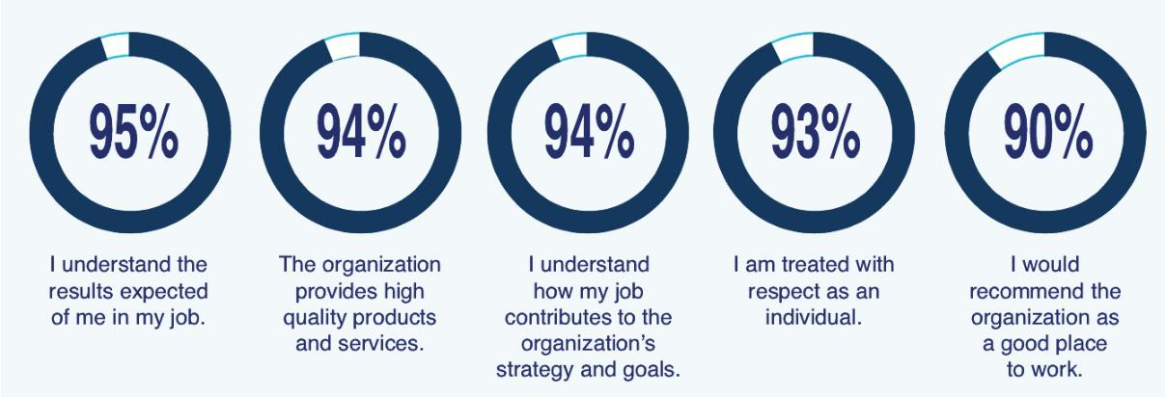

Information regarding our corporate responsibility and sustainability efforts, including additional details from our most recent Employee Survey results, can be found on our website at www.AFGinc.com under “Corporate Social Responsibility” where you can review our Corporate Social Responsibility Report.

2026 Proxy Statement | American Financial Group 33

TABLE OF CONTENTS

CORPORATE GOVERNANCE

Shareholder Engagement

We maintain an ongoing, proactive outreach effort with our shareholders. Throughout the year, members of our Investor Relations team and our business leaders, including AFG’s Co-CEOs, President and CFO, as well as the President and Chief Operating Officer of Great American Insurance Group, engage with our shareholders to help increase their understanding of our business and strategy and to remain well-informed regarding their perspectives on a wide variety of topics. Management regularly engages with investors by participating in industry conferences. We also meet in person, virtually through online meetings and by telephone with shareholders at other times throughout the year to answer questions and solicit input on all matters of shareholder interest, including strategic, financial, governance and sustainability. We believe our engagement with shareholders has been productive and provides an open exchange of ideas and perspectives.
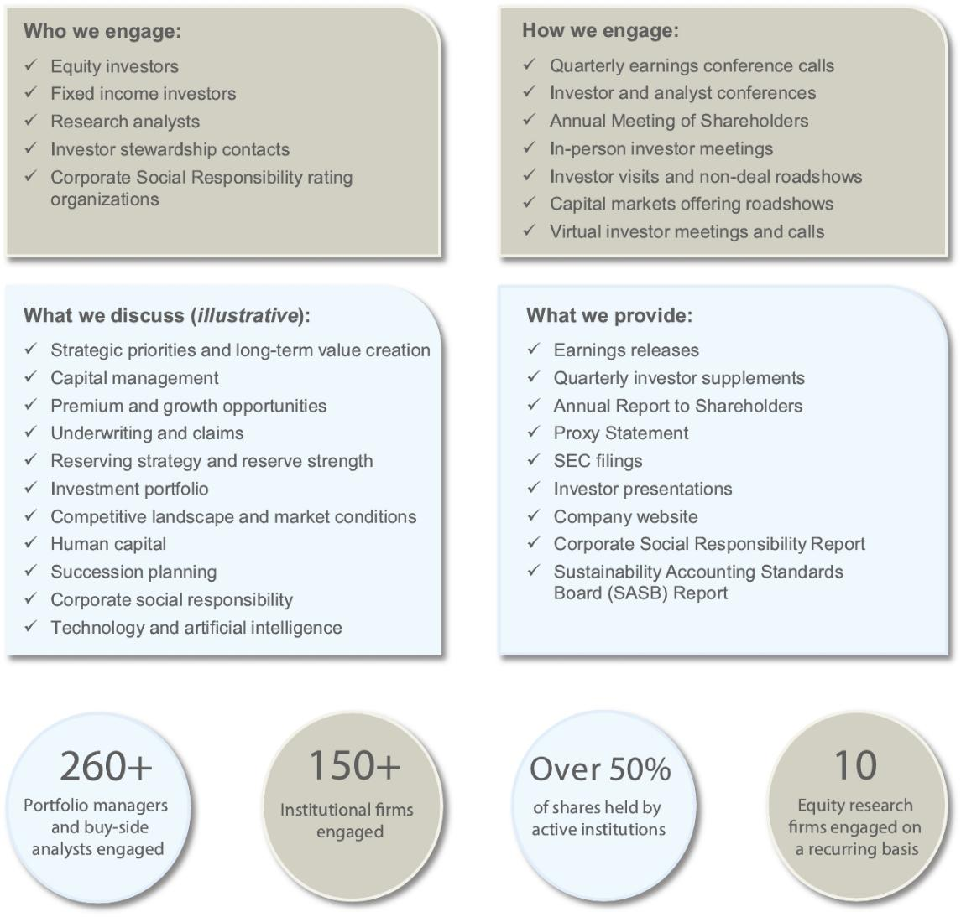

34 2026 Proxy Statement | American Financial Group

TABLE OF CONTENTS

CORPORATE GOVERNANCE

Director Education

The Corporate Governance Committee facilitates participation by directors in continuing education programs, including accredited director education programs paid by the Company and structured internal programs presented by management at least annually.

Annual Board Evaluation

The Corporate Governance Committee oversees the Company’s annual Board evaluation process, which is designed to elicit candid feedback and recommendations from the directors that will improve the effectiveness of the Board and each of its committees. The Corporate Governance Committee annually determines the process to be utilized for conducting Board evaluations. In recent years, evaluations have consisted of individual Board member interviews, in each case conducted by an outside third party. These interviews cover a broad range of topics, including Board and Committee functioning, succession planning, governance and strategy, and allow each director the opportunity to provide feedback on their fellow directors. The results of the evaluation are compiled by the outside third party and discussed with the committees and with the full Board.
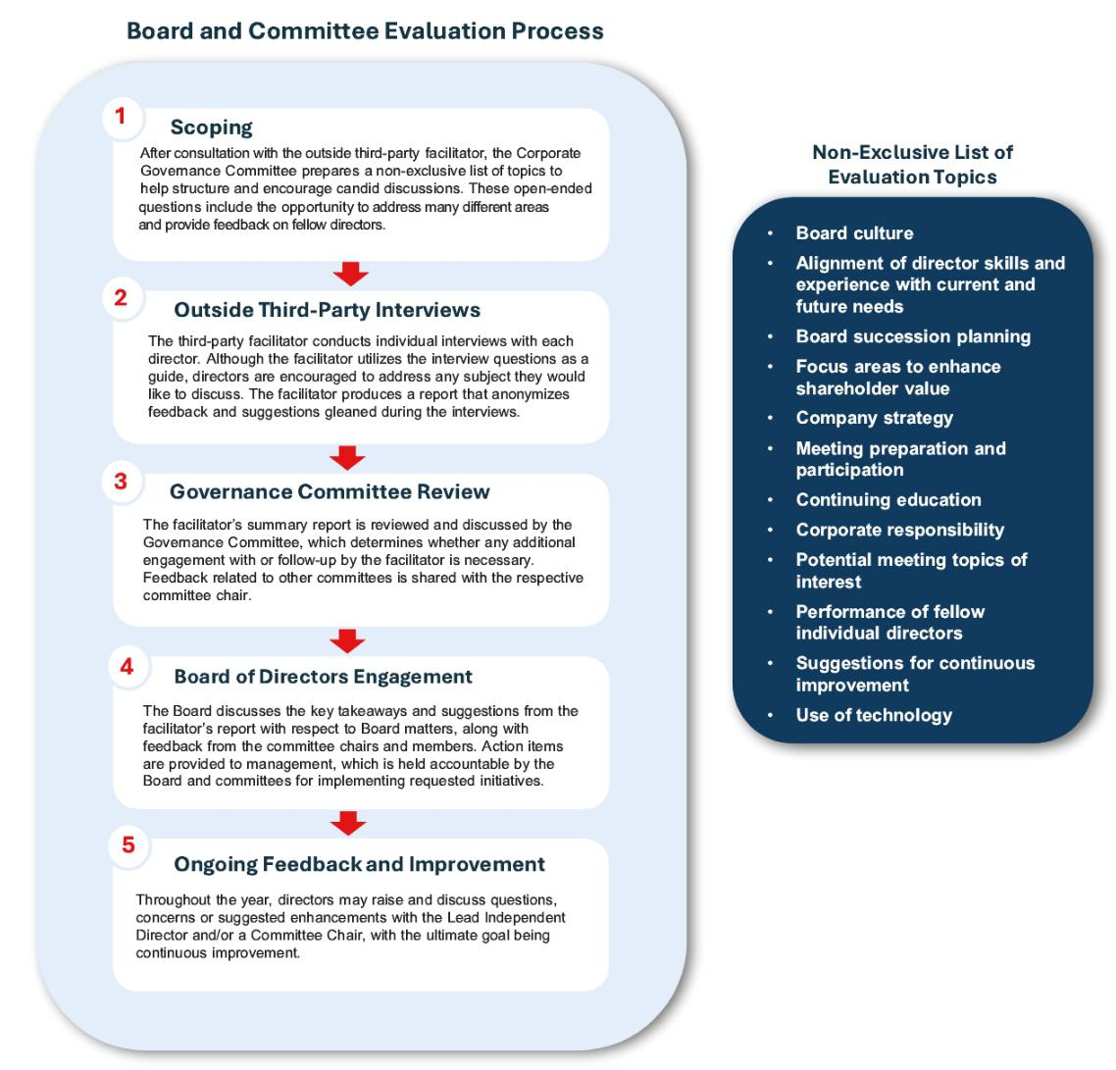

2026 Proxy Statement | American Financial Group 35

TABLE OF CONTENTS

CORPORATE GOVERNANCE

Executive Sessions

NYSE rules require independent directors to meet regularly in executive sessions. Four of these sessions were held during 2025.

The lead independent director presides over each session.

Communications with Directors

The Board of Directors has adopted procedures for shareholders and other interested parties to send written communications to the Board as a group. Communications must be clearly addressed either to the Board of Directors, a committee of the Board or any or all of the independent directors and sent to either of the individuals as set forth under, “Board Communications” in the Proxy Statement Summary. Any communications except for spam, junk mail, mass mailings, resumes, job inquiries, surveys, business solicitations or advertisements, or patently offensive, hostile, threatening or otherwise unsuitable or inappropriate material will be forwarded.

Compensation Committee Interlocks and Insider Participation

No member of AFG’s Compensation Committee was at any time during 2025 or at any other time an officer or employee of the Company, and none had any relationship with the Company requiring disclosure as a related-person transaction. None of our executive officers served on the compensation committee (or its equivalent) or board of directors of another entity that has, or had during any time during 2025, an executive officer who served as a member of our Board or our Compensation Committee.

Review, Approval or Ratification of Transactions with Related Persons

Stock exchange rules require that the Company conduct an appropriate review of all related party transactions (including those required to be disclosed by the Company pursuant to SEC Regulation S-K Item 404) for potential conflict of interest situations on an ongoing basis and that all such transactions must be reviewed and evaluated by the Audit Committee or another committee comprised of independent directors. The Audit Committee reviews and evaluates all transactions with related parties. In addition, our Audit Committee Charter provides that the Audit Committee review and approve all related party transactions involving directors, executive officers and significant shareholders of the Company that require disclosure pursuant to SEC Regulation S-K Item 404. In considering any transaction, the Committee may consider all relevant factors, including as applicable: the Company’s business rationale for entering into the transaction; the alternatives to entering into a related person transaction; whether the transaction is on terms comparable to those available to third parties, or in the case of employment relationships, to employees generally; the potential for the transaction to lead to an actual or apparent conflict of interest and any safeguards imposed to prevent such actual or apparent conflicts; and the overall fairness of the transaction to the Company.

While the Company adheres to this policy for potential related person transactions, the policy is not in written form except as a part of listing agreements with the NYSE. However, approval of such related person transactions is evidenced by Audit Committee resolutions in accordance with our practice of reviewing and approving transactions in this manner.

Other than as follows, there were no such transactions in 2025 requiring disclosure under applicable rules. Craig Lindner, Jr., son of S. Craig Lindner, who serves as Divisional President of AFG Real Estate Investments, also serves as a director, and his compensation is discussed under “Director Compensation and Stock Ownership Guidelines” beginning on page 59. A son-in-law of Mr. Berding who is employed by the Company received salary and bonus of approximately $275,000 for 2025 and participates in employee benefit plans, including equity incentive plans, commensurate with his position and tenure with the Company.

FC Cincinnati Holdings LLC and its subsidiaries and affiliates (collectively, “FC Cincinnati”) is a member of Major League Soccer and operates a professional soccer franchise in Cincinnati, Ohio. Carl H. Lindner III is the principal investor and Chief Executive Officer of FC Cincinnati and controls that entity by contract. The Company and its subsidiaries have several relationships with FC Cincinnati. The Company purchases tickets and merchandise from FC Cincinnati at rates generally offered to the public as it has for many years purchased tickets and merchandise from other local professional franchises and universities. In 2025, the Company paid approximately $392,833 to FC Cincinnati for tickets and merchandise. FC Cincinnati also purchases insurance policies from a subsidiary of the Company, and through a subsidiary insurance agency, under the same terms that would prevail between unrelated third parties. These amounts totaled approximately $166,000 in 2025. Mr. Thompson and a brother of Mr. Joseph are part owners of FC Cincinnati.

36 2026 Proxy Statement | American Financial Group

TABLE OF CONTENTS

Compensation Discussion and Analysis

Named Executive Officers

In this section, we describe the material components of our executive compensation program for our named executive officers whose compensation is displayed in the 2025 Summary Compensation Table and the other compensation tables contained in this proxy statement. We also provide an overview of our executive compensation philosophy, and we explain how and why the Compensation Committee arrives at specific compensation policies and decisions.

Our 2025 named executive officers (“NEOs”) are our Co-Chief Executive Officers (“Co-CEOs”), our principal financial officer and the three other most highly compensated executive officers employed at the end of 2025 and are the same individuals as last year. They include:

- Carl H. Lindner III

Co-Chief Executive Officer (Co-Principal Executive Officer)

- S. Craig Lindner

Co-Chief Executive Officer (Co-Principal Executive Officer)

- John B. Berding

President of AFG and American Money Management Corporation

- Brian S. Hertzman

Senior Vice President and Chief Financial Officer (Principal Financial Officer)

- David L. Thompson

President and Chief Operating Officer of Great American Insurance Group

- Mark A. Weiss

Senior Vice President and General Counsel

OVERVIEW OF COMPENSATION PROGRAM

The Compensation Committee of the Board of Directors is responsible for designing the Company’s executive compensation program, reviewing and approving the compensation paid to the Company’s Co-CEOs and other Company senior executive officers, and overseeing the Company’s executive compensation policies. The Compensation Committee also administers the Company’s cash and equity incentive plans. In carrying out these responsibilities, the Compensation Committee seeks to ensure that the total compensation paid to the NEOs is fair, reasonable and competitive.

AFG’s executive compensation philosophy balances attracting, motivating, retaining and rewarding executives with a compensation package competitive among its peers and maximizing shareholder value by designing and implementing programs that tie compensation earned to the short-term and long-term performance of the Company. In evaluating the pay-for-performance alignment, the Compensation Committee compares the Company’s compensation practices to those of a peer group of publicly-held insurance holding companies against which it competes for business, talent and shareholder investment (collectively and as further described below, the “Compensation Peer Group”).

Guided by principles that reinforce the Company’s pay-for-performance philosophy, NEO compensation includes five components: base salary; annual performance-based cash awards; long-term stock incentives; cash awards based on long-term performance; and other compensation, including certain perquisites. A significant portion of each NEO’s compensation is dependent upon the Company achieving business and financial goals.

As part of its compensation program philosophy, the Compensation Committee evaluates the total target and maximum compensation that can be earned by each NEO, rather than considering each individual component in isolation. As such, the Compensation Committee views perquisites as an element of total compensation and, accordingly, would consider the elimination or diminution of any perquisite as a decrease in total compensation.

2026 Proxy Statement | American Financial Group 37

TABLE OF CONTENTS

COMPENSATION DISCUSSION AND ANALYSIS

Compensation Consultant Engagement

From time to time, the Company engages Pay Governance LLC (“Pay Governance”) as its independent compensation consultant. The scope of these engagements varies from full assessments of the Company’s executive compensation program to specific consulting projects. The Company most recently engaged Pay Governance in 2024, when Pay Governance provided the Compensation Committee with outside independent analysis and perspectives relating to the Committee’s evaluation of proposed changes to the Senior Executive Annual Bonus Plan (“Annual Bonus Plan”) and the impact of those changes on the Company’s overall executive compensation program.

The Company has also previously engaged Pay Governance to provide the Compensation Committee with advice and recommendations regarding the Company’s compensation philosophy and strategies; advice on the Company’s peer group; evaluation of performance metrics and peer performance; and analysis and recommendations regarding the Company’s salaries and incentive compensation plans, executive benefits and Co-CEO perquisites.

The Compensation Committee has reviewed the independence of Pay Governance considering applicable SEC rules and NYSE listing standards regarding compensation consultant independence and has affirmatively concluded Pay Governance is independent from the Company and has no conflict of interest relating to its engagement.

CEO Compensation

The Company has Co-CEOs serving as principal executive officers. The Co-CEOs work together in determining overall corporate strategy and planning, as well as in assessing and managing enterprise risks and opportunities. Key factors affecting the Compensation Committee’s judgment with respect to the Co-CEOs include the nature and scope of their responsibilities and their effectiveness in leading initiatives to effectively manage capital and increase sustainable shareholder value, productivity, profitability and growth. The design of the compensation programs for the Co-CEOs reflects the Company’s leadership structure, which is discussed in more detail above under “Corporate Governance—Leadership Structure” on page 24.

As in prior years, the Compensation Committee determined that the quantifiable measurements for each Co-CEO should be identical because the Compensation Committee believes that the Co-CEOs are ultimately jointly responsible for the Company achieving its objectives. Carl H. Lindner III also serves as CEO of AFG’s Great American Insurance Group and is primarily responsible for AFG’s property and casualty insurance operations. S. Craig Lindner is primarily responsible for AFG’s investment portfolio and heavily involved in capital management and strategic planning. Despite their different primary responsibilities, the Compensation Committee views the roles of the Co-CEOs as collaborative and complementary and does not seek to distinguish the performance of one from the other. Rather, the Compensation Committee scrutinized factors such as the Co-CEOs’ collective role in AFG’s achievement of operating and financial targets, the development of management personnel, the performance of the investment portfolio and the development and implementation of strategies and initiatives to enhance shareholder value.

The Co-CEOs’ performance-based compensation—consisting of annual incentive and long-term incentive components, as further discussed below—is based entirely on the achievement of objective measures of the Company’s business and financial performance. This differs from many companies in the Company’s Compensation Peer Group, which include some manner of subjective, discretionary component in their chief executive officer’s incentive compensation. As shown below, a majority of the compensation earned by the Co-CEOs for 2025 was based on objective measures of Company performance and consisted of long-term compensation components.

38 2026 Proxy Statement | American Financial Group

TABLE OF CONTENTS

COMPENSATION DISCUSSION AND ANALYSIS
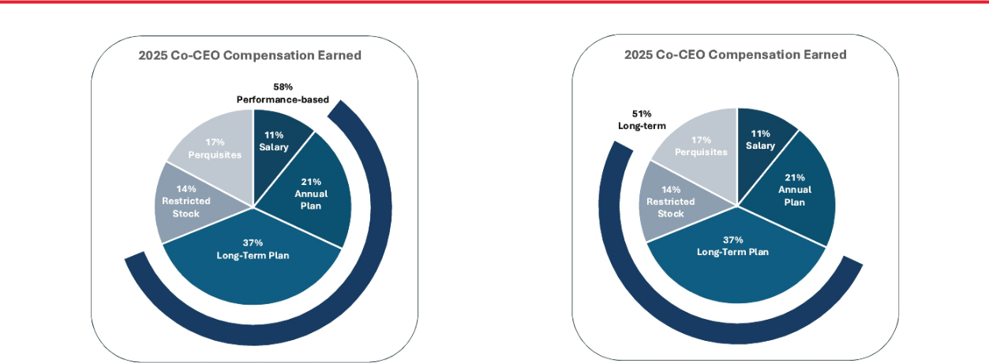

Notably, over the past five-year period, the Co-CEOs have had no increase in:

- Base salary;

- Annual incentive target compensation;

- Long-term incentive target compensation; or

- Targeted value of equity compensation.

When evaluating the Co-CEOs annual overall compensation, consistent with the approach of certain institutional investors and proxy advisory firms, the Compensation Committee considers the compensation of the highest-paid Co-CEO as “CEO compensation” and includes the other Co-CEO in its analysis as one of the three highest-paid, non-Chief Financial Officer officers. In addition, when considering the reasonableness of Co-CEO compensation, the Compensation Committee also compares the combined total compensation of the Co-CEOs to the compensation paid to the top two executives at the Company’s peers.

The Compensation Committee believes that the evaluation by certain institutional investors and proxy advisory firms of the Company’s pay-for-performance alignment is distorted by combining the compensation of the two Co-CEOs and representing that the combined compensation reflects “CEO” compensation. The Compensation Committee believes that this view skews compensation analysis and unfairly penalizes the Company for its leadership structure that the Board has determined is in the best interests of shareholders.

2026 Proxy Statement | American Financial Group 39

TABLE OF CONTENTS

COMPENSATION DISCUSSION AND ANALYSIS

Establishing Total Compensation Levels

The Compensation Committee believes that compensation levels for the Co-CEOs should be based primarily upon the Committee’s assessment of the Co-CEOs’ leadership performance and potential to enhance long-term sustainable shareholder value. The Compensation Committee relies upon a combination of judgment and guidelines in determining the amount and mix of compensation elements for the Co-CEOs. The compensation levels for the other NEOs are similarly determined by the Co-CEOs, and reviewed and approved by the Compensation Committee, again based primarily upon the assessment of each NEO’s leadership performance and potential to enhance long-term sustainable shareholder value.

The Compensation Committee and the Co-CEOs analyze peer groups, including the members of its Compensation Peer Group (as defined below), and industry pay rates at least annually in reviewing the appropriateness and competitiveness of the Company’s compensation programs. In analyzing market pay levels among the Compensation Peer Group, the Compensation Committee considers the variance in size among the companies, both in terms of revenues and market capitalization.

The Compensation Committee utilizes the peer and industry review as a point of reference for measurement and not as a determinative factor. Although the Company seeks to offer total compensation to NEOs that is competitive with the compensation paid by companies in the Compensation Peer Group, the Company does not target or benchmark a particular percentile for its executives’ total pay packages or any individual pay components. Rather, the compensation levels and performance of the Compensation Peer Group constitute one of many factors considered by the Compensation Committee.

The Compensation Peer Group, which the Compensation Committee annually reviews and updates when appropriate, is designed to reflect the Company’s business mix and to consist of companies against which AFG competes for business, talent and shareholder investment. The Compensation Peer Group for 2025, which was unchanged from 2024, consists of the following companies:

- Arch Capital Group Ltd.

- Assurant Inc.

- Axis Capital Holdings Limited

- Chubb Limited

- Cincinnati Financial Corporation

- CNA Financial Corp.

- The Hanover Insurance Group, Inc.

- Hartford Insurance Group, Inc.

- Markel Corporation

- RenaissanceRe Holdings Ltd.

- RLI Corp.

- Selective Insurance Group, Inc.

- The Travelers Companies, Inc.

- W. R. Berkley Corporation

The Compensation Committee’s decisions concerning the specific 2025 compensation elements for the Co-CEOs were made within this framework. The Compensation Committee also considered each Co-CEO’s performance and prior-year salary, incentive awards and other compensation. In all cases, specific decisions involving 2025 compensation were ultimately based upon the Compensation Committee’s judgment about the Co-CEOs’ performance, potential future contributions and about whether each payment or award would provide an appropriate incentive and reward for performance that sustains and enhances long-term shareholder value without subjecting the Company to inappropriate or unreasonable risk.

Based on its review, the Compensation Committee found the NEOs’ total compensation to be reasonable and consistent with the Company’s pay-for-performance compensation philosophy.

Compensation Risk Analysis

The Compensation Committee has reviewed the risk profile of the components of AFG’s executive compensation programs, both individually and in the aggregate, including the performance objectives and target and maximum levels used in connection with incentive awards. The Company analyzes and structures its overall compensation program to discourage excessive risk-taking through

40 2026 Proxy Statement | American Financial Group

TABLE OF CONTENTS

COMPENSATION DISCUSSION AND ANALYSIS

a balanced use of compensation vehicles and metrics with an overall goal of delivering sustained long-term shareholder value while aligning executives’ interests with those of shareholders. Further, our program makes a substantial portion of each NEO’s compensation contingent on delivering performance results intended to benefit our shareholders. The Compensation Committee believes that AFG’s executive compensation programs incentivize the appropriate level of risk-taking behavior by its NEOs needed to grow the business, while encouraging prudent decision-making that focuses on both short-term and long-term results.

No Change in Control or Employment Agreements; All Equity Awards Include “Double Trigger”

Neither of the Co-CEOs or any other NEO is a party to an employment or other agreement providing for severance or change in control payments.

Awards under the Company’s shareholder-approved equity incentive plan do not provide for automatic acceleration of awards for any participant, including the Co-CEOs and other NEOs. All awards include a “double trigger” provision providing that if the awards are assumed by the surviving entity in the change of control, vesting of the awards will not accelerate unless the participant also has a qualifying termination of employment (by the Company without cause or by the participant for good reason). If the surviving entity does not assume the equity awards upon the change in control, unvested awards will become vested upon the occurrence of the change in control.

Tally Sheets

The Compensation Committee reviews at least annually a comprehensive tally sheet compiled internally to review all elements of the NEOs’ compensation. The tally sheet includes all of the information that is reflected in the Summary Compensation Table as well as amounts and descriptions of perquisites not required to be specifically identified by SEC regulations, generally because the amount of such items are not deemed material under applicable SEC regulations. The review by the Compensation Committee analyzes how changes in any element of compensation would impact other elements. Such analysis has become a key facet of the Compensation Committee’s review of NEO compensation as various components, including perquisites, are deemed by the Compensation Committee to be important elements of an executive’s overall compensation. This also allows the Compensation Committee to make compensation decisions and evaluate management recommendations based upon a complete analysis of an NEO’s total compensation. In evaluating perquisites paid to the Co-CEOs, the Compensation Committee considered the annual limitations on certain perquisites applied by the Committee and described under “Perquisites and Other Personal Benefits” on page 52.

Equity Incentive Compensation

The Compensation Committee views long-term incentive compensation in the form of equity awards as a critical element of the executive compensation program. The Company utilizes restricted share awards that cliff-vest after four years. The Compensation Committee believes that this incentivizes and rewards our NEOs for long-term performance based on the value of our common shares and aligns the interests of our NEOs and our shareholders. The Compensation Committee, as well as the Co-CEOs, also believe that the four-year cliff vesting period provides the Company with retention benefits for the NEOs and other key employees.

The Compensation Committee was mindful of the substantial ownership of the Company’s common shares by executive officers, particularly the Co-CEOs, and the effect of such ownership in aligning their interests with those of the Company’s shareholders.

Internal Pay Equity

The Compensation Committee does not apply fixed ratios when conducting an analysis of the relative difference between the Co-CEOs’ compensation and the compensation of the Company’s other senior executives. However, the Compensation Committee believes that the Company’s internal pay equity structure is appropriate based upon the contributions to the success of the Company and as a means of motivation to other executives and employees.

2026 Proxy Statement | American Financial Group 41

TABLE OF CONTENTS

COMPENSATION DISCUSSION AND ANALYSIS

Share Ownership Requirements

The NEOs and other senior executives of the Company and its subsidiaries are subject to the Company’s share ownership requirements. Pursuant to the requirements, each Co-CEO must own five times his base salary in Company common shares while the other NEOs and certain other senior management members must own one times his or her base salary in Company common shares. The Company has also established share ownership guidelines for its non-employee directors and other senior management members of the Company, which are discussed below under “Executive Compensation—Director Compensation and Stock Ownership Guidelines” on page 59.

Insider Trading Policy

AFG’s Insider Trading Policy governs the purchase, sale and other dispositions of the Company’s securities by our directors, officers and employees, as well as their related persons (as defined in the Policy). The Company believes that these policies and procedures are reasonably designed to promote compliance with insider trading laws, rules and regulations and applicable listing standards. It is also the Company’s policy to comply with all applicable securities laws when transacting in its own securities. A copy of the Insider Trading Policy is filed as Exhibit 19 to the Company’s Annual Report on Form 10-K for the year ended December 31, 2024.

Hedging and Pledging Transactions

The Company’s Insider Trading Policy also governs the hedging and pledging of AFG common shares. Transactions involving hedging of Company shares by directors and executive officers are prohibited. The Policy discourages any pledging of the Company’s common shares, including holding common shares in a margin account. Directors and executive officers are required to obtain pre-approval from the Chair of the Corporate Governance Committee before pledging common shares. Such approval will be granted only if the individual can clearly demonstrate the financial capacity to repay the loan without resorting to the pledged securities and/or after a determination that the number of shares that the individual proposes to pledge is unlikely to affect the market for the common shares when viewed in relation to the market value or trading volume. For more than ten years, no NEO or director has pledged any common shares.

Outside Consultants

The Compensation Committee has the authority to retain and from time to time has retained outside consultants to assist in evaluating the Company’s executive compensation programs and practices. The Compensation Committee has engaged independent compensation consultant Pay Governance from time-to-time as discussed above.

Tax Deductibility of Pay

On December 22, 2017, the Tax Cuts and Job Act of 2017 (the “TCJA”) was signed into law. The TCJA includes significant changes to the rules under Section 162(m) of the Internal Revenue Code for deducting certain executive compensation. In general, for years prior to 2018, Section 162(m) of the Internal Revenue Code disallowed a tax deduction to publicly held companies for compensation paid in any year to certain executive officers in excess of $1 million per officer that did not qualify as “performance-based compensation.” Under the TCJA, the exemption from Section 162(m)’s deduction limit for performance-based compensation has been repealed. The new rules generally apply to taxable years beginning after December 31, 2017, but do not apply to remuneration paid in future years pursuant to a written binding contract in effect on November 2, 2017 that is not modified in any material respect after that date. In December 2020 the Internal Revenue Service issued final regulations with regard to the new Section 162(m) rules provided by the TCJA. Despite the Compensation Committee’s efforts in prior years to structure certain incentive programs as “performance-based compensation” intended to be exempt from Section 162(m)’s deduction limits, because of uncertainties as to the interpretation and application of the new rules, no assurance can be given that compensation intended to satisfy the requirements for exemption from Section 162(m) in fact will do so.

42 2026 Proxy Statement | American Financial Group

TABLE OF CONTENTS

COMPENSATION DISCUSSION AND ANALYSIS

Section 409A

Section 409A of the Internal Revenue Code requires that “nonqualified deferred compensation” be deferred and paid under plans or arrangements that satisfy the requirements of the law with respect to the timing of deferral elections, timing of payments and certain other matters. In general, it is AFG’s intention to design and administer its compensation and benefits plans and arrangements for all of its employees so that they are either exempt from, or satisfy the requirements of, Section 409A.

Recovery of Prior Awards

The Company’s Executive Officer Clawback Policy (the “Clawback Policy”) is designed to comply with the clawback rules adopted by the Securities and Exchange Commission and New York Stock Exchange rules. The Board has designated the Compensation Committee to administer the Clawback Policy. The Clawback Policy applies in the case of an accounting restatement due to the material noncompliance of the Company with any financial reporting requirement under the securities laws, including any required accounting restatement to correct an error in previously issued financial statements that is material to the previously issued financial statements, or that would result in a material misstatement if the error were corrected in the current period or left uncorrected in the current period. The recovery of such compensation applies regardless of whether an executive officer engaged in misconduct or otherwise caused or contributed to the requirement of an accounting restatement.

The Clawback Policy provides that the Company, on a reasonably prompt basis following such an accounting restatement, will require the reimbursement or forfeiture of erroneously-awarded compensation received by current and former executive officers during the three completed fiscal years immediately preceding the required restatement date over the amount of incentive-based compensation that otherwise would have been received had it been determined based on the restated amounts. The Company will provide any affected executive officer with a written notice of such amount and a demand for repayment or return. If an executive officer fails to repay erroneously awarded compensation to the Company when due, the Company will take all actions reasonable and appropriate to recover such amounts.

The Company’s ability to recoup incentive compensation paid under the Clawback Policy is in addition to the recoupment requirements of the Sarbanes-Oxley Act. Also, each of the Senior Executive Annual Bonus Plan and Senior Executive Long Term Incentive Compensation Plan contain specific provisions regarding recovery of awards in the event of restatement of materially inaccurate financial results, which provisions apply to senior employees of the Company beyond the executive officers to which the Clawback Policy applies.

Additionally, the Company maintains a broader recoupment policy for performance awards that applies to senior management employees beyond the executive officer group to which the Clawback Policy applies.

2025 COMPENSATION COMPONENTS

The Compensation Committee carefully considers the mix of cash and equity compensation awarded to the NEOs and the extent to which such compensation aligns the interests of the NEOs with those of AFG’s shareholders. The Compensation Committee annually considers and discusses the structure of the Company’s executive compensation program and the relative weighting of various compensation elements. For 2025, the principal components of compensation for NEOs were unchanged from recent prior years:

- base salary;

- annual performance-based incentive compensation;

- long-term performance-based incentive compensation;

- retirement and deferred compensation benefits; and

- perquisites and other personal benefits.

2026 Proxy Statement | American Financial Group 43

TABLE OF CONTENTS

COMPENSATION DISCUSSION AND ANALYSIS

Each of these components plays a different strategic role in the Company’s compensation program:

Compensation Compensation

Type Element

Base salary is determined

based on position, scope of

Fixed responsibilities, experience, tenure, qualifications and competitive data.

Strategic Role in Compensation |  | Page
• | Provides a fixed level of compensation for services rendered during
 | the year.
• | Attracts and retains executive talent. | Page 46

 |  |  |  | Annual incentive awards are | • | Provides focus on annual performance goals linked to Company
 |  |  |  | variable cash awards based |  | success and shareholder value.
 |  |  |  | 100% on Company | • | Motivates and rewards NEOs to achieve strong annual business | Pages
 |  |  |  | performance for the Co-CEOs |  | results that will contribute to the Company’s long-term success without
 |  |  |  | performance for the Co-CEOs |  |  | 46-49
 |  |  |  | and President and |  | creating an incentive to take excessive risk.
 |  |  |  | performance-based in large
 |  |  |  | part for the other NEOs.
 |  |  |  | Long-term incentive awards | • | Encourages focus on growth in book value and return on equity,
 | “At-Risk” |  |  | are variable cash awards |  | primary drivers of long-term shareholder value. | Pages
 | Performance- |  |  | based 100% on Company | • | Encourages retention through three-year performance periods.
 | Performance- |  |  | based 100% on Company | • | Encourages retention through three-year performance periods. | 50-52
 | Based |  |  | performance for the Co- | • | Long-term focus discourages excessive risk taking.
 |  |  |  | CEOs and President.
 |  |  |  |  | • | Ensures that the NEOs have a significant continuing interest in long-
 |  |  |  | Long-term stock-based |  | term value creation for the Company.
 |  |  |  | Long-term stock-based | • | Aligns the interests of the NEOs with Company shareholders.
 |  |  |  | incentive awards through | • | Aligns the interests of the NEOs with Company shareholders.
 |  |  |  | incentive awards through | • | Encourages decisions and rewards performance that contributes to | Page 52
 |  |  |  | annual restricted share grants | •
 |  |  |  | annual restricted share grants |  | long-term Company success.
 |  |  |  | with four-year cliff vest. |  | long-term Company success.
 |  |  |  | with four-year cliff vest. | • | Encourages executive retention through four-year cliff vesting.
 |  |  |  |  | • | Discourages excessive risk taking.

Perquisites including health

care; life, disability, auto and

home insurance; executive

security; aircraft usage;

entertainment; and

administrative services.

• Provides competitive compensation elements designed to attract and retain executive talent.

• Viewed as a component of total compensation where diminishing or eliminating any perquisites would require a corresponding increase in

other compensation components. Page 52 • Personal use of Company aircraft is encouraged for the Co-CEOs for

security and personal safety and to enhance productivity.

• Executive security services to ensure the personal safety of key leaders.

 | Deferred compensation | • | Permits NEOs to defer receipt of up to 80% of their base salary and/or
 | elections, which are voluntary |  | annual cash incentive awards.
 | and permit deferral of base | • | Provides a retention feature through reasonable return potential.
 | salary or cash incentive | • | Provides an attractive tax planning opportunity designed to attract and | Page 53
 | awards into our common |  | retain executives.
 | shares and/or cash at an
 | interest rate determined
 | annually.

Competitive retirement benefits are generally comparable to those provided to all Company employees.

• | Provides qualified retirement benefits through Company matching of a
 | percentage of contributions in a defined contribution plan.
• | Provides non-qualified contributions where tax law limits amounts. | Page 53
• | Attracts executive talent.
• | Provides the opportunity to accrue a reasonable retirement benefit.

44 2026 Proxy Statement | American Financial Group

TABLE OF CONTENTS

COMPENSATION DISCUSSION AND ANALYSIS

What We Do

Compensation heavily weighted toward variable “at risk,” performance-based annual and long-term pay aligned with Company financial and stock performance


Significant portion of executive officer’s compensation package is based on the Company’s long-term financial performance

Double-trigger requirement for equity vesting upon a change of control

Four-year cliff vesting of equity awards with proportionate vesting upon a qualified retirement

Periodic engagement of independent compensation consultant

Robust share ownership guidelines for executive officers and non-employee directors

Both annual and long-term incentive awards include absolute and relative performance metrics

Broad recoupment policy for performance awards that applies to senior management employees beyond executive officer group required by SEC/NYSE rules

What We Don't Do

No guaranteed minimums for performance-based cash incentives

No executive officer tax gross-ups for perquisites

No individual employment agreements or change of control agreements


No director or executive officer hedging and no pledging of common shares unless preapproved in limited circumstances

No plans that encourage excessive risk-taking

2025 COMPENSATION DETERMINATIONS AND RESULTS

Overview of 2025 Compensation Determinations and Results

AFG annually holds an advisory vote on the compensation of its NEOs, commonly referred to as a Say-on-Pay vote. In 2025, our shareholders approved the compensation of our NEOs, with approximately 93% of votes cast in favor of our Say-on-Pay resolution. The Compensation Committee believes that the result of the advisory vote is valuable in assessing its compensation decisions and considers each year’s vote in its annual review and design of the Company’s executive compensation program.

In 2024, the Company performed well overall, both on an absolute basis and relative to its industry peers, including core earnings per share of $10.75, a core return on equity of 19.3%, growth in book value per share, excluding accumulated other comprehensive income, plus dividends (“GBVPS”) of 19.6%, and the return of approximately $791 million to shareholders through regular and special dividends and share repurchases. AFG’s strong 2024 financial performance resulted in the NEOs earning Annual Bonus Plan awards modestly above their respective targets, ranging from 111-115% of those targets.

The executive compensation program for 2025 was designed similarly to 2024 program. Despite certain signs of softening business conditions, the Compensation Committee remained consistent with its approach in adopting very challenging incentive plan goals. For the Annual Bonus Plan, the Committee used the same three components as 2024, given their ongoing criticality to the Company’s creation of long-term shareholder value: (1) Operating EPS, (2) core return on equity (“ROE”), and (3) relative GBVPS compared to the companies in the Compensation Peer Group. The Committee grounded the Annual Plan performance goals in the Company’s annual business plan while being mindful of the projected performance of the Company’s peers and anticipated property and casualty industry conditions. As such, the Committee set goals that would require strong business and financial performance to earn a target award and extraordinary performance—likely near or at the top of its Compensation Peer Group—to earn a maximum award.

In 2025, AFG continued to deliver a high level of financial and operational performance, including Operating EPS of $10.29, strong underwriting performance and P&C investment income, annual ROE of 18.2%, and GBVPS of 17.2%. This performance enabled the

2026 Proxy Statement | American Financial Group 45

TABLE OF CONTENTS

COMPENSATION DISCUSSION AND ANALYSIS

Company to return $707 million of capital to shareholders, comprised of $274 million of regular dividends, $334 million of special dividends and $99 million of share repurchases. As a result, under the Annual Bonus Plan the NEOs earned awards ranging from 99% to 108% of target, as Operating EPS fell below target level and ROE and relative GBVPS each exceeded target but did not reach the maximum level.

2025 Say-on-Pay Vote

AFG annually holds an advisory vote on the compensation of its NEOs, commonly referred to as a Say-on-Pay vote. Our shareholders approved the compensation of our NEOs with approximately 93% of votes cast in 2025 in favor of our Say-on-Pay resolution. The Compensation Committee believes that the result of the advisory vote is valuable in assessing its compensation decisions and considers each year’s vote in its annual review of the Company’s executive compensation programs.

Compensation Committee Discussions with Co-CEOs

Our Co-CEOs determine the compensation for the NEOs other than themselves, which is annually reviewed by the Compensation Committee. The Compensation Committee evaluates and makes recommendations to the Board and the Co-CEOs with respect to incentive compensation plans and equity-based plans.

The Co-CEOs meet with the Compensation Committee to discuss their assessment of the Company’s performance, their individual performance, current and potential future compensation levels, and the compensation practices of companies in the Compensation Peer Group. In those discussions, the Co-CEOs recommended that the Committee consider AFG’s business plan when establishing annual compensation objectives and targets. The Compensation Committee considers the annual business plan as part of its review and approval of corporate goals and objectives relevant to Co-CEO compensation, its evaluation of Co-CEO performance against those goals, and its determination of Co-CEO compensation levels. The Compensation Committee also recognizes that Mr. Berding, the Company’s President, closely collaborates with the Co-CEOs in executing AFG’s business plan and achieving its objectives. In recognition of this collaborative role, the compensation components applicable to Mr. Berding are identical to those of the Co-CEOs.

Base Salary

The Company pays salaries designed to attract and retain superior leaders. After reviewing compiled data and materials as discussed above, the Compensation Committee determines annual base salaries for the Co-CEOs that are appropriate, in its subjective judgment, based on each Co-CEO’s responsibilities and performance and input from the Co-CEOs themselves. The Co-CEOs set salaries for the other NEOs, which are reviewed and approved by the Compensation Committee. The Co-CEOs believe that such salaries are appropriate in light of the levels of responsibility of such officers and their individual contributions to the Company’s success.

Annual Bonus Plan

Under the Annual Bonus Plan, participants can earn annual performance-based cash awards based on AFG’s current year performance, as the Committee believes that the Company’s overall performance is substantially related to the performance of its executives.

The Committee conducted an in-depth evaluation of the Annual Bonus Plan in 2024 to better align annual incentive compensation with the achievement of operating results that the Committee believe are critical to long-term shareholder value. Specifically, the Committee structured annual incentive compensation designed to incentivize participants to produce outcomes aligned with the Company’s financial success and shareholder value creation; cover both specialty P&C insurance performance and investment performance; be well-tailored and not incentivize improper risk-taking; and, ideally, include both absolute and relative measures comparing performance to peer companies. As part of its evaluation, which was assisted by Pay Governance, the Committee analyzed a wide variety of potential structures and metrics, benchmarked annual incentive plans of Compensation Peer Group companies and other insurance and non-insurance companies, reviewed incentive plan trends and prevailing practices generally for large public companies, and conducted discussions with the other independent directors, the Co-CEOs and other senior executives.

46 2026 Proxy Statement | American Financial Group

TABLE OF CONTENTS

COMPENSATION DISCUSSION AND ANALYSIS

As a result of this evaluation process, the Committee ultimately selected as metrics key financial measures that management utilizes internally and emphasizes externally in communications (e.g., earnings releases, earnings calls, securities filings and investor meetings) as critical drivers of its business performance and shareholder value creation. Those three metrics were also selected to measure performance under the 2025 Annual Plan:

- Operating EPS;

- Annual return on equity (“Annual ROE”); and,

- Relative annual growth in book value per share (“GBVPS”).

The Compensation Committee also evaluated and discussed with Pay Governance the advantages and disadvantages of including two new metrics in the Annual Bonus Plan—Annual ROE and relative annual GBVPS—that were similar to, though different from, measures utilized in the Senior Executive LTIC (as defined below). Among the factors considered by the Committee were the difference in performance measurement periods (one year vs. three years); the different composition of peer companies for relative measurement of GBVPS performance (14 companies in the Compensation Peer Group and 23 companies in the Senior Executive LTIC comparison group at the time); the difference in relative weighting of the metrics between the two plans (three near-equally weighted metrics vs. two equally weighted metrics); target, maximum and threshold hurdle levels that are not aligned between the two plans; and the different participants in each plan (only the Co-CEOs and President are participants in the Senior Executive LTIC). The Committee also considered that the different performance measurement periods between the Annual Bonus Plan and the Senior Executive LTIC have the potential to create some constructive, natural tension when senior management is considering alternatives for key strategic and business initiatives, as certain decisions may positively impact metrics under one plan’s period while potentially creating offsetting results in the other plan period. Accordingly, notwithstanding some similarity, the Committee determined to include Annual ROE and relative annual GBVPS from among the many alternatives they considered because of the metrics’ criticality to AFG’s success and their heightened importance to investors.

All of the NEOs other than Mr. Thompson participate in the Annual Bonus Plan. Awards to the Co-CEOs and Mr. Berding under the 2025 Annual Bonus Plan were weighted as follows: Operating EPS: 34%; annual ROE: 33%; and relative annual GBVPS: 33%. These three metrics constituted 60% of the annual award (20% for each metric) for Messrs. Hertzman and Weiss, with the remaining 40% subjectively determined by the Co-CEOs based on individual performance. If earned, the Company pays cash awards under the Annual Bonus Plan in the first quarter for the prior year’s performance.

The Compensation Committee delineated levels of achievement under each Company performance component. For results below a defined threshold, no award would be earned for the relevant component. Hurdle levels were established to earn a threshold award, target award and maximum award. The Committee determined that exceeding the highest threshold under any component would reflect significant outperformance and merit payment of the maximum award amounts.

The Compensation Committee established the 2025 performance metrics after reviewing the Company’s 2025 business plan prepared by management, as approved by the Co-CEOs and reviewed with the Board of Directors, as well as peers’ historical and projected financial performance and expectations for property and casualty industry business conditions and macroeconomic information. Results for each component are determined from the Company’s results reported consistent with past practice. The Annual Bonus Plan includes provisions for adjustments to performance thresholds in the event of a modification of the methodology of Company reporting for any measure. Any modification would result in an adjustment, as determined by the Compensation Committee, in a manner that provides for an identical award for the affected component based on identical adjusted results.

Mr. Thompson’s cash incentive compensation was determined based on numerous objective factors contained in multiple annual

and multi-year compensation programs applicable to Great American Insurance Company and the business units overseen by

Mr. Thompson. Amounts paid to Mr. Thompson each year, including during 2025, represent business results from prior years which

may have been affected by subsequent development of the business results. The bonus shown for Mr. Thompson reflects the

amounts paid to him during 2025.

2026 Proxy Statement | American Financial Group 47

TABLE OF CONTENTS

COMPENSATION DISCUSSION AND ANALYSIS

Annual Bonus Plan – 2025 Targets and Maximums

The target and maximum awards for each participant are set forth in the table below.

 |  |  | Relative Annual
 | Operating EPS | Annual ROE | GBVPS Target | Discretionary | Total
Name | Target ($) | Target ($) | ($) | Target ($) | Target ($) | Maximum ($)
Carl H. Lindner III | 782,000 | 759,000 | 759,000 | — | 2,300,000 | 3,450,000
S. Craig Lindner | 782,000 | 759,000 | 759,000 | — | 2,300,000 | 3,450,000
John B. Berding | 595,000 | 577,500 | 577,500 | — | 1,750,000 | 2,450,000
Brian S. Hertzman | ​84,000 | 84,000​ | 84,000​ | ​168,000 | 420,000​ | 525,000​
Mark A. Weiss | ​80,000 | 80,000​ | 80,000​ | ​160,000 | 400,000​ | 500,000​

Annual Bonus Plan – 2025 Components

Operating EPS is calculated as the Company’s diluted core earnings per share. As in prior years, the Compensation Committee set the target level at the Company’s 2025 business plan ($10.50 per share), with the maximum level requiring an outstanding result 10% above the target level ($11.55 per share) and the threshold level ($8.40 per share) to earn any payment at 20% below the target.

Annual ROE is calculated as the percentage equal to the Company’s core operating earnings divided by the Company’s shareholders’ equity (excluding accumulated other comprehensive income). In setting the 2025 Annual ROE goals, the Compensation Committee evaluated the Company’s 2025 business plan, as well as projected peer company ROEs (as prepared by our in-house investment professionals) and expected property and casualty industry conditions for the coming year. For example, when considering the goals for the Annual ROE component in the 2025 first quarter, the Committee noted that the Company’s internal analysis of Compensation Peer Group companies’ forecasted 2025 Annual ROE indicated that first quartile performance would require an Annual ROE above 16% and that an Annual ROE of 19% would outperform all peers. Based upon its evaluation of all the relevant factors, the Committee selected a target goal of 16%, which would represent a strong return, and a maximum goal of 20%, which would require the Company to produce Annual ROE performance at or near the top the Compensation Peer Group.

Relative Annual GBVPS is defined as annual growth in book value per share, excluding accumulated other comprehensive income, plus dividends, relative to AFG’s Compensation Peer Group companies. The Compensation Committee continued to include this relative component in addition to the other two absolute components of the Annual Plan. The Committee designed this metric to award a target bonus for top third performance relative to the Compensation Peer Group and a maximum bonus only for top annual performance against those peers. Threshold performance to earn any award would require the Company to perform above the bottom third of peer companies.

In addition to the foregoing data, when weighing potential 2025 target and maximum levels for each of the Annual Plan components, the Compensation Committee also considered other factors that might impact the Company’s ongoing financial performance, including, but not limited to, competition, macroeconomic conditions, market influences, governmental regulation and the Board of Directors’ desire to devote resources to other internal corporate objectives, such as acquisitions or start-ups. The Compensation Committee’s overarching approach for each metric was to set the target at levels that would represent very strong Company performance and the maximum at levels that would represent extraordinary performance, both objectively under AFG’s business plan and comparatively relative to its peers’ projected performance.

Each of Operating EPS, Annual ROE and growth in book value per share are reported to shareholders in the Company’s quarterly earnings releases and exclude certain items that may not be indicative of its ongoing core operations such as the impact of discontinued operations, net realized gains and losses and special items that are not necessarily indicative of operating trends.

For each component under the Annual Bonus Plan, payments may be earned relative to each NEO’s target amount, as follows:

- Below threshold: 0% of target

- Threshold: 20% of target

- Target: 100% of target

- Maximum: Co-CEOs = 150% of target; President = 140% of target; Other NEOs = 125% of target

48 2026 Proxy Statement | American Financial Group

TABLE OF CONTENTS

COMPENSATION DISCUSSION AND ANALYSIS

Straight-line interpolation is used to determine earned payouts for results that exceed threshold but fall below target, and for results that exceed target but do not meet the maximum level.

 |  | Award as |  | Award as |  | Award as
 |  | Percentage of |  | Percentage of | Relative Annual | Percentage of
 | Operating EPS | Target⁽¹⁾ | Annual ROE | Target⁽¹⁾ | GBVPS⁽²⁾ | Target⁽¹⁾
Below threshold | Less than $8.40 | 0% | Less than 12% | 0% | Bottom third | 0%
Threshold | $8.40 | 20% | 12% | 20% | 10th place | 20%
Target | $10.50 | 100% | 16% | 100% | 5th place | 100%
Maximum | $11.55 or more | Maximum | 20% or more | Maximum | 1st place | Maximum

- A result below the threshold level does not earn any award. Where results for any metric fell between the threshold, target and maximum performance ranges, the award for the component was to be determined by straight-line interpolation rounded up to the nearest dollar.

- The Company’s Relative Annual GBVPS must be in the top third of the 14 companies comprising the Compensation Peer Group to earn a target award. A maximum award is earned only if the Company is first among all Compensation Peer Group companies in annual GBVPS. No award is earned if the Company’s performance places it below the threshold level, which is the bottom third among the Compensation Peer Group.

As in prior years, 40% of the Annual Plan target award for Mr. Hertzman and Mr. Weiss was determined under the discretionary component by the Co-CEOs based on the Co-CEOs’ evaluation of their respective personal performance against certain business, strategic and development objectives established at the beginning of the year. The determination for Mr. Hertzman and Mr. Weiss included a consideration of all factors deemed relevant, including, but not limited to, operational, qualitative measurements relating to the development and implementation of strategic initiatives and annual objectives; responses to unexpected developments; the development of management personnel; and the impact of any extraordinary transactions involving or affecting the Company and its subsidiaries.

Annual Bonus Plan – 2025 Component Results and Awards

The percentage achievement and award paid to each participant under each component of the Annual Bonus Plan is set forth below.

 | Reported Operating EPS of |  | Reported Annual ROE of |  | Relative Annual GBVPS:
Results: | $10.29 |  | 18.2% |  | Sixth in Peer Group |  | Discretionary Award
 | Award as |  | Award as |  | Award as |  | Award as
 | Percentage of |  | Percentage of |  | Percentage of |  | Percentage of
 | Target (%) | Award ($) | Target (%) | Award ($) | Target (%) | Award ($) | Target (%) | Award ($)
Carl H. Lindner III | 92.0 | 719,440 | 127.5 | 967,725 | 84.0 | 637,560​ | — | —
S. Craig Lindner | 92.0 | 719,440 | 127.5 | 967,725 | 84.0 | 637,560​ | — | —
John B. Berding | 92.0 | 547,400 | 122.0 | 704,550 | 84.0 | 485,100​ | — | —
Brian S. Hertzman | 92.0 | 77,280 | 113.8 | 95,550 | 84.0 | 70,560​ | 125.0 | 210,000
Mark A. Weiss | 92.0 | 73,600 | 113.8 | 91,000 | 84.0 | 67,200​ | 125.0 | 200,000

The total award, also expressed as a percentage of the target and maximum award, paid to each participant for 2025 under the

Annual Bonus Plan was:

Total Award as a Percentage of

Name | Total 2025 Award ($) | Target (%) | Maximum (%)
Carl H. Lindner III | 2,324,725 | 101.1 | 67.4
S. Craig Lindner | 2,324,725 | 101.1 | 67.4
John B. Berding | 1,737,050 | 99.3 | 70.9
Brian H. Hertzman | 453,390 | 108.0 | 86.4
Mark A. Weiss | 431,800 | 108.0 | 86.4

2026 Proxy Statement | American Financial Group 49

TABLE OF CONTENTS

COMPENSATION DISCUSSION AND ANALYSIS

Senior Executive Long Term Incentive Compensation Plan

The Senior Executive Long Term Incentive Compensation Plan (the “Senior Executive LTIC”) rewards long-term Company performance through cash awards payable upon the achievement of three-year performance goals determined annually by the Compensation Committee. The Compensation Committee sets these three-year performance goals during the first quarter of each three-year period. As such, the Senior Executive LTIC performance goals for the 2023-2025 period discussed below were determined by the Compensation Committee in the first quarter of 2023.

Awards under the Senior Executive LTIC utilize two evenly weighted performance criteria: (1) book value per share growth versus the book value per share growth of a larger group of 22 companies (the “Comparison Companies”); and (2) average annual return on equity.

The long-term book value per share (“Long-Term Relative GBVPS”) calculations for the Company and each of the Comparison Companies, are adjusted to add dividends and other capital distributions made on common shares, exclude accumulated other comprehensive income, and negate the effects of any accounting changes. The awards provide for such adjustments so that accounting changes do not artificially affect book value per share and so that other comprehensive income and the impact of distributions do not influence Company decisions like, for example, the timing and amount of dividends paid in a manner not consistent with a goal of continuing to increase shareholder value.

Long-term average annual return on equity (“Long-Term ROE”) is defined as the percentage equal to the Company’s core operating earnings divided by the Company’s shareholders’ equity (excluding accumulated other comprehensive income), and the applicable percentage in determining award amounts, if any, is the average return on equity for each of the three years in the performance period.

Awards granted under the Senior Executive LTIC to the Co-CEOs and Mr. Berding for the period ending December 31, 2025, are provided in the table below. Each of the performance components are equally weighted with one-half of the target amount and maximum amount allocated to each of Long-Term Relative GBVPS and Long-Term ROE.

Potential Payments
 |  | Three-Year
 | Grant | Performance | Target | Maximum
Name | Year | Period Ending | ($) | ($)
Carl H. Lindner III | 2023 | 12/31/2025 | 2,500,000 | 5,000,000
S. Craig Lindner | ​2023 | 12/31/2025 | 2,500,000 | 5,000,000
John B. Berding | 2023 | 12/31/2025 | 1,600,000 | 3,200,000

The following table shows the performance targets established to earn the threshold and maximum awards under the Senior Executive LTIC for the performance periods ending 2022 through 2025, during which the Compensation Committee increased both the threshold and maximum goals.

 |  |  | Calculation of Award Amount
 |  | Long-Term Relative |  | Long-Term
 | Three-Year Performance Period |  | GBVPS⁽¹⁾ |  | ROE⁽²⁾
 | Ending | Threshold | Maximum | Threshold | Maximum
12/31/2022 |  | Exceed lowest quartile | Exceed all Comparison Companies | 10.0% | 14.00%
12/31/2023 |  | Exceed lowest quartile | Exceed all Comparison Companies | 10.0% | 14.50%
12/31/2024 |  | Exceed lowest quartile | Exceed all Comparison Companies | 11.0% | 15.25%
 | 12/31/2025 | Exceed lowest quartile | Exceed all Comparison Companies | 11.0% | 16.50%

- No award will be paid for results below the threshold. For a Relative GBVPS greater than the threshold but less than the maximum, the award amount is calculated by applying straight-line interpolation, rounded to the nearest whole dollar amount. The target amount is payable at the midpoint between the threshold and maximum.

50 2026 Proxy Statement | American Financial Group

TABLE OF CONTENTS

COMPENSATION DISCUSSION AND ANALYSIS

- No award will be paid for results below the threshold. For a Long-Term ROE greater than the threshold but less than the target, or greater than the target but less than the maximum, the award amount is calculated by applying straight-line interpolation, rounded to the nearest whole dollar amount. The target amount is payable at the midpoint between the threshold and maximum.

Consistent with its pay-for-performance philosophy, the Committee determined that Long-Term Relative GBVPS performance in the bottom quartile of the Comparison Companies would not be consistent with the Company’s focus on long-term shareholder value creation and, as such, would result in no award under the Senior LTIC. The Committee similarly concluded that Long-Term Relative GBVPS performance above all Comparison Companies would represent extraordinary performance and earn a maximum award. To earn an award in excess of the target level, the Company would need to place at least ninth versus the 22 Comparison Companies, representing strong performance. Long-Term Relative GBVPS exceeding the fourth (lowest) quartile of the Comparison Companies but not all Comparison Companies would entitle each participant to an award (expressed as a percentage of target) calculated by applying straight-line interpolation for growth in book value per share between 0% and the maximum award of 200%. As provided in the Senior Executive LTIC, one plan company that was acquired during the three-year performance period was excluded when calculating awards. After excluding that acquired company, the Comparison Companies for the three-year period ended December 31, 2025, were:

1. American International Group, Inc. |  | 12. The Hartford Insurance Group, Inc.
2. Arch Capital Group Ltd. |  | 13. Horace Mann Educators Corp.
3. | Assurant, Inc. | 14. | Markel Corporation
4. Axis Capital Holdings Ltd. |  | 15. Old Republic International Corporation
5. | Chubb Limited | 16. | ProAssurance Corporation
6. | Cincinnati Financial Corp. | 17. | RenaissanceRe Holdings Ltd.
7. | CNA Financial Corporation | 18. | RLI Corp.
8. | Employers Holdings, Inc. | 19. Safety Insurance Group, Inc.
9. Fairfax Financial Holdings Limited |  | 20. | Selective Insurance
10. Global Indemnity Group, LLC |  | 21. | Travelers Companies, Inc.
11. The Hanover Insurance Group, Inc. |  | 22. | W.R. Berkley Corporation

The Company’s growth in book value per share for the period from January 1, 2023 through December 31, 2025 placed it seventh in comparison to the Comparison Companies (entitling each participant to 65.2% of the maximum award for this component). Each Co-CEO received an award of $1,630,045 and Mr. Berding received an award for this component of $1,043,478 for the performance period.

Long-Term ROE awards are based on average annual return on equity for the performance period. For the 2023-2025 performance period, the Committee set the threshold, target and maximum performance goals at 11%, 13.75% and 16.5%, respectively. If Long-Term ROE does not exceed 11%, the participant would receive no award amount.

The Compensation Committee recognizes that there is inherent uncertainty in forecasting financial results—particularly over a three-year period—and evaluates the best information available when considering potential Long-Term ROE goals to ensure an appropriate level of rigor. This includes a review of the Company’s ROE projections in its then-current business plan (covering the first year of the three year period) and, for reference purposes historical and forecasted ROEs for companies in the Comparison Group for the next two year period, for which forward-looking projections are available (as prepared by our in-house investment professionals). The Committee uses this information to calibrate what may constitute a reasonably possible range of ROEs among industry players in the coming years based upon factors such as the competitive environment, macroeconomic conditions and the property and casualty insurance cycle, and other key influences. In the first quarter of 2023, when the Long-Term ROE goals for the 2023-2025 period were set, the Committee weighed all of the principal relevant factors, including projected average ROEs for the Comparison Companies over the forthcoming two-year period (i.e., 2023 and 2024), for which projected first quartile performance was 12.9% and the highest overall was 16.8%. Upon consideration of the various forecasts, the Committee selected a target and maximum level of 13.75% and 16.5%, respectively, which would represent strong and extraordinary performance, both objectively and compared to projected Compensation Peer Group performance based on available data.

2026 Proxy Statement | American Financial Group 51

TABLE OF CONTENTS

COMPENSATION DISCUSSION AND ANALYSIS

The Company’s Long-Term ROE for the 2023-2025 period was 19.1%, representing outstanding performance, both objectively and compared to peers. For illustration purposes, during each annual period spanning the 2023-2025 Senior LTIC period, the Company’s Annual ROE placed it in the top quartile versus the Comparison Companies. As a result of this extraordinary performance, each participant earned the maximum award for this component. Each Co-CEO earned an award of $2,500,000 and Mr. Berding earned an award of $1,250,000.

After combining the two components, each of the Co-CEOs received an award of $4,130,045 and Mr. Berding received an award of $2,643,200, representing 165.2% of the target award and 82.6% of the maximum award.

LONG-TERM EQUITY INCENTIVE COMPENSATION—BROAD-BASED EQUITY AWARD

The Compensation Committee believes long-term equity incentive compensation encourages management to focus on long-term Company performance and provides an opportunity for the NEOs and certain designated key employees to increase their stake in the Company through equity awards that vest over time. The Compensation Committee believes that equity awards represent an important part of AFG’s performance-based compensation system and that they align AFG’s senior executives’ interests with those of its shareholders.

Equity awards are generally granted at a regularly scheduled Compensation Committee meeting in February after the market has had the opportunity to assess AFG’s announcement of results of the recently ended year and fourth quarter and key points of the Company’s business plan for the coming year. The Company does not currently grant new awards of stock options, stock appreciation rights or similar option-like instruments. Accordingly, the Company has no specific policy or practice on the timing of such awards in relation to the disclosure of material public information.

Annual grants by the Compensation Committee consist of restricted shares awarded to executive officers and certain designated key employees. All restricted shares cliff-vest after four years and contain double-trigger vesting, which limits acceleration of awards to situations where a change in control is accompanied by a qualified termination of employment.

In determining the value of annual grants to key employees, the Compensation Committee takes into consideration the dilutive effect to shareholders as well as the expense to AFG as stock-based awards vest. The Compensation Committee believes that several features present in stock-based awards give recipients substantial incentive to maximize AFG’s long-term success.

Specifically, the Compensation Committee believes that, because all awards vest over time, with restricted stock awards “cliff” vesting in four years, these awards promote executive retention due to the potential for forfeiture of awards that have not fully vested upon departure from AFG.

Equity award levels for participants are determined based on market and compensation peer company data, expense to AFG, the relative benefits to participants of such expense, the performance and overall compensation level of participants and award amounts from previous years. Equity grants vary among participants based on their positions within the Company, and AFG believes that the consideration of these factors results in reasonable grant levels to its NEOs and other employees. Restricted shares granted in 2025 to the NEOs, which are scheduled to vest in 2029 under the terms of their award agreements, are set forth in the Grants of Plan-Based Awards Table on page 56 of this proxy statement.

PERQUISITES AND OTHER PERSONAL BENEFITS

Perquisites, such as insurance coverage, the personal use of corporate aircraft, executive security services, certain entertainment expenses and administrative staff attending to occasional personal matters are made available to AFG’s executive officers. The Compensation Committee views the perquisites provided to the NEOs together with all other compensation elements as a component of total compensation and believes that diminishing or eliminating any perquisites may require a corresponding increase in other compensation components. Therefore, the Compensation Committee believes these perquisites, as a component of total executive compensation, to be reasonable and consistent with the overall goal of offering competitive compensation programs. The benefits and the estimated costs to the Company of such benefits are included in the All Other Compensation table below on page 55.

During 2025, as in prior years, the Company operated corporate aircraft used for the business travel of management and staff of the Company and its subsidiaries. The Board has encouraged the Co-CEOs to use corporate aircraft for all travel whenever practicable for

52 2026 Proxy Statement | American Financial Group

TABLE OF CONTENTS

COMPENSATION DISCUSSION AND ANALYSIS

security, productivity, health, safety and confidentiality reasons. Notwithstanding the increased focus on executive safety and protection, the Compensation Committee and the Co-CEOs jointly acknowledge that personal aircraft use is a personal benefit. Each Co-CEO and the President is provided a fixed number of hours per year for personal use (140 flight hours for each Co-CEO and 40 hours for the President, with the ability to carryover unused hours to the succeeding year) to replace additional cash compensation that would have been paid. In utilizing personal flight hours, an executive’s spouse, other family members or guests may fly on the corporate aircraft. Members of the Co-CEOs family can use up to an additional four flight legs or ten flight hours on the corporate aircraft annually (neither Co-CEO may use these flight legs or hours). The flight hour benefit for the Co-CEOs has remained the same since 2020. For taxable benefits, the dollar amounts are included as taxable income to the NEOs, and the Company does not provide tax gross-up payments for any perquisites. See footnote (2) to the “All Other Compensation” table below on page 55 for a discussion of the tax treatment of aircraft benefits. In 2025, in response to the increased threat level to executives, the Company also enhanced its executive security to provide broader personal security services beyond its existing personal and business-related security and protection program. The Board supports this enhanced security program given the AFG Security Department’s assessment of ongoing potential threats and the overall environment.

In addition to the flight hour limit, the Compensation Committee also limits the annual insurance benefit, and NEOs reimburse the Company for any amounts exceeding the limit. As discussed above, the Compensation Committee views perquisites as an element of the Co-CEOs’ total compensation and evaluates any increase in perquisites with reference to the entirety of the Co-CEOs’ compensation package. Moreover, the Co-CEOs have not had an increase in base salary, annual incentive target compensation, long-term incentive target compensation, or the target value of their equity compensation in over five years.

The Company also maintains a Deferred Compensation Plan pursuant to which certain employees of AFG and its subsidiaries (currently those paid $155,000 or more annually) may defer up to 80% of their annual salary and/or bonus. For 2025, participants could elect to have the value of deferrals earn a fixed rate of interest, set annually by the Board of Directors (4.75% in 2025), or earn a return as determined by one or more publicly traded mutual funds. A deferral term of either a fixed number of years or upon termination of employment must be elected at the time of deferral. Under the plan, no federal or state income taxes are paid on deferred compensation. Rather, such taxes will be due upon receipt at the end of the deferral period.

Retirement and Other Related Benefits

The Company provides retirement benefits to NEOs through a combination of qualified (under the Internal Revenue Code) and nonqualified plans. AFG provides retirement benefits to all qualified employees through the 401(k) Retirement and Savings Plan (“RASP”), a defined contribution plan. AFG matches 100% on the first 3% of employee contributions and an additional 50% on the next 3% of employee contributions and makes discretionary contributions to the retirement fund portion of the plan. The amount of such contributions and matching payments are based on a percentage of the employee’s salary up to certain thresholds. AFG also makes available to certain employees benefits in its Nonqualified Auxiliary RASP (“Auxiliary RASP”). The purpose of the Auxiliary RASP is to enable employees whose contributions in the retirement contribution portion of the RASP are limited by IRS regulations to have an additional benefit to the RASP.

2026 Proxy Statement | American Financial Group 53

TABLE OF CONTENTS

Executive Compensation

SUMMARY COMPENSATION TABLE

The following table summarizes the aggregate compensation paid to or earned by the NEOs for each of the last three years. Such compensation includes amounts paid by AFG and its subsidiaries and certain affiliates for the years indicated. Amounts shown relate to the year indicated, regardless of when paid. AFG has no employment agreements with the NEOs.

 |  |  |  |  | Non-Equity
 |  |  |  |  | Incentive
 |  |  |  | Stock | Plan | All Other
Name and |  |  | Salary | Awards | Compensation | Compensation | Total
Principal Position |  | Year | ($)⁽¹⁾ | ($)⁽²⁾ | ($)⁽³⁾ | ($)⁽⁴⁾ | ($)
Carl H. Lindner III | 2025 |  | 1,250,000 | 1,500,009​ | 6,454,770 | 1,837,764​ | 11,042,543​
Co-Chief Executive Officer
(Co-Principal Executive Officer) | 2024 |  | 1,250,000 | 1,500,013 | 7,057,180 | 1,762,836 | 11,570,029
 | 2023 |  | 1,250,000 | 1,500,054 | 5,308,570 | 1,785,524 | 9,844,148
S. Craig Lindner |  | 2025 | 1,250,000 | 1,500,009​ | 6,454,770 | 1,943,517​ | 11,148,296​
Co-Chief Executive Officer
(Co-Principal Executive Officer) |  | 2024 | 1,250,000 | 1,500,013 | 7,057,180 | 1,738,584 | 11,545,807
 |  | 2023 | 1,250,000 | 1,500,054 | 5,308,570 | 1,855,942 | 9,914,566
John B. Berding | 2025 |  | 1,050,000 | 1,175,044​ | 4,380,528 | ​ 389,229 | ​ 6,994,801
President of AFG and American Money
Management | 2024 |  | 1,050,000 | 1,125,073 | 4,154,180 | 416,474 | 6,745,749
 | 2023 |  | 1,050,000 | 3,125,187 | 2,859,005 | 276,300 | 7,310,492
Brian S. Hertzman |  | 2025 | 550,000 | ​ 400,051 | 453,390 | ​ 123,210 | ​ 1,526,651
Senior Vice President and Chief Financial
Officer |  | 2024 | 525,000 | 400,062 | 446,200 | 108,189 | 1,479,459
 |  | 2023 | 500,000 | 320,128 | 261,812 | 110,629 | 1,192,569
David L. Thompson | 2025 |  | ​ 800,000 | ​ 600,077 | 1,041,900 | ​ 219,130 | ​ 2,661,106
President and Chief Operating Officer of
Great American Insurance Group | 2024 |  | 770,000 | 600,031 | 917,550 | 196,585 | 2,484,178
 | 2023 |  | 700,000 | 500,018 | 632,775 | 174,234 | 2,007,027
Mark A. Weiss |  | 2025 | 580,000 | ​ 400,051 | 431,800 | ​ 95,408 | ​ 1,507,259
Senior Vice President and General Counsel |  | 2024 | 560,000 | 380,116 | 423,890 | 81,257 | 1,445,263
 |  | 2023 | 540,000 | 320,128 | 226,432 | 79,785 | 1,166,345

(1) Amounts shown are not reduced to reflect the NEOs’ elections, if any, to defer receipt of salary into the Deferred Compensation Plan.

54 2026 Proxy Statement | American Financial Group

TABLE OF CONTENTS

EXECUTIVE COMPENSATION

- Amount shown for 2025 represents the dollar amount which will be expensed for financial statement reporting purposes over the four-year cliff vesting period of discretionary restricted stock awards made by the Compensation Committee for compensation expense incurred by the Company. Amounts were determined in accordance with FASB ASC 718 (Compensation – Stock Compensation), rather than as an amount paid to or realized, and as such, dividends paid on restricted stock awards are not reported. Mr. Berding’s total for 2023 includes a grant of restricted stock upon his promotion to President of the Company in June 2023, which has a four-year cliff vesting period.

- Non-equity incentive plan compensation payments to all NEOs except Mr. Thompson include those made pursuant to the Annual Bonus Plan, a performance-based annual cash bonus plan. For the Co-CEOs and Mr. Berding, amounts also include payments under the Senior Executive LTIC, which are further described in the Compensation Discussion and Analysis section beginning on page 50 of this proxy statement. For discussion of Mr. Thompson’s incentive compensation, see “Compensation Discussion & Analysis—Annual Bonus Plan” beginning on page 46.

- The All Other Compensation chart below details the components of these amounts.

All Other Compensation ($)—2025

 |  | C.H. | S.C. | J.B. | B.S. | D.L. | M.A.
 | Item | Lindner III | Lindner | Berding | Hertzman | Thompson | Weiss
 | Insurance (Auto/Home Executive Insurance | 600,000 | 600,000 | 51,580 | 45,943 | 100,000 | 16,836​
 | Program)⁽¹⁾
 | Aircraft Usage⁽²⁾ | 945,957 | 1,068,181 | 240,579 | — | — | —
 | Annual RASP Contribution⁽³⁾ | 26,250 | 26,250 | 26,250 | 26,250 | 26,250 | 26,250
 | Annual Auxiliary RASP Contribution⁽³⁾ | 32,500 | 32,500 | 32,500 | 32,070 | 32,500 | 32,500
 | Other⁽⁴⁾ | ​ 233,057 | ​ 216,586 | ​ 38,050 | ​ 18,947 | ​ 60,380 | ​19,822
 | Total | 1,837,764​ | 1,943,517​ | 389,229​ | 123,210​ | 219,130​ | ​95,408

- The insurance benefit is limited to $600,000 for Mr. C.H. Lindner III and Mr. S.C. Lindner, who reimburse the Company for premiums in excess of the limit. The insurance benefit is limited to $100,000 for Mr. Thompson, who reimburses the Company for premiums in excess of the limit.

- The value of the use of corporate aircraft is calculated based on the aggregate incremental cost to the Company, including fuel costs, trip-related maintenance, universal weather-monitoring costs, on-board catering, landing/ramp fees and other miscellaneous variable costs. Fixed costs which do not change based on usage, such as pilot salaries, the amortized costs of the company aircraft, and the cost of maintenance not related to trips, are excluded. Amounts for personal use of company aircraft are included in the table. This incremental cost valuation of aircraft use is different from the standard industry fare level valuation used to impute income to the executives for tax purposes.

- For information regarding the RASP and Auxiliary RASP, see “Compensation Discussion and Analysis—Retirement and Other Related Benefits” on page 53.

- Includes executive security services (see page 53 regarding the AFG security program’s 2025 enhancements), group life insurance; car, parking and related expenses; business club dues; and health savings account company match. Also includes estimated amounts for meals and entertainment, travel services, including limited corporate aircraft use by Co-CEO family members, and administrative services.

POTENTIAL PAYMENTS UPON TERMINATION OR CHANGE IN CONTROL

As described in the Compensation Discussion and Analysis section, the NEOs do not have employment, severance or change in control agreements with the Company. All outstanding unvested equity awards are subject to a double trigger.

2026 Proxy Statement | American Financial Group 55

TABLE OF CONTENTS

EXECUTIVE COMPENSATION

GRANTS OF PLAN-BASED AWARDS

 |  |  |  |  |  |  |  |  |  | All other
 |  |  |  |  |  | Estimated Future Payouts |  |  |  | Stock | Closing
 |  |  |  |  | Under Non-Equity Incentive Plan |  |  |  |  | Awards: | Market | Grant Date
 |  |  |  |  |  |  | Awards |  |  | Number | Price on | Fair Value
 |  |  |  |  |  |  |  |  |  | of Shares | the | of Stock and
 |  |  |  |  |  |  |  |  |  | of Stock | Date | Option
 |  |  |  |  | Threshold |  | Target | Maximum |  | or Units | of Grant | Awards
 | Name |  | Grant Date |  | ($) |  | ($) | ($) |  | _{(#)}(1) | ($/Sh) | ($)
 |  | 2/19/2025 |  |  |  | — | — | — |  | 12,306 | 121.90 | 1,500,009​
 | Carl H. Lindner III | 2/19/2025⁽²⁾ |  |  |  | — | 2,300,000 | 3,450,000 |  | — | — | —
 |  | 2/19/2025⁽³⁾ |  |  |  | — | 2,500,000 | 5,000,000 |  | — | — | —
 |  |  | 2/19/2025 |  |  | — | — | — |  | 12,306 | 121.90 | 1,500,009​
 | S. Craig Lindner |  | 2/19/2025⁽²⁾ |  |  | — | 2,300,000 | 3,450,000 |  | — | — | —
 |  |  | 2/19/2025⁽³⁾ |  |  | — | 2,500,000 | 5,000,000 |  | — | — | —
 |  | 2/19/2025 |  |  |  | — | — | — |  | 9,640 | 121.90 | 1,175,044​
 | John B. Berding | 2/19/2025⁽²⁾ |  |  |  | — | 1,750,000 | 2,450,000 |  | — | — | —
 |  | 2/19/2025⁽³⁾ |  |  |  | — | 2,000,000 | 4,000,000 |  | — | — | —
 | Brian S. Hertzman |  | 2/19/2025 |  |  | — | — | — |  | 3,282 | 121.90 | ​ 400,051
 | Brian S. Hertzman |  | 2/19/2025⁽²⁾ |  |  | — | 420,000 | 525,000 |  | — | — | —
 | David L. Thompson | 2/19/2025 |  |  |  | — | — | — |  | 4,923 | 121.90 | ​ 600,077
 | Mark A. Weiss |  | 2/19/2025 |  |  | — | — | — |  | 3,282 | 121.90 | ​ 400,051
 | Mark A. Weiss |  | 2/19/2025⁽²⁾ |  |  | — | 400,000 | 500,000 |  | — | — | —

- These restricted shares were granted pursuant to the Company’s stock incentive plan and cliff-vest four years after the grant date. Holders of restricted shares generally have full voting and dividend rights on all restricted shares during the vesting period.

- These represent awards under the Annual Bonus Plan. These amounts, to the extent earned for 2025 and paid in 2026, are shown in the Summary Compensation Table in the column titled “Non-Equity Incentive Plan Compensation” because these awards were recognized in 2025 for financial statement reporting purposes.

- These represent awards under the Senior Executive LTIC. Grants in 2025 cover a three-year performance period 2025-2027. One-half of the award payment is based on the Company’s Long-Term Relative GBVPS over the three years compared to the Comparison Companies, and one-half of the award payment is based the Company’s Long-Term ROE over the three-year period. Payments of awards, if any, will be made in the first quarter of 2028.

56 2026 Proxy Statement | American Financial Group

TABLE OF CONTENTS

 |  |  |  |  |  | EXECUTIVE COMPENSATION
OUTSTANDING EQUITY AWARDS AT FISCAL YEAR-END
 |  |  |  |  |  | Stock Awards
 |  |  |  |  | Number of
 |  |  |  |  | Shares or Units | Market Value of
 |  |  |  |  | of Stock That | Shares or Units of Stock That
 |  |  |  |  | Have Not Vested | Have Not Vested
 | Name |  | Grant Date |  | (#)⁽¹⁾ | ($)
 |  | 2/22/2022 |  |  | 11,200 | 1,530,816
 | Carl H. Lindner III | 2/22/2023 |  |  | 11,349 | 1,551,181
 | Carl H. Lindner III | 2/27/2024 |  |  | 11,882 | 1,624,032
 |  | 2/19/2025 |  |  | 12,306 | 1,681,984
 |  |  | 2/22/2022 |  | 11,200 | 1,530,816
 | S. Craig Lindner |  | 2/22/2023 |  | 11,349 | 1,551,181
 | S. Craig Lindner |  | 2/27/2024 |  | 11,882 | 1,624,032
 |  |  | 2/19/2025 |  | 12,306 | 1,681,984
 |  | 2/22/2022 |  |  | 7,093 | 969,471
 |  | 2/22/2023 |  |  | 8,512 | 1,163,420
 | John B. Berding | 6/26/2023 |  |  | 17,114 | 2,339,142
 |  | 2/27/2024 |  |  | 8,912 | 1,218,092
 |  | 2/19/2025 |  |  | 9,640 | 1,317,595
 |  |  | 2/22/2022 |  | 2,390 | ​ 326,665
 | Brian S. Hertzman |  | 2/22/2023 |  | 2,422 | ​ 331,039
 | Brian S. Hertzman |  | 2/27/2024 |  | 3,169 | ​ 433,139
 |  |  | 2/19/2025 |  | 3,282 | 448,584
 |  | 2/22/2022 |  |  | 3,734 | 510,363
 | David L. Thompson | 2/22/2023 |  |  | 3,783 | 517,060
 | David L. Thompson | 2/27/2024 |  |  | 4,753 | 649,640
 |  | 2/19/2025 |  |  | 4,923 | 672,876
 |  |  | 2/22/2022 |  | 1,419 | 193,949
 | Mark A. Weiss |  | 2/22/2023 |  | 2,422 | 331,039
 | Mark A. Weiss |  | 2/27/2024 |  | 3,011 | 411,543
 |  |  | 2/19/2025 |  | 3,282 | 448,584

(1) Represents restricted shares which cliff-vest four years following the award grant date.

2026 Proxy Statement | American Financial Group 57

TABLE OF CONTENTS

EXECUTIVE COMPENSATION

OPTION EXERCISES AND STOCK VESTED

The table below sets forth information regarding restricted share awards which vested in 2025.

 |  | Stock Awards
 | Number of | Value Realized on
 | Shares Acquired | Value Realized on
 | on Vesting | Vesting
Name | (#) | ($)⁽¹⁾
Carl H. Lindner III | 11,200 | 1,458,352
S. Craig Lindner | 11,200 | 1,458,352
John B. Berding | 7,093 | 923,579
Brian S. Hertzman | 2,390 | 311,201
David L. Thompson | 3,734 | 486,204
Mark A. Weiss | 1,419 | 184,767

- The dollar value realized reflects the market value of the vested shares based on the closing price of the Company common shares on the vesting date or, if not a business day, the next preceding business day.

NONQUALIFIED DEFINED CONTRIBUTION AND OTHER NONQUALIFIED DEFERRED COMPENSATION PLANS

The Company provides retirement benefits to NEOs through a combination of qualified (under the Internal Revenue Code) and nonqualified plans. AFG makes available to certain employees, including its NEOs, benefits in its Nonqualified Auxiliary RASP (“Auxiliary RASP”). The purpose of the Auxiliary RASP is to enable employees whose contributions are limited by IRS regulations in the retirement contribution portion of the AFG Retirement and Savings Plan (“RASP”) to have an additional benefit to the RASP.

The Company also maintains a Deferred Compensation Plan pursuant to which certain key employees of AFG and its subsidiaries may defer up to 80% of their annual salary and/or bonus. The deferral term of either a fixed number of years or upon termination of employment must be elected at the time of deferral. Under the plan, no federal or state income taxes are paid on deferred compensation. Rather, such taxes will be due upon receipt at the end of the deferral period.

The table below discloses information on the nonqualified deferred compensation of the NEOs, including the Auxiliary RASP for the 2025 plan year and the Deferred Compensation Plan.

 | Executive | Registrant | Aggregate | Aggregate | Aggregate
 | contributions in | contributions in | earnings (loss) | withdrawals / | balances at last
 | last FY | last FY | in last FY | distributions | FYE
Name | ($) | ($)⁽¹⁾ | ($)⁽²⁾ | ($) | ($)
Carl H. Lindner III | — | 32,750 | 1,612,263 | — | 9,343,817
S. Craig Lindner | — | 32,750 | 1,224,286 | — | 9,701,137
John B. Berding | — | 32,750 | 438,900 | — | 4,277,110
Brian S. Hertzman | — | 21,850 | 35,590 | — | 248,631
David L. Thompson | — | 32,750 | 51,648 | — | 318,024
Mark A. Weiss | — | 21,879 | 47,145 | — | ​ 316,279

- Represents Company contributions credited to participants’ Auxiliary RASP accounts for 2025 which are included in the supplemental All Other Compensation table on page 55.

- Earnings are calculated by reference to actual earnings or losses of mutual funds and securities, including Company common shares, held by the plans.

58 2026 Proxy Statement | American Financial Group

TABLE OF CONTENTS

EXECUTIVE COMPENSATION

COMPENSATION COMMITTEE REPORT

The Compensation Committee has reviewed and discussed the Compensation Discussion and Analysis required by Item 402(b) of Regulation S-K with management. Based on these reviews and discussions, the Compensation Committee recommended to the Board of Directors that the Compensation Discussion and Analysis be included in the Company’s proxy statement on Schedule 14A.

Members of the Compensation Committee: Mary Beth Martin, Chair

Amy Y. Murray

William W. Verity

DIRECTOR COMPENSATION AND STOCK OWNERSHIP GUIDELINES

The Corporate Governance Committee reviews the structure and philosophy of our non-employee director compensation program annually during the second quarter. In performing its annual review, the Corporate Governance Committee utilizes the same group of peer companies used by the Compensation Committee in assessing compensation for NEOs to evaluate the competitiveness of non-employee director compensation. In addition to peer group information, the Corporate Governance Committee also evaluates overall market data, trends and leading practices in non-employee director compensation for large public companies.

In the second quarter of 2025, the Corporate Governance Committee conducted its annual review. The Committee’s extensive evaluation included, among other items, a review of the workloads of the Board and its Committees relative to director compensation, director compensation levels at AFG’s Compensation Peer Group companies and other large public companies, and director compensation trends and practices generally. As a result of this process, the Committee determined to recommend a modest 3% increase to the annual Board member restricted stock award. In addition, the Committee recommended increasing each of the Audit Committee Chair and Audit Committee (non-Chair) member retainer by $5,000, which would bring each retainer closer to the median of the AFG’s Compensation Peer Group companies.

After consideration and evaluation of these Corporate Governance Committee recommendations, the Board approved the limited proposed changes to the non-employee director compensation program. Accordingly, the Board increased:

- The annual director restricted stock award by $5,000, to $170,000;

- The Audit Committee Chair retainer by $5,000, to $20,000; and

- The Audit Committee (non-Chair) member retainer by $5,000, to $15,000.

These changes are reflected in the “2025 Director Compensation Schedule” below. Also, for the amounts actually paid to each non-employee director in 2025, please see the “2025 Director Compensation” table on page 60.

The Board has established a share ownership target for non-employee directors with the objective that all own at least three times the annual Board retainer (i.e., currently $435,000) within five years after the later of receiving his or her first annual restricted stock award or the implementation of any increase in the share ownership target.

2026 Proxy Statement | American Financial Group 59

TABLE OF CONTENTS

EXECUTIVE COMPENSATION

The table below shows the fees in effect for and the amounts to be paid to each non-employee director upon the implementation of the aforementioned changes to the director compensation program that became effective on July 1, 2025.

2025 Director Compensation Schedule

Compensation Element | ($)⁽¹⁾
Board Member Annual Retainer | 145,000
Lead Independent Director Retainer | 30,000
Audit Committee Chair Annual Retainer | 20,000
Compensation Committee Chair Annual Retainer | 5,000
Corporate Governance Committee Chair Annual Retainer | 5,000
Audit Committee Non-Chair Member Annual Retainer | 15,000
Attendance Fee per Day for Offsite Meetings | 2,000
Annual Restricted Stock Award | 170,000

- The Company reimburses non-employee directors for travel and lodging expenses incurred in connection with meeting attendance. The Audit Committee chair does not receive a member retainer in addition to the chair retainer.

The table below shows the fees actually paid to each non-employee director in 2025.

2025 Director Compensation

 | Fees Earned | Stock
 | or Paid in | Stock
 | Cash | Award | Total
Name | ($) | ($)⁽¹⁾ | ($)
Gregory G. Joseph | 198,500 | 170,000 | 368,500
Mary Beth Martin | 158,000 | 170,000 | 328,000
Amy Y. Murray | 165,500 | 170,000 | 335,500
Roger K. Newport | 165,500 | 170,000 | 335,500
Evans N. Nwankwo | 153,000 | 170,000 | 323,000
William W. Verity | 158,000 | 170,000 | 328,000
John I. Von Lehman | 157,500 | 170,000 | 327,500

- Calculated as the compensation cost for financial statement reporting purposes with respect to the annual stock grant under the Non-Employee Director Compensation Plan. See “Security Ownership of Certain Beneficial Owners and Management” on page 22 for detail on beneficial ownership of AFG common shares by directors.

Mr. Lindner Jr. does not receive compensation for his role as a member of the Board. As an employee of the Company, for 2025 he received total compensation of approximately $1.71 million, comprised of an annual salary of $560,000, non-equity incentive compensation of $700,000, a stock award under the Company’s equity incentive plan valued at $450,027 (representing the dollar amount which will be expensed for financial statement reporting purposes), and certain perquisites commensurate with his position and tenure with the Company.

RATIO OF CO-CEO TOTAL PAY TO “MEDIAN EMPLOYEE” TOTAL PAY

Under rules adopted pursuant to the Dodd-Frank Wall Street Reform and Consumer Protection Act of 2010, the Company is providing the following information about the relationship of the annual total compensation of its employees and the annual total compensation of the Co-CEOs. The pay ratio included in this information is a reasonable estimate calculated in a manner consistent with SEC rules. This information should be read together with the “Compensation Discussion and Analysis” beginning on page 37.

60 2026 Proxy Statement | American Financial Group

TABLE OF CONTENTS

EXECUTIVE COMPENSATION

AFG identified the “median employee” as of December 31, 2023. The median employee was a full-time, salaried employee located in the United States.

AFG’s employee base may differ from other companies in the insurance and financial service industry. In total, at December 31, 2023, AFG employed a total of 922 part-time seasonal insurance adjusters and other part-time employees (approximately 11% of all employees) which are included in the total employee numbers, but all earned less from the Company than the median employee in 2024. As a result, the ratio set forth below may not be correlative to the ratio for other companies comparable in size or industry because of differences in operations.

AFG utilized the following methodology and the material assumptions, adjustments, and estimates:

- As of December 31, 2023, our total employee population consisted of 8,520 individuals working at our parent company and consolidated subsidiaries, with approximately 5.3% located in Mexico.
- SEC rules permit us to exclude up to 5% of our non-U.S. employees when identifying the median employee. AFG excluded employees in England (60 employees), Ireland (25 employees), Singapore (99 employees) and Canada, Spain and Denmark (total of 15 employees), which collectively represented less than 2.4% of AFG’s employees.

- For the remaining employees, AFG compiled total 2023 wages, tips, and other compensation from 2023 year-end tax reporting data. For amounts paid in foreign currencies, AFG converted 2023 wages based on the conversion rate on the last business day of 2023.

- AFG calculated the median employee’s 2025 total compensation using the same methodology as used to determine the Co-CEOs total compensation as set forth in the Summary Compensation Table on page 54 of this proxy statement.
- With respect to the 2025 total compensation of each Co-CEO, the Company used the amount reported in the “Total” column of the Summary Compensation Table.

The 2025 total compensation for the median employee (other than the Co-CEOs) was $110,944, and the 2025 total compensation of each Co-CEO is set forth under “Total Compensation” in the Summary Compensation Table. Based on this information, the ratios of 2025 total compensation of each Co-CEO to the 2025 total compensation of the median employee were 100 to 1.

2026 Proxy Statement | American Financial Group 61

TABLE OF CONTENTS

EXECUTIVE COMPENSATION

PAY VERSUS PERFORMANCE

The following table reports the compensation of our Principal Executive Officer (PEO), and the average compensation of our other Named Executive Officers (Other NEOs) as reported in the Summary Compensation Table for the past five fiscal years, as well as their “compensation actually paid” as calculated pursuant to SEC rules and certain performance measures required by such rules.

 | Summary
 | Compensation Table
 | Total Compensation for
 | PEO |  | Compensation Actually |  |  |  | Value of Initial Fixed $100
 | ($)⁽¹⁾ |  | Paid to PEO ($)⁽²⁾ |  | Average |  | Investment Based On:
 |  |  |  |  | Summary |  |  |  | Peer
 |  |  |  |  | Compensation | Average |  |  | Group⁽⁴⁾
 |  |  |  |  | Table Total | Compensation | Total |  | Total |  | Net
 |  |  |  |  | Compensation | Actually Paid to | Shareholder |  | Shareholder |  | Income⁽⁵⁾ | Core
 | Carl H. | S. Craig | Carl H. | S. Craig | for Other NEOs | Other NEOs | Return |  | Return |  | (millions) | EPS
Year | Lindner III | Lindner | Lindner III | Lindner | ($)⁽³⁾ | ($)⁽²⁾ | ($) |  | ($) |  | ($) | ($)
2025 | 11,042,543 | 11,148,296 | 11,330,815 | 11,436,568 | 3,172,454 | 3,341,827 | 260.78 |  | 228.84 |  | 842 | 10.29
2024 | 11,570,059 | 11,545,807 | 12,918,695 | 12,894,443 | 3,038,664 | 3,609,210​ | 247​ | .28 | 209​ | .20 | 887 | 10.75
2023 | 9,844,148 | 9,914,566 | 9,311,061 | 9,381,479 | 2,919,108 | 2,775,585​ | 199​ | .86 | 154​ | .70 | 852 | 10.56
2022 | 12,670,399 12,637,868 13,456,927 13,424,396 |  |  |  | 2,854,120 | 3,133,065​ | 216​ | .22 | 139​ | .69 | 898 | 11.63
2021 | 12,449,582 12,341,739 16,851,687 |  |  | 16,743,844 | 2,639,597 | 4,137,031​ | 194​ | .78 | 117​.51 |  | 1,995 | 11.59

- For 2021 through 2025, our PEOs were the Co-CEOs, Carl H. Lindner III and S. Craig Lindner. The dollar amounts reported in this column are the amounts of total compensation reported for the Co-CEOs for each corresponding year in the “Total” column of the Summary Compensation Table.

- “Compensation actually paid” to our Co-CEOs and Other NEOs in each of 2025, 2024, 2023, 2022 and 2021 reflects the respective amounts set forth in the “Total” column of the Summary Compensation Table, as adjusted as set forth in the table below (dollars in thousands), in accordance with SEC rules. The dollar amounts reflected in the “Total” column of the Summary Compensation Table and above do not reflect the actual amount of compensation earned by or paid to our Co-CEOs and Other NEOs during the applicable year. For information regarding the decisions made by our management and Compensation Committee in regards to the NEO compensation for each fiscal year, please see the Compensation Discussion & Analysis section of this proxy statement.

 | Covered Year |  |  |  | 2025 |  |  | 2024 |  |  | 2023 |  |  | 2022 |  |  | 2021
 |  |  |  |  |  | Non-PEO |  |  | Non-PEO |  |  | Non-PEO |  |  | Non-PEO |  |  | Non-PEO
 |  |  | Carl H. |  | S. Craig | NEOs | Carl H. | S. Craig | NEOs | Carl H. | S. Craig | NEOs | Carl H. | S. Craig | NEOs | Carl H. | S. Craig | NEOs
 |  | Lindner III |  |  | Lindner | Average | Lindner III | Lindner | Average | Lindner III | Lindner | Average | Lindner III | Lindner | Average | Lindner III | Lindner | Average
 |  |  | ($) |  | ($) | ($) | ($) | ($) | ($) | ($) | ($) | ($) | ($) | ($) | ($) | ($) | ($) | ($)
 | Summary
 | Compensation | 11,042​ |  | .5 | 11,148.3 | 3,172.5 | 11,570.1 | 11,545.8 | 3,038.7 | 9,844.1 | 9,914.6 | 2,919.1 | 12,670.4 | 12,637.9 | 2,854.1 | 12,449.6 | 12,341.7 | 2,639.6
 | Table “Total”
 | Less: Stock
 | Award Values
 | Reported in
 | Summary | ​(1,500.0) |  |  | (1,500.0) | (643.8) | (1,500.0) | (1,500.0) | (626.3) | (1,500.1) | (1,500.1) | (1,066.4) | (1,500.1) | (1,500.1) | (592.6) | (1,500.1) | (1,500.1) | (538.8)
 | Compensation
 | Table for
 | Covered Year
 | Plus: Fair Value
 | of Stock Awards | ​ 1,682.0 |  |  | 1,682.0 | 721.9 | 1,627.0 | 1,627.0 | 679.3 | 1,349.3 | 1,349.3 | 1,018.1 | 1,537.5 | 1,537.5 | 607.4 | 1,853.5 | 1,853.5 | 665.8
 | Granted in
 | Covered Year
 | Change in Fair
 | Value of
 | Outstanding
 | Unvested Stock | ​ | (8.6) |  | (8.6) | (4.3) | 650.3 | 650.3 | 292.5 | (718.8) | (718.8) | (210.0) | (1.7) | (1.7) | (0.6) | 2,126.9 | 2,126.9 | 718.0
 | and Option
 | Awards from
 | Prior Years
 | Change in Fair
 | Value of Stock
 | and Option
 | Awards from | ​ | (226.3) |  | (226.3) | (67.0) | 111.4 | 111.4 | 29.1 | (89.5) | (89.5) | (22.8) | (25.9) | (25.9) | (8.2) | 341.1 | 341.1 | 110.9
 | Prior Years that
 | Vested in
 | Covered Year
 | Dividends Paid
 | during Covered
 | Year on | ​ | 341.2 |  | 341.2 | 162.5 | ​ 460.0 | ​ 460.0 | 195.9 | 425.9 | 425.9 | 137.4 | 776.7 | 776.7 | 273.0 | ​ 1,580.8 | ​ 1,580.8 | 541.6
 | Unvested Stock
 | Awards
 | Compensation | 11,330​ |  | .8 | 11,436.6 | 3,341.8 | 12,918.7 | 12,894.4 | 3,609.2 | 9,311.1 | 9,381.5 | 2,775.6 | 13,456.9 | 13,424.4 | 3,133.1 | 16,851.7 | 16,743.8 | 4,137.0
 | Actually Paid

- For 2025, 2024 and 2023, the Other NEOs were John B. Berding, Brian S. Hertzman, David L. Thompson and Mark A. Weiss. For 2022, the Other NEOs were John B. Berding, Brian S. Hertzman, Vito C. Peraino and David L. Thompson. For 2021, the Other NEOs were John B. Berding, Michelle A. Gillis,
Brian S. Hertzman and Vito C. Peraino.

- For the relevant fiscal year, the dollar amounts reported represent the cumulative total shareholder return (TSR) of the S&P 500 Property & Casualty Index (“Peer Group TSR”) for the measurement periods ending on December 31 of each of 2025, 2024, 2023, 2022 and 2021, respectively.

62 2026 Proxy Statement | American Financial Group

TABLE OF CONTENTS

EXECUTIVE COMPENSATION

- The dollar amounts reported represent the amount of net income (loss) reflected in our consolidated audited financial statements in the Company’s Annual Reports on Form 10-K for each of the years ended December 31, 2025, 2024, 2023, 2022 and 2021, respectively.

The most important financial performance measures that link “compensation actually paid” to named executive officers in the applicable year to Company performance are listed below. For a description of these financial measures, see pages 45-52.

Most Important Performance Measures

Core Earnings per Share

Book Value per Share Growth vs. Industry Companies One Year and

Three Year

Core Return on Equity One Year and Three Year

RELATIONSHIP BETWEEN COMPENSATION ACTUALLY PAID AND PERFORMANCE MEASURES

In the “Compensation Discussion and Analysis” section beginning on page 37 of this proxy statement, we provide greater detail on the elements of our executive compensation program and our “pay-for-performance” compensation philosophy. We believe the Company’s executive compensation program and the executive compensation decisions included in the Summary Compensation Table and related disclosures appropriately incentivize our Co-CEOs and the Other NEOs for Company and individual performance, assist the Company in retaining our senior leadership team and support long-term value creation for our shareholders.

The “compensation actually paid” in each of the years reported above and over the five-year cumulative period are reflective of the Compensation Committee’s emphasis on “pay-for-performance” as the “compensation actually paid” fluctuated year-over-year, primarily due to the result of stock performance and dividends paid and varying levels of achievement against pre-established performance goals. Moreover, awards that may be earned under the Senior Executive Long-Term Incentive Compensation Plan, which represent a substantial percentage of target and maximum incentive compensation for the Co-CEOs payable each year, relate to performance results over a three-year period and may not specifically align the Company’s performance measures with “compensation actually paid” in a particular year.

Co-CEO compensation in the tables below are averages of the compensation paid to our Co-CEOs in the applicable year.

2026 Proxy Statement | American Financial Group 63

TABLE OF CONTENTS

EXECUTIVE COMPENSATION

Relationship Between Compensation Actually Paid to our Co-CEOs and the Average of the Compensation Actually Paid to the Other NEOs and the Company’s Cumulative TSR and Comparison of Company’s Cumulative TSR and Peer Group TSR.

The table below reflects the relationship between the “compensation actually paid” for the Company’s Co-CEOs and the average Other NEOs versus the Company’s TSR and the peer group TSR, assuming an initial fixed investment of $100 for the years ended December 31, 2025, 2024, 2023, 2022 and 2021.
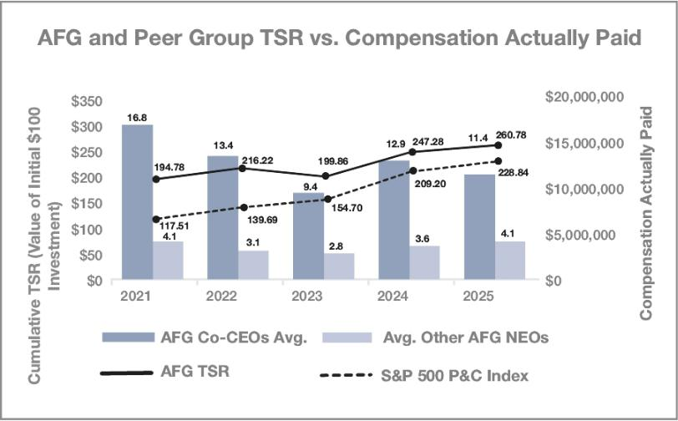

Relationship Between Compensation Actually Paid to our Co-CEOs and the Average of the Compensation Actually Paid to the Other NEOs and the Company’s Net Income.

The table below reflects the relationship between the “compensation actually paid” for the Company’s Co-CEOs and the average Other NEOs versus the Company’s Net Income (in thousands) for the years ended December 31, 2025, 2024, 2023, 2022 and 2021. Net income for 2021 includes the sale of the annuity business to Massachusetts Mutual Life Insurance Company for approximately $3.5 billion of after-tax proceeds.
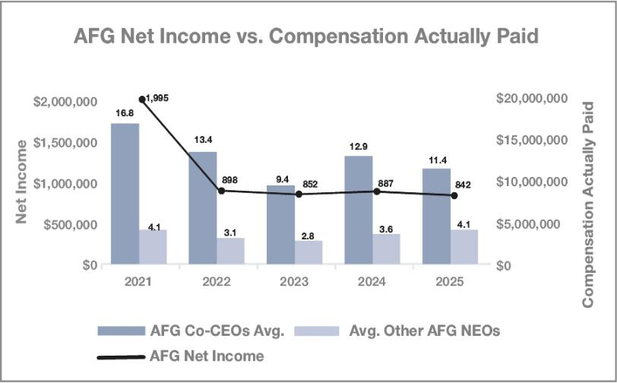

64 2026 Proxy Statement | American Financial Group

TABLE OF CONTENTS

EXECUTIVE COMPENSATION

Relationship Between Compensation Actually Paid to our Co-CEOs and the Average of the Compensation Actually Paid to the Other NEOs and the Company’s Core Earnings Per Share.

The table below reflects the relationship between the “compensation actually paid” for the Company’s Co-CEOs and the average Other NEOs versus the Company’s Core EPS for the years ended December 31, 2025, 2024, 2023, 2022 and 2021.
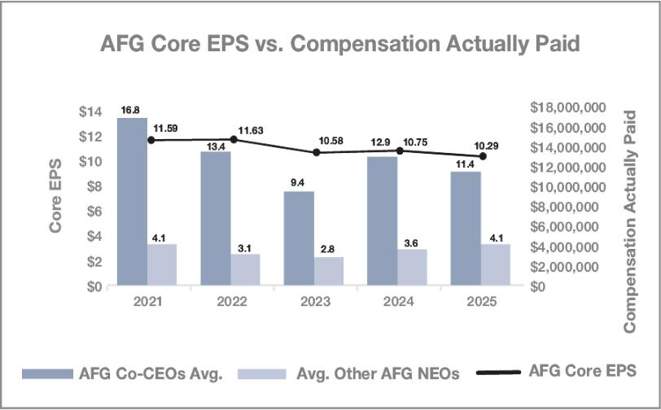

EQUITY COMPENSATION PLAN INFORMATION

The following reflects certain information about common shares authorized for issuance at December 31, 2025, under the Company’s equity compensation plans.

 |  |  | (c)
 |  |  | Number of securities remaining
 |  |  | available for
 | (a) | (b) | future issuance under
 | Number of securities to be | Weighted-average | equity compensation
 | issued upon exercise of | exercise price of | plans (excluding
 | outstanding options, | outstanding options, | securities reflected in
Plan category | warrants, and rights | warrants, and rights | column (a))
Equity compensation plans |  |  | 2,486,513⁽¹⁾
approved by security | — | — | 2,486,513⁽¹⁾
holders
Equity compensation plans
not approved by security | — | — | —
holders
Total | — | — | 2,436,513⁽¹⁾

- Includes 2.18 million shares issuable under the Company’s equity incentive plans and 204,061 shares issuable under AFG’s Employee Stock Purchase Plan. 2026 Proxy Statement | American Financial Group 65

TABLE OF CONTENTS

EXECUTIVE COMPENSATION

DELINQUENT SECTION 16(a) REPORTS

Section 16(a) of the Exchange Act requires our executive officers and directors, and persons who own more than ten percent of a registered class of our stock, to file reports of ownership and changes in ownership with the SEC (“Reporting Parties”). Reporting Parties are required by SEC regulation to furnish us with copies of all Section 16(a) forms they file. The Company believes that, for the period from January 1, 2025 through December 31, 2025, its executive officers and directors complied with all filing requirements applicable to them, other than three reports, none of which involved any market transaction. On August 4, 2025, each of the Co-CEOs received a distribution of shares from a family trust over which they have no control. On December 16, 2025,
Mr. Lindner III gifted shares. In each case, a Section 16(a) form was thereafter filed reporting the transactions. The Company based its determination on its review of such forms filed electronically or written representations from certain Reporting Parties.

66 2026 Proxy Statement | American Financial Group

TABLE OF CONTENTS

Information about the Annual Meeting and Voting

Important Notice Regarding the Availability of Proxy Materials for the Annual Meeting of Shareholders to Be Held on Wednesday, May 20, 2026. The Proxy Statement and Annual Report to Shareholders and Form 10-K are available at www.AFGinc.com.

Why did I receive these proxy materials?

You received a copy of this proxy statement (or a notice of internet availability of proxy materials) because you owned shares of our stock on March 27, 2026, the record date, and that entitles you to vote at the annual meeting. This proxy statement describes the matters to be voted on at the meeting and provides information on those matters. It also provides certain information about the Company that we must disclose to you when the Board solicits your proxy.

What is the record date and what does it mean?

The Board established March 27, 2026, as the record date for the annual meeting of shareholders to be held on May 20, 2026. Shareholders who own common shares of the Company at the close of business on the record date are entitled to notice of and to vote at the annual meeting.

Why are you holding a virtual annual meeting?

The annual meeting will be a virtual meeting of shareholders held via a live audio webcast. Our goal for the annual meeting is to enable the largest number of shareholders to participate in the meeting, while providing shareholders with substantially the same access and opportunities to participate as an in-person meeting while reducing the cost to shareholders and the Company. We will have technical support available for all participants during the meeting. Technical support information can be found on the sign-in page for the meeting at www.virtualshareholdermeeting.com/AFG2026. If you have difficulties accessing the virtual meeting of shareholders during check-in or during the meeting, please call the technical support number listed on the annual meeting sign-in page.

Why did I receive a one-page notice in the mail regarding the internet availability of proxy materials instead of a full set of the printed proxy materials?

We are making this proxy statement and our annual report available to our shareholders electronically via the Internet. We believe this delivery method expedites your receipt of materials, while also lowering costs of our annual meeting. The notice of electronic availability contains instructions on how to access this proxy statement and our annual report and how to vote online.

If you received a notice by mail, you will not receive a printed copy of the proxy materials unless you request one in accordance with the instructions provided in the notice. The notice has been mailed to shareholders on or about April 3, 2026, and provides instructions on how you may access the proxy materials on the Internet.

How do I attend the annual meeting?

If your shares are registered in your name, you will need to provide your 16-digit control number included on your notice or your proxy card (if you receive a printed copy of the proxy materials) in order to be able to participate in the meeting. If your shares are not registered in your name (if, for instance, your shares are held in “street name” for you by your broker, bank or other institution), you must follow the instructions printed on your Voting Instruction Form. In order to participate in the annual meeting, please log on to www.virtualshareholdermeeting.com/AFG2026 at least 15 minutes prior to the start of the annual meeting to provide time to register and download the required software, if needed. If you access the meeting but do not enter your control number, you will be able to listen to the proceedings, but you will not be able to vote or otherwise participate.

2026 Proxy Statement | American Financial Group 67

TABLE OF CONTENTS

INFORMATION ABOUT THE ANNUAL MEETING AND VOTING

How do I submit a question at the annual meeting?

Following the business of the annual meeting, we answer questions submitted by shareholders. Once you have logged into the webcast at www.virtualshareholdermeeting.com/AFG2026, simply type your question in the “ask a question” box and click “submit.” You can submit a question beginning 15 minutes prior to the start of the annual meeting and until the time we indicate that the question-and-answer session is concluded.

Why did I receive more than one proxy card?

You will receive multiple proxy cards if you hold your common shares in different ways (e.g., trusts, custodial accounts, joint tenancy) or in multiple accounts. If your common shares are held by a broker or bank (i.e., in “street name”), you will receive your proxy card and other voting information from your broker, bank, trust, or other nominee. It is important that you complete, sign, date, and return each proxy card you receive, or vote using the telephone, or by using the Internet (as described in the instructions included with your proxy card(s) or in the notice).

How many common shares are entitled to vote at the annual meeting?

As of the record date, there were 83,086,295 common shares outstanding and eligible to vote.

How many votes must be present to hold the annual meeting?

A majority of the Company’s outstanding common shares as of the record date must be present in order for us to hold the annual meeting. This is called a quorum. Broker “non-votes” and abstentions are counted as present for purposes of determining whether a quorum exists. A broker “non-vote” occurs when a broker, bank or other nominee holding shares for a beneficial owner does not vote on a particular proposal because the broker, bank or other nominee does not have discretionary voting power for the particular item and has not received voting instructions from the beneficial owner.

What vote is required to approve each proposal?

Shareholders are entitled to one vote per common share on all matters submitted for consideration at the annual meeting.

The 12 nominees receiving the most votes will be elected under Ohio law, but pursuant to our Regulations, any director-nominee who fails to receive a majority of votes cast must tender his or her resignation to the Board, and the resignation will be considered by the Board and the Corporate Governance Committee as set forth on page 29 above under “Corporate Governance—Majority Voting for Directors.” Therefore, a withhold vote will be treated as a vote against the nominee for the purpose of the vote required under our Regulations.

The affirmative vote of a majority of the common shares represented in person or by proxy at the annual meeting is required for the non-binding ratification of appointment of Ernst & Young LLP as the Company’s independent registered public accounting firm for the year ending December 31, 2026, and approval of the advisory vote to approve named executive officers’ compensation. Abstentions and broker non-votes will not count as a vote for or against either of these proposals.

Where will I be able to find voting results of the annual meeting?

We will announce preliminary voting results at the annual meeting. We will also publish final voting results in a Current Report on Form 8-K to be filed with the SEC within four business days after the annual meeting.

68 2026 Proxy Statement | American Financial Group

TABLE OF CONTENTS

INFORMATION ABOUT THE ANNUAL MEETING AND VOTING

How do I vote my common shares?

- Via Internet: Go to www.proxyvote.com to vote via the Internet. You will need to follow the instructions on your notice or proxy card and the website. If you vote via the Internet, you may incur telephone and Internet access charges.

- By Telephone: Call the toll-free telephone number on the proxy card or the website to vote by telephone. You will need to follow the instructions and the voice prompts.

- By Mail: Request, complete and return a paper proxy card, following the instructions on your notice.

- At the Meeting: Vote electronically during the annual meeting at www.virtualshareholdermeeting.com/AFG2026.

If you vote via the Internet or by telephone, your electronic vote authorizes the named proxies in the same manner as if you signed, dated and returned your proxy card. If you vote via the Internet or by telephone, do not return your proxy card.

If your shares are held in “street name” (that is, in the name of a bank, broker or other holder of record), you will receive instructions from the holder of record that you must follow in order for your shares to be voted, or you may request the record holder to issue you a proxy covering your shares.

Can I change my vote after I have mailed in my proxy card(s) or submitted my vote using the Internet or telephone?

Yes, whether you vote by mail, via the Internet or by telephone, you may revoke your proxy at any time before it is voted by submitting a new proxy with a later date, voting via the Internet or by telephone at a later time, delivering a written notice of revocation to the Company’s Secretary, as follows, or by voting in person at the meeting:

Joseph C. Alter

Vice President, Deputy General Counsel & Secretary

American Financial Group, Inc.

Great American Insurance Group Tower

301 East Fourth Street

Cincinnati, Ohio 45202

What if I hold shares through the Company’s 401(k) Retirement and Savings Plan?

If you are a participant in the Company’s 401(k) Retirement and Savings Plan (RASP) with a balance in the AFG Common Stock Fund, the accompanying proxy card shows the number of common shares attributed to your RASP account balance, calculated as of the record date. In order for your RASP shares to be voted in your discretion, you must vote by the end of the day on May 17, 2026, either by Internet, telephone, or returned properly signed proxy card. If you choose not to vote or if you return an invalid or unvoted proxy card, the Administrative Plan Committee, consisting of current or former senior officers of the Company, will vote your RASP shares in the Committee’s sole discretion. It has been the practice of the Administrative Plan Committee to vote all such shares in accordance with Board recommendations. Plan participants’ votes will be processed by the plan trustee and will not be disclosed to the Company.

How will my proxy be voted?

If you complete, sign, date, and return your proxy card(s) or vote by telephone or by using the Internet, your proxy will be voted in accordance with your instructions. If you sign and date your proxy card(s) but do not indicate how you want to vote, your common shares will be voted as the Board recommends.

What is the difference between a “registered shareholder” and a “street name shareholder”?

These terms describe how your common shares are held. If your common shares are registered directly in your name with Broadridge Corporate Issuer Solutions, our transfer agent, you are a “registered shareholder.” If your common shares are held in the name of a broker, bank or other nominee as a custodian, you are a “street name shareholder.”

2026 Proxy Statement | American Financial Group 69

TABLE OF CONTENTS

INFORMATION ABOUT THE ANNUAL MEETING AND VOTING

What if my common shares are held in “street name” through a broker, bank or other nominee?

If your common shares are held in “street name” through a broker, bank or other nominee, you are considered the beneficial owner of those common shares, but not the record holder. As a beneficial owner, in order to ensure your shares are voted in the way you would like, you must provide voting instructions to your broker by the deadline provided in the proxy materials you receive from your broker. Under the rules of the NYSE, unless you provide specific voting instructions, your broker is not permitted to vote your shares on your behalf, except with respect to routine proposals. The ratification of the appointment of our independent registered public accounting firm (Proposal 2) constitutes a routine proposal. For your vote on any other matter to be counted, you will need to provide voting instructions to your broker before the date of the 2026 annual meeting using the instructions provided by your broker.

What are the Board’s recommendations on how I should vote my common shares?

The Board recommends that you vote your common shares as follows:

- “FOR” the election of the 12 nominees proposed for the Board of Directors;

- “FOR” the ratification of the appointment of our independent registered public accounting firm; and,

- “FOR” the approval, on an advisory basis, of compensation of our named executive officers as disclosed in this proxy statement.

Do I have an opportunity to cumulate my votes for director nominees?

Cumulative voting allows a shareholder to multiply the number of shares owned on the record date by the number of directors to be elected and to cast the total for one nominee or distribute the votes among the nominees as the shareholder desires. Shareholders of the Company have cumulative voting rights in the election of directors if certain conditions are met. In order for cumulative voting to apply, notice of cumulative voting must be given in writing to the Company’s Secretary not less than 48 hours before the time fixed for the holding of the meeting. As of the date of this proxy statement, the Company has not received a notice from any shareholder requesting cumulative voting. If proper notice of cumulative voting is received by the Company, the 12 nominees who receive the greatest number of votes will be elected, subject to the tender of resignation and related procedures set forth above under, “What vote is required to approve each proposal” with respect to incumbent directors who fail to receive more votes in favor than votes withheld. The authority solicited by this proxy statement includes discretionary authority to cumulate votes in the election of directors. If cumulative voting is in effect with respect to the election of directors, the named proxies reserve the right to cumulate the votes represented by the proxies they receive and distribute such votes in accordance with their sole discretion, except that shareholders’ votes will not be cast for a nominee as to whom such shareholder instructs that such votes be cast “AGAINST” or “ABSTAIN.”

70 2026 Proxy Statement | American Financial Group

TABLE OF CONTENTS

Other Matters

COPIES OF ANNUAL REPORT ON FORM 10-K

The Company makes available on its website all of its filings that are made electronically with the Securities and Exchange Commission (“SEC”), including Forms 10-K, 10-Q and 8-K. To access these filings, go to the Company’s website (www.AFGinc.com), click on “Investor Relations” on the home page and select “Financial Information.” Copies of the Company’s Annual Report on Form 10-K for the year ended December 31, 2025, including financial statements and schedules, as filed with the SEC, are also available without charge to shareholders upon written request addressed to:

Investor Relations
American Financial Group, Inc.
Great American Insurance Group Tower
301 East Fourth Street
Cincinnati, Ohio 45202

SUBMITTING SHAREHOLDER PROPOSALS FOR THE 2027 ANNUAL MEETING OF SHAREHOLDERS

Under the rules and regulations of the SEC, any proposal that a shareholder of the Company intends to present at the annual meeting of shareholders to be held in 2027 and which such shareholder desires to have included in the Company’s proxy materials for such meeting must be received by the Secretary of the Company not less than 120 calendar days before the one-year anniversary date of this year’s proxy statement, or December 4, 2026. Our Regulations, as they may be amended from time to time, may contain additional requirements for matters to be properly presented at annual meetings of shareholders.

The proxy card used by AFG for the annual meeting typically grants authority to management to vote in its discretion on any matters that come before the meeting for which adequate notice has not been received. In order for a notice to be deemed adequate for the 2027 annual meeting, it must be received by February 17, 2027.

Shareholders wishing to nominate a director candidate must provide written notice at least 90 and not more than 120 days prior to the annual meeting to the Secretary of the Company setting forth or accompanied by: (1) certain biographical, stock ownership and investment intent disclosures about the proposed nominee as set forth in the Regulations; (2) certain biographical, stock ownership and hedging or similar activity disclosures about the shareholder giving the notice and specified persons associated with such shareholder as set forth in the Regulations; (3) verification of the accuracy or completeness of any nomination information at the Company’s request; (4) a statement that a nomination that is inaccurate or incomplete in any manner shall be disregarded; (5) a representation that the shareholder was a record holder of the Company’s voting stock and intended to appear, in person or by proxy, at the meeting to make the nomination; and (6) the consent of each such nominee to serve as director if elected.

In addition, to comply with the universal proxy rules, shareholders who intend to solicit proxies in support of director nominees other than the Company’s nominees at the 2027 annual meeting must provide notice that sets forth the information required by Rule 14a-19 under the Exchange Act no later than December 4, 2026.

2026 Proxy Statement | American Financial Group 71

TABLE OF CONTENTS
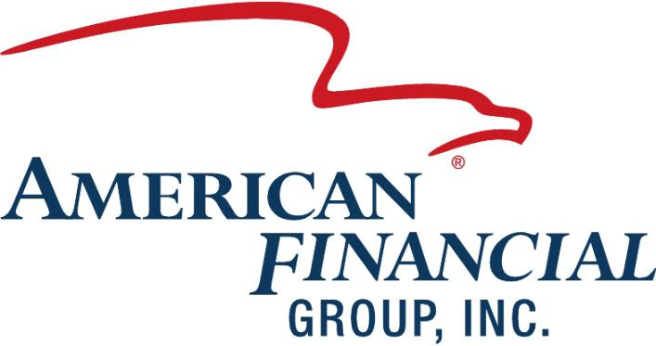

TABLE OF CONTENTS
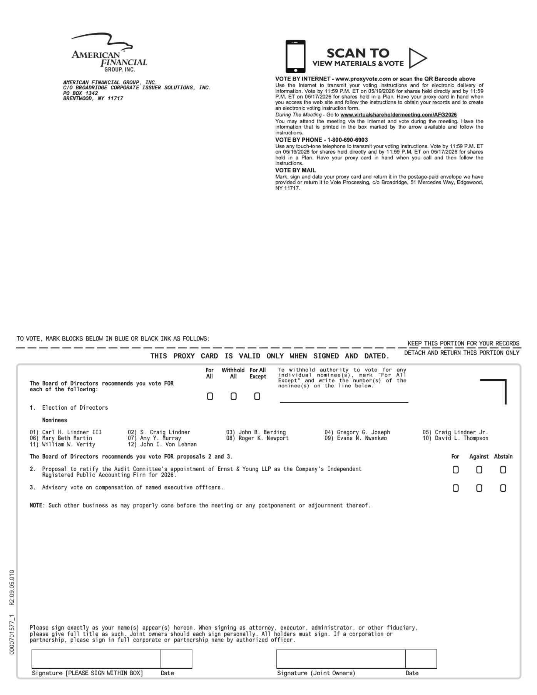

TABLE OF CONTENTS


